Colt Voice REST APIs Guide
Copyright ©
No part of this document may be reproduced or adapted in any form, including photocopying or storing it by electronic means, except as is necessary for the purpose of the recipient's dealings with Colt, without the written permission of Colt. Any copies made of any part of this document shall include the notice:
© 2022 Colt Technology Services. The Colt name and logos are trademarks. All rights reserved.
No information contained in this document shall be disclosed to any third party without the written permission of Colt.
CDR APIs Implementation Guide

Document Version 1.3
Release Date 24/09/2022

Document History

Soft copies of this document are maintained under change control, but hard copies are not. This may not be a printout of the latest version.

Revision history
Revision | Date | Description
1.0 | 12th July 2022 | Document Launch
1.1 | 23rd July 2022 | Document updated reflecting 23rd July 2022 release changes  - JWT Authentication mechanism details added in sections  - Added updated API specifications in APPENDIX A: API Specifications
1.2 | 8th August 2022 | Document updates are highlighted in RED  - Added details for allowed resource name in section ‘Access & End-Point URLs’  - Added more details in Input parameter section for Authorization API (3.1.2) and functional APIs (5.1.2, 5.2.2, 5.3.2,6.2 and 7.2)  - Updated product Name as per OAS Specification in sections 5.1.2 and 5.2.2
1.3 | 24th September 2022 | Document updated with list of error codes in Appendix C: Error Codes

Contents
1. Introduction 5
1.1. Access & End-Point URLs 5
1.1.1. Error handling 5
1.2. How to get access to new REST APIs, Colt API portal & support 6
2. Authorization 8
2.1. Oauth 2.0 Authentication 8
2.1.1. API Details 8
2.1.2. Input parameter(s) 8
2.1.3. Error handling 8
2.1.4. Response samples 8
3. Billing APIs 10
3.1. Resource names 10
4. Unrated CDRs 11
4.1. Get Unrated CDRs 11
4.1.1. Description 11
4.1.2. Input parameter(s) 11
4.1.3. Response 12
4.2. Post Consolidated Unrated CDRs 12
4.2.1. Description 12
4.2.2. Input parameter(s) 12
4.2.3. Response 13
4.3. Get Consolidated unrated CDR 14
4.3.1. Description 14
4.3.2. Input parameter(s) 15
4.3.3. Response 15
4.4. CDR file details and format 16
4.4.1. CDR File Format 16
4.4.2. Character Coding 16
4.4.3. File Mark-up Coding 16
4.4.4. Compression/Decompression Algorithms 16
4.4.5. File Name 16
4.5. Call Detail Record format 17
4.6. Sample Call Detail Record 19
5. Rated CDR 22
5.1. Description 22
5.2. Input parameter(s) 22
5.3. Response 22
6. Non usage report 24
6.1. Description 24
6.2. Input parameter(s) 24
6.3. Response 24
7. How to save/extract binary file 26
APPENDIX A: API Specifications 28
OAS Specification for Authorization 28
OAS Specification for CDR APIs 28
Appendix B: Country Codes 29
Appendix C: Error Codes 29

Introduction

We now support Next Gen REST APIs for call detail records (CDRs).
Our Next Gen APIs:
- Conform to the Industry standard REST-JSON APIs
- Aligns with TMF conventions
- Support OAuth2 and JWT based authentication and authorization
- Support open API specifications (earlier swagger)
- Supports flexible version management (from our next release)
- Offers a standard format for numbers, date-time, etc.
- Optimizes fields
- No change with respect to synchronous/asynchronous API behavior

Access & End-Point URLs

Colt REST APIs can be enabled in these environments below:
- Production: live environment. Network, billing & emergency services are enabled.
- Sandbox: non-production environment for testing the production version of the APIs.
  - Beta: non-production environment for testing new features before a release, with an upcoming version of APIs. Only available before a new release.
Interface | Production
REST | Authorization  end point: https://apimgd01.colt.net:8443/oauth/v2/resource name  resource name: allowed resource name is as below  - token
REST | Billing APIs  End point: https://apimgd01.colt.net:8443/usageManagement/v1/resource name  resource name: allowed resource names are as below.  - unratedCallDetailRecord  - generateConsolidatedUnratedCallDetailRecord  - consolidatedUnratedCallDetailRecord  - ratedCallDetailRecord  - nonUsageReport

Error handling

Error Schema
description: | Used when an API throws an Error, typically with a HTTP error response-code (3xx, 4xx, 5xx)
code* | string  example: ERR01  Application relevant detail, defined in the API or a common list.
reason* | String  Explanation of the reason for the error which can be shown to a client user.
Message | String  More details and corrective actions related to the error which can be shown to a client user.
Status | string  example: 401-02  HTTP Error code extension

Header:
Name | Description | Type
Content-Type |  | string  Example: multipart/form-data; boundary=645501572420247968528808
APIGWExceptionSystem |  | string
APIGWExceptionCode |  | string
APIGWTrackingId | Id to track the request end to end | string  Example: abcd456e-d45645-dfaafda-1232345667dd

Example
Below is the TMF compliant error payload:
{
"code": "ERR01",
"reason": "string",
"message": "string",
"status": "401-02"
}

How to get access to new REST APIs, Colt API portal & support

Please inform your account manager to request access to the sandbox and/or production environments for the REST APIs and access to Colt API portal.
Sandbox support
Support for sandbox testing will be provided by the Voice API Support team and is a chargeable service. Please contact your account manager for further information.

Beta support
Support in the beta environment will be provided by our testing team who are directly involved and responsible for the upcoming release. Contact details are published in the Number Hosting or CDR specific release note.

Production support
Please inform your account manager to request access to the sandbox and/or production environments for the REST APIs. You can raise any questions or issues to them directly and they will work to resolve these with our back office IT support.
- Oauth 2.0 authentication:
Your Client ID and Client Secret will be shared with you by Colt’s Reseller Support Voice team and
- JWT Authentication:
If you wish to use JWT authentication, then you will need to share the JWT public certificate (zipped) and name of the token issuer. Your Application ID (s) to add into the JWT key as the ‘Audience’ value will be shared with you by Colt’s Reseller Support Voice team.

Authorization

Industry standard authentication and authorization mechanism is now enabled
- Authentication API is implemented
- OAuth 2.0 access token (applicable for 30 mins only) with client_credential grant type used to authenticate clients You can request up to 5 CLIENT_ID + CLIENT_Secret per company account.
- JWT authentication type is also supported now
- This will give options to users to opt for any one of the authentication types

Oauth 2.0 Authentication

API Details
Operation | Resource Name
Access token for Functional APIs | /token

Input parameter(s)

Parameter | Type | Description
HTTP Headers:
APIGWTrackingId | Mandatory | description: Unique identifier for the order  example: abcd456e-d45645-dfaafda-1232345667dd  pattern: ^[\w.~:@-]{1,255}$
Authorization | Mandatory | Base64 encoded ClientID and secret joined by colon  Example: Basic dGVzdDp0ZXN0MTIz

Please note: Once a client ID and secret have been obtained, get the access token using HTTP Basic Auth, where the client ID is the username and the client secret is the password.

Error handling

Below would be TMF complaint error payload:
{
"code": "ERR01",
"reason": "string",
"message": "string",
"status": "401-02"
}

Response samples

Success response
{
"access_token": "d3a1a83223e84bbe9d90173d784aaddf",
"token_type": "Bearer",
"expires_in": 1800,
"scope": "OauthScope NhScope"
}

Expiry response
{
"code": "APIGW-400-00",
"reason": "Unauthorized",
"message": "Token specified is invalid or has expired..",
"status": "400-00"
}

Billing APIs

Next Gen REST CDR APIs will enable you to download the following:
- Daily unrated and/or consolidated unrated CDRs for the products listed below
  - Geographic Number Hosting
  - IN for Resellers (e.g. Freephone, Shared Cost, IN Geo etc.)
  - Voice Line
  - Voice Line (v) (also known as IPVoiceLine)
  - SIP Trunking
  - Colt Intelligent Communications (CIC)
- monthly rated CDRs for any Colt voice product
- non-usage files (.r.cat) containing e.g. Number Hosting order charges, such as new number activation
- The existing rules will not change e.g. regarding the availability of the CDRs & non-usage files (e.g. unrated CDRs will continue to be available for the past 90 days only).
- The existing CDR download functionality available in Colt Online will continue to be available.

Resource names
Operation | Resource Name
Unrated CDR | /unratedCallDetailRecord
Generate consolidated unrated CDR | /generateConsolidatedUnratedCallDetailRecord
Consolidated unrated CDR | ​/consolidatedUnratedCallDetailRecord
Rated CDR | /ratedCallDetailRecord
Non usage report | ​/nonUsageReport

Unrated CDRs
Twice a day, every day of the week, Colt will deposit a file of Call Detail Records (CDR) on the server.
The exception is for the Global SIP countries such as Luxembourg, the Czech Republic, Slovakia & Romania, where the unrated CDRs are delivered daily.
This will contain all of the CDRs collected by the Colt network since the last file, typically each 12 hours. The CDR files are provided in a pre-defined, fixed length format. CDR file format description has been detailed in section 6

Get Unrated CDRs

Description

GET/unratedCallDetailRecord allows you to fetch the unrated CDR for a specific date.

Input parameter(s)

Parameter | Type | Description
HTTP Headers
APIGWTrackingId | Mandatory | description: Unique identifier for the order  example: abcd456e-d45645-dfaafda-1232345667dd  pattern: ^[\w.~:@-]{1,255}$
Authorization | Mandatory | Bearer Access_token*  Example: Bearer dGVzdDp0ZXN0MTIz
Query
profile | Mandatory | string($^[a-zA-Z0-9]{1,5}$)
product | Mandatory | 0-Voice Line  10-SIP Trunking  11-IP Voice Line  12-IN For Resellers  15-Geographic Number Hosting  19-CIC for Resellers
date | Mandatory | string($date)  example: 2019-05-17  date time in ISO 8601 format

*Please note: ‘Authorization’ should have Type as ‘Oauth 2.0’ and you need to provide Access_token received via ‘Authorization API’

Response

Response Schema
string($binary)

Headers:
Name | Description | Type
Content-Type |  | string  Example: multipart/form-data; boundary=645501572420247968528808
APIGWTrackingId | Id to track the request end to end | string  Example: abcd456e-d45645-dfaafda-1232345667dd

There is no change to the unrated, or rated CDR or non-usage file contents.

Sample success response
The Response to the request will always be in a zipped file (Binary data).
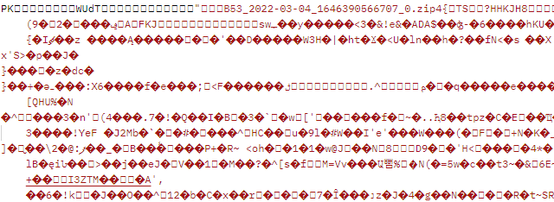

Post Consolidated Unrated CDRs
This feature enables you to place a request for a consolidated CDR file through APIs.
Up to 90 days of CDRs can be requested, e.g. a consolidated file of a week’s worth of CDRs and these files will be delivered to both Colt Online & APIs.

Description

POST/generateConsolidatedUnratedCallDetailRecord API allows you to initiate consolidated unrated CDR file generation

Input parameter(s)

Parameter | Type | Description
HTTP Headers
APIGWTrackingId | Mandatory | description: Unique identifier for the order  example: abcd456e-d45645-dfaafda-1232345667dd  pattern: ^[\w.~:@-]{1,255}$
Authorization | Mandatory | Bearer Access_token*  Example: Bearer dGVzdDp0ZXN0MTIz
Query
profile | Mandatory | string($^[a-zA-Z0-9]{1,5}$)
product | Mandatory | 0-Voice Line  10-SIP Trunking  11-IP Voice Line  12-IN For Resellers  15-Geographic Number Hosting  19-CIC for Resellers
fromDate | Mandatory | string($date)  example: 2019-05-17  date time in ISO 8601 format
toDate | Mandatory | string($date)  example: 2019-05-17  date time in ISO 8601 format

*Please note: ‘Authorization’ should have Type as ‘Oauth 2.0’ and you need to provide Access_token received via ‘Authorization API’

Response

Response Schema

order
 | {  href | string  example: https://apigw-uat.colt.net/usageManagement/v1/consolidatedCallDetailRecord/{orderId}
 | orderId  } | orderIdType  string($[A-Za-z0-9\-]{1,36})

Headers:
Name | Description | Type
Content-Type |  | string  Example: multipart/form-data; boundary=645501572420247968528808
APIGWTrackingId | Id to track the request end to end | string  Example: abcd456e-d45645-dfaafda-1232345667dd

Sample success response

Sample success response
{
"responseMessage": "Order ID for your request is 2022031141858 You can download your consolidated CDR file B532022031141858.cdr.zip within the next 2 hours using GET consolidatedUnratedCallDetailRecord API.",
"orderID": "2022031141858"
}

Get Consolidated unrated CDR
Within 2 hours the consolidated CDR file will be available for download via APIs which you used in your request.
The consolidated CDR file will be available to download for 5 days, after that the file will be removed and you will need to submit a new request (if you have not downloaded it).
All Consolidated CDR files delivered have a filename in the following format:-
<profile><orderID>.cdr.zip.
Where:
- <profile> is up to 5 alphanumeric and is the applicable profile for the product
- <orderID> is the combination of date and unique number returned after requesting for consolidated CDR
- .cdr is the extension
- .zip is where the file is zipped
Example: AM220120110182.cdr.zip
The content of the consolidated CDR file is the same as the standard twice daily delivered CDRs, as described in section 6

Description

GET/consolidatedUnratedCallDetailRecord API allows you to get consolidated unrated CDR file based on orderID received.

Input parameter(s)

Parameter | Type | Description
HTTP Headers
APIGWTrackingId | Mandatory | description: Unique identifier for the order  example: abcd456e-d45645-dfaafda-1232345667dd  pattern: ^[\w.~:@-]{1,255}$
Authorization | Mandatory | Bearer Access_token*  Example: Bearer dGVzdDp0ZXN0MTIz
Query
profile | Mandatory | string($^[a-zA-Z0-9]{1,5}$)
orderID | Mandatory | string($[A-Za-z0-9\-]{1,36})

*Please note: ‘Authorization’ should have Type as ‘Oauth 2.0’ and you need to provide Access_token received via ‘Authorization API’

Response
The Response to the request will always be in a zipped file.

Response Schema
string($binary)

Headers:
Name | Description | Type
Content-Type |  | string  Example: multipart/form-data; boundary=645501572420247968528808
APIGWTrackingId | Id to track the request end to end | string  Example: abcd456e-d45645-dfaafda-1232345667dd
Content-Disposition |  | string
x-content-type-options |  | string

There is no change to the unrated, or rated CDR or non-usage file contents.

Sample success response

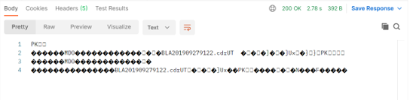

CDR file details and format
The CDR file contains only CDR records in a fixed length format. A CDR file is made available twice per day – once in the morning and once in the afternoon. The files are delivered at approximately 9AM and 5PM CET.
- The 9 AM CET file contains calls from 4PM CET the previous day until 8AM CET on the current day
- The 5 PM CET file contains calls from 8AM CET to 4PM CET on the current day
Please note that CDR files are delivered to your directory 7 days a week and will vary in size depending on the level of traffic that your customers generate.
Please note the exception is for the Global SIP countries such as Luxembourg, the Czech Republic, Slovakia & Romania, where the unrated CDRs are delivered daily at approximately 9 AM CET.

CDR File Format

Character Coding
ASCII

File Mark-up Coding

- No structured Mark-Up used
- Fixed length records
- Fixed length fields, space filled

Compression/Decompression Algorithms
CDR files are delivered in Zip format (Unix Gzip, MS Windows Zip). However, Colt recognizes that this can be difficult for certain companies to receive and the CDR files can be delivered in plain text if required. Please notify the Colt Customer Services if you need the CDR files to be delivered as plain text (Uncompressed) files.

File Name
All unrated CDR files delivered to Colt Online and APIs have a filename in the following format:-
<countrycode>_<profile>_<productidentifier>_<sequence no>_<date>.cdr.gz
Where:
- <countrycode> in ISO 2 character format
- <profile> is up to 5 alphanumerics and is the applicable profile for the product
- <productidentifier> is the product identifier (1-2 alphanumerics) – see table below
- <sequence no> is a rolling four digit sequence per <profile>_<product> combination
- <date> is YYYYMMDDHHmmss
- .cdr is the extension
- .gz is where the file is zipped

Product Identifier | Product name
00 | Voice Line
10 | SIP Trunking
11 | IP Voice Line (Voice Line (v))
12 | IN for Resellers
15 | Geographic Number Hosting
19 | CIC for Resellers

Example: DE_ABC_01_0001_20101208090122.cdr.gz

Call Detail Record format
A standard format for unrated CDRs applies to our reseller and wholesale product portfolio.. This standard CDR format is harmonised across all Colt countries and applies to existing and new products going forward in Colt Online
The data lines are 229 bytes in length and organised as:
Ref | Name | Bytes/  Length | Position | Alpha/  Numeric | Format & Description
1 | Origin | 20 | 1 | N | Originating CLI with leading 0. Filler spaces must be added to fill in the spaces designated for a field. In the case of IN, the last 4 digits are replaced with ‘x’.  In the case of Czech Republic (CZ), Poland (PL), Romania (RO) ,Slovakia (SK), Luxembourg (LUX), Finland (FI) ,Norway (NO), Japan (JP) for SIP Trunking, the Originating CLI starts with the country code  In the case of Global IN for Resellers ordered through the UK, the caller’s number will be in the international format, starting with 00 + the country code + the number (omitting the leading zero) e.g. caller calling from a mobile in Romania: 004074582xxxx
2 | Destination (Terminating) | 20 | 21 | N | Destination 0 = Domestic and National, Destination 00 = International  In the case of Czech Republic (CZ), Poland (PL), Romania (RO) ,Slovakia (SK), Luxembourg (LUX), Finland (FI) ,Norway (NO), Japan (JP) for SIP Trunking, the destination starts with the country code
3 | Product Type | 2 | 41 | N | ‘01’=Indirect Service  ‘00’ = Direct Service  '04' = Direct Service  ’06‘=NH Geo Premium  ‘07’=NH Geo Wholesale  '08'=NH Geo Retail  '09'=NH Geo Incoming  '10'=NH IN Incoming  '79' = SIP Trunking  ‘80’ = IP Voice Line (Voice Line (v))  CIC for Reseller is SIP trunk reseller, so cdr format will have product code as ‘79’
4 | Date | 8 | 43 | N | YYYYMMDD
5 | Time | 8 | 51 | N | HHMMSSss . Time duration is broken up into tenths of a second. Fractions of a second will be ignored.
6 | Duration | 8 | 59 | N | Duration of the call to the nearest 1/10th of a second SSSSSSSs
7 | Continuation | 1 | 67 | N | ‘0’, ‘1’, ‘2’, ‘3’ or ‘5’ – normally a 0. To be used only if calls are greater than 6 hours
8 | Switch ID | 25 | 68 | N | Unique switch identifier
9 | Trunk incoming | 25 | 93 | N | Internal use only
10 | Trunk outgoing | 25 | 118 | N | Internal use only
11 | Account Code | 20 | 143 | A | Not in use
12 | Pulses in | 6 | 163 | N | Not in use
13 | Pulses generated | 6 | 169 | N | Not in use
14 | Pulses sent | 6 | 175 | A | In use for all IN, Voice & VoIP services in UK & France: Charge Band defined by Regulator(Ofcom UK/Arcep FR) for calls to non-geographic numbers. If no Charge Band is available, the value is 000000 or blank.
15 | Service Indicator | 4 | 181 | N | 0000 for standard calls, 0001 for ISDN calls
16 | Charged (C-Num) | 20 | 185 | N | Trunk ID shown here for IP Voice Line (Voice Line (v)) and for SIP Trunking  In use for IN services – the number to which the IN service number is translated.  In the case of Global IN for Resellers ordered through the UK, this number will be in the international format, starting with 00 + the country code + the number (omitting the leading zero)
17 | Dialled (D-Num) | 20 | 205 | N | In use for IN services (IN service number)  In the case of Global IN for Resellers ordered through the UK, the IN service number will be in the international format, starting with 00 + the country code + the number (omitting the leading zero) e.g. Romania freephone number: 0040800890123
18 | Carrier | 3 | 225 | A | The Reseller profile of up to 3 alphanumerics
19 | End of Record | 1 | 228 | A | Value of zero is shown
20 | Line Feed | 1 | 229 | ASCII Control Character | Line Feed (ASCII Control Character not visible in plain text editors

Please note: There is an ASCII Control Character (Line Feed, HEX 0A) after the last field 19 “End of record”. This Control character generates a new line for the next CDR and shows that the actual CDR ends. Normally you can ignore this control character except you use a HEX-Editor to process your CDRs.

Sample Call Detail Record

Sample unrated CDRs for Voice Line:-
06971041234 0368751234002011093007235400000007301 00063 OF3XBN33687512340 0000010000010000 0368751234 SV0
06971041234 038203731234002011093007225600000013201 00063 OF3XBN33855523484 0000010000010000 038203731234 SV0
06971041234 066311234002011093007250000000001101 00063 OF3EZLA663121234 0000010000010000 066311234 SV0

Sample unrated CDRs for Voice Line (FR):-
0982406525 0841118663002015082009134390000074070 03300 1088 1062 000000000000 A0050010 0033899108018PBW0 PBW2S
0494270512 0494107021002015082011415520000000540 03302 1503 1503 000000000000 A0050010 0033826106714PAC0 PAC2S

Sample unrated CDRs for SIP Trunking:-
038422001234 081010251234792011060314221108000000000 ZHA CXVIE013038422001234 0000 ABC0
038422001234 0517661234792011060314222708000022440 ZHA CXVIE013038422001234 0000 ABC0
0732388824321 0732771234792011060314261409000013790 ZHA CXVIE0130732388824321 0000 ABC0
0158031234 00351913231234792011060314323700000000210 ZHA CXMAD0130158031234 0000 ABC0

Sample unrated CDRs for SIP Trunking (CZ, FI, JP, LU, NO, RO & SK):-
352206099 442033535570792015091610405600 170 0000 ALB0
420296180311 442033535475792015100911120200 550 0000 AAX0
40312200237 40753086507792015070215113800 1480 0000 BKD0
421232335698 390321393652792015092110045300 90 0000 BKE0

Sample unrated CDRs for IN for Resellers (Freephone & shared cost):-
0129356xxxx 08003581234002011101923483510000008300 01001 3059 0129356xxxx 0000000000000000000000 01618361234 08003581234ADC0
0773777xxxx 08003581234002011101923455270000068380 01001 2702 0773777xxxx 0000000000000000000000 01618361234 08003581234ADC0
0755747xxxx 08003581234002011101923580620000008090 01001 2042 0755747xxxx 0000000000000000000000 01618361234 08003581234ADC0

Sample unrated CDRs for Geographic Number Hosting:-
0307870098 0230333517082012110610363380000005050 MIA SNCB0103 CXMIT0130307870098 0000 AJC0
0230333517 0307870098092012110610401400000002570 MIA CXMIT013 SNCB01010230333517 0000 AJC0

Sample unrated CDRs for IN Number Hosting:-
0230329xxx 800909395002012102610530410000000730 00225 10270230329xxx 0000000000000000000010 3483954697 39800909395AJB0

Sample unrated CDR for Global IN for reseller (CA, CZ, FI, HK, JP, NO, RO & US):-
004074582xxxx 0040800890020002018032308352100000000240 00000 004074582xxxx 0000 00 0040800890020DMP0
004074582xxxx 0040800890020002018032308394500000000240 00000 004074582xxxx 0000 00 0040800890020DMP0

Please Note: The first CDR file will appear in Colt Online after the first call has been made.

Rated CDR
Every month Colt will deposit a file of rated Call Detail Records (CDR) on the server which provide further details of the total call usage displayed on your Cotl invoice for our Voice, VoIP & IN products.
This will contain all of the CDRs collected by the Colt network since the last monthly file.

Description
GET/ratedCallDetailRecord allows you to fetch the rated CDR.

Input parameter(s)

Parameter | Type | Description
HTTP Headers
APIGWTrackingId | Mandatory | description: Unique identifier for the order  example: abcd456e-d45645-dfaafda-1232345667dd  pattern: ^[\w.~:@-]{1,255}$
Authorization | Mandatory | Bearer Access_token*  Example: Bearer dGVzdDp0ZXN0MTIz
Query
OCN | Optional | string  ($^[A-Za-z0-9]*$)
BCN | Optional | string  ($^[A-Za-z0-9]*$)
invoiceNumber | Optional | String
month | Optional | Available values:  Jan, Feb, Mar, Apr, May, Jun, Jul, Aug, Sep, Oct, Nov, Dec
year | Optional | string ($^[0-9]{4}$)  example: 2022

*Please note: ‘Authorization’ should have Type as ‘Oauth 2.0’ and you need to provide Access_token received via ‘Authorization API’

Response

The Response to the request will always be in a zipped file (Binary data).

Response Schema
string($binary)

Headers:
Name | Description | Type
Content-Type |  | string  Example: multipart/form-data; boundary=645501572420247968528808
APIGWTrackingId | Id to track the request end to end | string  Example: abcd456e-d45645-dfaafda-1232345667dd

There is no change to the unrated, or rated CDR or non-usage file contents.

Sample success response

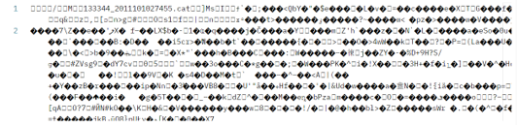

Non usage report
Every month Colt will deposit a file of non-usage charges on the server which provide further details of the total transactional charges displayed on your Colt invoice primarily for our Number Hosting service such as number reservation & activation & port-in activation charges.
This will contain all of the non-usage charges collected by the Colt network since the last monthly file.

Description
GET/nonUsageReport allows you to fetch the non-usage report.

Input parameter(s)

Parameter | Type | Description
HTTP Headers
APIGWTrackingId | Mandatory | description: Unique identifier for the order  example: abcd456e-d45645-dfaafda-1232345667dd  pattern: ^[\w.~:@-]{1,255}$
Authorization | Mandatory | Bearer Access_token*  Example: Bearer dGVzdDp0ZXN0MTIz
Query
OCN | Optional | string  ($^[A-Za-z0-9]*$)
BCN | Optional | string  ($^[A-Za-z0-9]*$)
invoiceNumber | Optional | String
month | Optional | Available values: Jan, Feb, Mar, Apr, May, Jun, Jul, Aug, Sep, Oct, Nov, Dec
year | Optional | string ($^[0-9]{4}$)  example: 2022

*Please note: ‘Authorization’ should have Type as ‘Oauth 2.0’ and you need to provide Access_token received via ‘Authorization API’

Response

The Response to the request will always be in a zipped file (Binary data).

Response Schema
string($binary)

Headers:
Name | Description | Type
Content-Type |  | string  Example: multipart/form-data; boundary=645501572420247968528808
APIGWTrackingId | Id to track the request end to end | string  Example: abcd456e-d45645-dfaafda-1232345667dd

There is no change to the unrated, or rated CDR or non-usage file contents.

Sample response schema
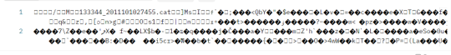

How to save/extract binary file

Please see below steps:

- Save response to a file


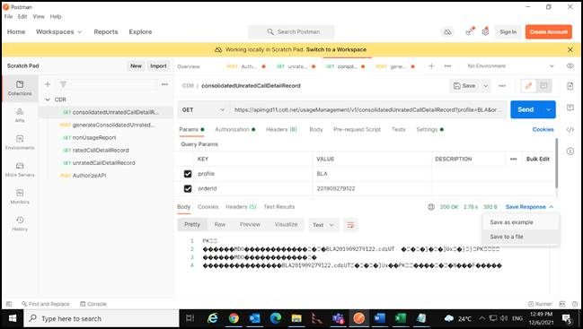
- Select your folder where you want to save the file and click on ‘Save’
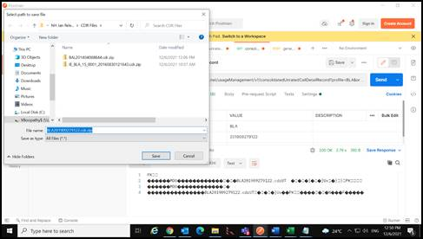

- To access the file, open your saved location. You’ll find the zip file. This Zip file will contain the CDR file.
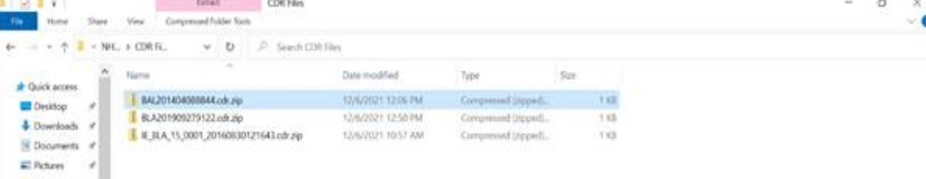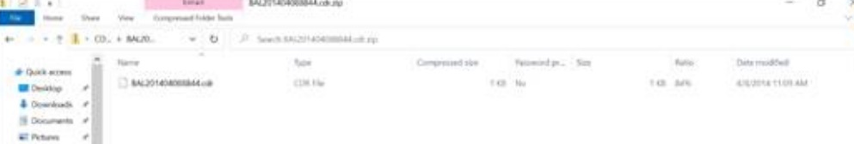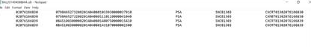

APPENDIX A: API Specifications

OAS Specification for Authorization

Type | Attachment
YAML
RAML
SWAGGER JSON
OPEN API JSON

OAS Specification for CDR APIs

Type | Attachment
YAML
RAML
SWAGGER JSON
OPEN API JSON

Appendix B: Country Codes
Country Code | Country Name
AT | Austria
BE | Belgium
DE | Germany
ES | Spain
FR | France
GB | Great Britain
IE | Ireland
IT | Italy
NL | Netherlands
SE | Sweden
DK | Denmark
PT | Portugal
CH | Switzerland
LU* | Luxembourg
CZ* | Czech Republic
SK* | Slovakia
RO* | Romania
PL* | Poland
FI* | Finland
NO* | Norway
JP* | Japan

*Unrated CDRs for these countries are available for the SIP Trunking service only.

Appendix C: Error Codes
Below are the error codes which comes as the part of API response
Error Code | Description | Next Step
200 | Success | Order ID is successfully generated- no further action required
400 | Bad request | Request was not successful because of any one of the reasons below:  - Check the request submitted as per the validation error received and resubmit the request.  - Header or body parameter or Query parameter or API GW tracking ID is missing. Please check and resubmit your request.
401 | Unauthorized | Request was not authorized because of any one of the reasons below:  - Either Access token is not valid or has expired.  - CLIENT ID and CLIENT Secret or Application ID is not valid  Please check the above and resubmit the request.
403 | Forbidden | Application has been identified but it is currently suspended. Please contact Colt’s support team.
404 | Not found | Resource not found. Please check and resubmit the request.
405 | Method not allowed | Entered method (GET/POST) is not correct. Please check and resubmit the request.
406 | Not allowed | Request not allowed. Please check and resubmit the request or contact Colt’s support team.
413 | Payload too large | The size of response is too large. Please contact Colt’s support team.
415 | Unsupported media type | Please provide the correct content type and resubmit the request.
429 | Too many requests | Total number of invocations has reached the maximum limit. Please retry after some time.
500 | Internal server error | This is an intermittent issue. Please retry to submit the request.
503 | Service Unavailable | Please try accessing this API after some time.
504 | Gateway Timeout | Please try accessing this API after some time.

