Colt Online User Guide for Unrated CDRs
Document History
Soft copies of this document are maintained under change control, but hard copies are not. This may not be a printout of the latest version.

Revision history
Reseller Guide | Version | Issue Date | Description of change from previous version
Generic Body | 1.0 | 01/04/2011 | Initial Document for Launch
 | 1.1 | 24/08/2011 | Added more detailed information about the new CDR format
 | 1.2 | 14/11/2011 | Added additional sample CDR files for reference
 | 1.3 | 20/01/2012 | Updated with details of the new consolidated CDR feature
 | 1.4 | 31/10/2012 | Updated with details of Contact Centre services
 | 1.5 | 22/11/2012 | Updated with details of Number Hosting services
 | 1.6 | 29/05/2013 | Further updates in reference to Contact Centre Services
 | 1.7 | 05/09/2013 | Further updates in reference to International Contact Centre services
 | 1.8 | 24/07/2015 | Updated to reflect the UK & France Regulatory impacts on the unrated CDRs for calls to non-geographic numbers.
 | 1.9 | 10/08/2015 | We have extended the SIP Trunking service to the following countries: Czech Republic & Luxembourg and unrated CDRs are now available for you to download from Cocom Web Manager & FTP. The country codes now include CZ & LU as seen in appendix B.
 | 2.0 | 27/10/2015 | Sample CDRs refreshed.
 | 2.1 | 20/01/2016 | Updated to Reflect the new COLT logo, browser related information and Sample CDRs refreshed.
 | 2.2 | 02/03/2017 | Replaced VoIP Access with SIP Trunking, updated to reflect browser related information in section 1.2, alternative access to Cocom Web Manager details in section 2.2, change in the notification period for planned maintenance work in section 3,addition of new countries in sectionB.1
 | 2.3 | 08/03/2017 | We now support an enhanced ISDN service over SIP, which is a next generation version of Voice Line. Unrated CDRs for Voice Line (v) will be available under “IP Voice Line” in Cocom.
 | 2.4 | 26/04/2017 | Additional information provided for Voice Line (v) and SIP Trunking to the CDR contents
 | 2.5 | 06/04/2018 | Additional information for Global IN to the CDR contents
 | 2.6 | 04/02/2022 | Updated to reflect CDRs being migrated from Cocom Web Manager to Colt Online and general updates.
Table of Contents
1 INTRODUCTION 5
1.1 Overview 5
1.2 Scope 6
1.3 Description 6
2 Using Cocom Web manager 7
2.1 Login To Colt Online Application 7
2.2 Access to CDR functionality in Colt Online 8
2.3 Unrated CDRs page 8
2.4 CDR Delivery 9
2.4.1 CDR File Delivery and Naming Convention 9
10
2.4.2 CDR Download 11
2.4.3 CDR File Format: 11
2.4.4 Consolidated CDR Request 12
2.4.5 Consolidated CDR Search 13
2.4.6 Consolidated CDR File Format: 15
3 Cocom Web Manager 16
3.1 Access To Cocom Web Manager 16
3.2 Welcome Page On Cocom Web Manager 16
3.3 View Reseller Data 18
4 Documents 19
4.1 VPN Access 20
4.2 Cocom Web Manager Exit 20
5 MAINTENANCE AND SUPPORT 22
6 GLOSSARY 23
APPENDIX A Call Data Record Format 25
A.1 CDR File Format 25
A.1.1 Character Coding 25
A.1.2 File Mark-up Coding 25
A.1.3 Compression/Decompression Algorithms 25
A.1.4 File Name 26
A.2 Call Detail Record Format 26
A.3 Sample Call Detail Record 30
APPENDIX B Colt Error codes 32
B.1 Country Codes 33

INTRODUCTION

Overview
Colt Technology Services (Colt) has provided you with an electronic interface, Colt Online, for the daily transfer of Call Detail Records (CDR) for all Colt Reseller and Service Provider voice products.
Colt Online allows you to retrieve the CDRs resulting from your end-customers’ traffic within the Colt network.
Alternatively you can use the existing FTP (File Transfer Protocol) Flat File Transfer or our new APIs. Please refer to the FTP and API user guides if you use these interfaces.
This document describes the process of how to successfully retrieve CDR files from Colt Online.

Scope
In order to use Colt Online you won’t need any additional software or development. A Browser and an Internet connection will be sufficient.

Web browser compatibility - the below browser versions are recommended:
- Safari
- Mozilla Firefox 40
- Google Chrome 45

Description
The diagram below shows the principle structure of the systems and their interfaces for the delivery of unrated CDRs.
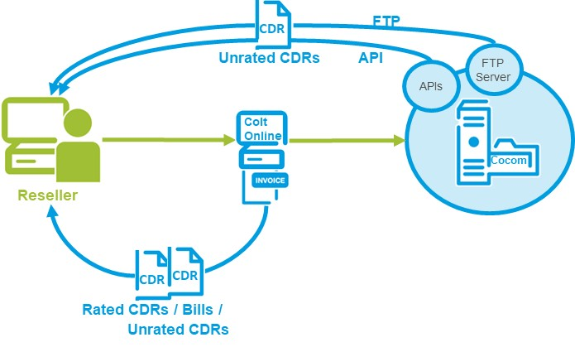
Figure 1 CDR Delivery via Colt Online, FTP & API

Using Colt Online
The following section describes the login to the CDR functionality in the Billing section of Colt Online

Login To Colt Online Application
The access to CDR functionality is available through Colt’s customer portal Colt Online via your single login .
Please use your Colt Online access with the following URL:
www.colt.net/online
Then login through the following steps:
- Enter your Username (Authenticated by Colt in your Welcome letter)
- Enter your Password (Authenticated by Colt in your Password letter)
- Click on the button ‘Login’ to access Colt Online. Please note that during your first login, you will be requested to change your password.
- If you have forgotten your password, please click on ‘Forgotten your password’. You are then requested to enter your ‘Login ID’ and your ‘E-Mail’ address.
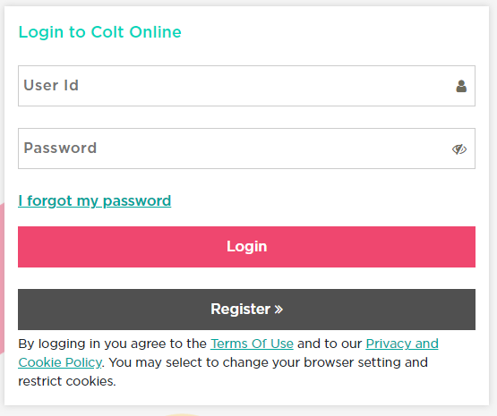
4
3
1
2

Access to CDR functionality in Colt Online
You can access the CDR functionality via the Billing heading in the top navigation bar:
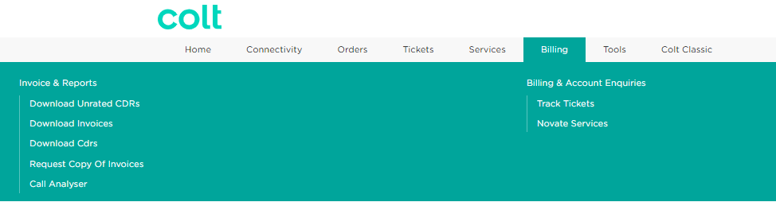
1
2

- Place the mouse over the “Billing heading” in the Main menu

- The “Download Unrated CDRs” Sub menu item with link is displayed if you have been setup with access to unrated CDRs which will have been triggered via your Colt order for your Voice service.

Unrated CDRs page
When you enter the Unrated CDRs page, you are presented with a list of your unrated CDRs.

This includes the details of the: Product, OCN, BCN, Country, Profile of each unrated CDR, and you have the ability to download them and request consolidated CDRs (or view your consolidated CDRs).

Please Note: The consolidated CDR file will be available to download from the Cocom server for 5 days, after that the file will be removed and you will need to submit a new request (if you have not downloaded it).

By using the icons in the top right of the screen, you can:

Filter your results by: Country, Product or Profile


Use the column customizer to adjust your view so only the information you want to see is presented

Download a list of your available unrated CDR files in an Excel file
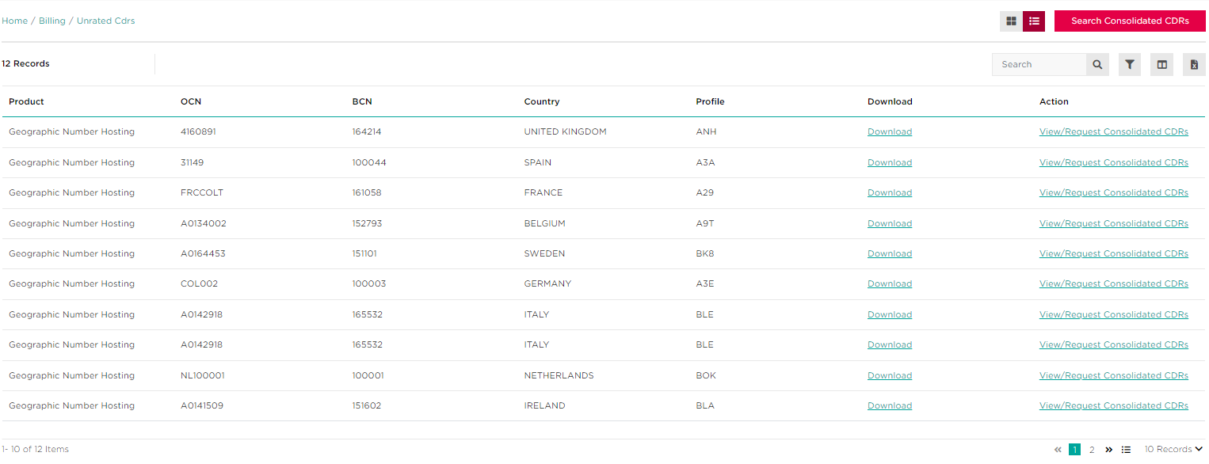

Please Note: Only the last 90 calendar days of unrated CDRs are available for download.

CDR Delivery
CDR delivery allows you to download unrated CDRs from Colt Online which will be delivered twice a day by default.
The following sections describe the CDR delivery functionality in more detail, including:
- CDR File Delivery and Naming Convention
- CDR Download
- Consolidated CDRs
Please Note: The first CDR file will appear in Colt Online after the first call has been made.

CDR File Delivery and Naming Convention
Twice a day, every day of the week, Colt will deposit a file of unrated Call Detail Records (CDR) into Colt Online. This will contain all of the unrated CDRs collected by the Colt network since the last file, typically every 12 hours.
The unrated CDRs will be delivered 2 working days after the call has been made.
Files transferred to and from Colt are all uniquely identified and adhere to the following file format
<countrycode>_<profile>_<productidentifier>_<sequence no>_<date>.cdr.gz

Where:
- <countrycode> in ISO 2 character format
- <profile> is up to 5 alphanumerics and is the applicable profile for the product
- <productidentifier> is the product identifier (1-2 alphanumerics) – see table below
- <sequence no> is a rolling four digit sequence per <profile>_<product> combination
- <date> is YYYYMMDDHHmmss
- cdr.gz is where the file is zipped

Product Identifier | Product name
01 | Reseller Connect
00 | Voice Line
10 | SIP Trunking
11 | IP Voice Line (Voice Line (v))
12 | IN for Resellers
15 | Geographic Number Hosting
16 | IN Number Hosting

Account profiles are set up based on your billing account (BCN), whereas service profiles are set up per service instance. Account profiles will apply to products such as SIP Trunking and Voice Line, and service profiles will apply to Reseller Connect.
If you have more than one product on the same billing account (BCN), e.g. SIP Trunking & Voice Line, then they will have the same account profile.
Service profiles apply for the products Reseller Connect, Geographic Number Hosting and IN Number Hosting (unrated CDRs). Service profiles enable Colt to continue to support multiple Reseller service profiles being billed on the same Colt billing account (BCN) and provide unrated CDRs per service profile to Cocom.
The unrated CDR files will be generated in separate files by profile.
The CDR files are provided in a pre-defined fixed length format, independent of country and product. These files are detailed in Appendix A.

2.4.2 CDR Download

3
After finding the CDR file you want to download (either through our filtering or search functions), you can download the CDR by clicking the ‘Download’ link.
1

After clicking on the required link, a pop-up opens and you will be presented with the upload date, file name, size and the action to download.
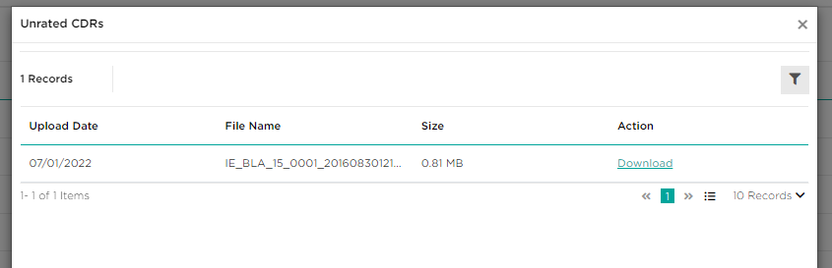

By clicking on download, the CDR will then be downloaded.

Please Note: Only the last 90 calendar days of unrated CDRs are available for download.

2.4.3 CDR File Format:
All your CDR files will be either zipped or plain CDR format. This has been setup based on your input in your Voice order form. We recommend you select zipped CDRs to ensure CDR download is completed efficiently.
Please note: The extension .cdr may be used by other application like Corel draw and therefore may open automatically the file. Please use the function “open with” to open it with an editor in the CSV-Format

2.4.4 Consolidated CDR Request
This feature enables you to place a request for a consolidated CDR file through Colt Online. Up to 90 days of CDRs can be requested, e.g. a consolidated file of a week's worth of CDRs.

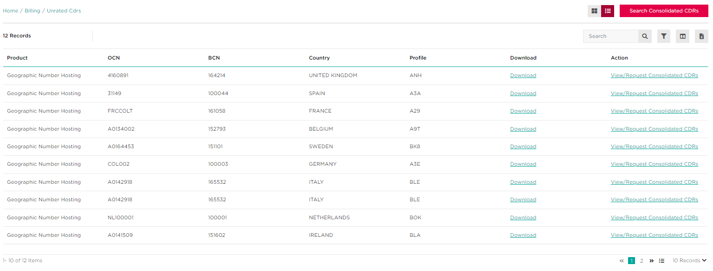
- Select either “View/Request Consolidated CDRs” if you see the order you want to request a consolidated CDR file for, or “Search Consolidated CDRs”.
1
1

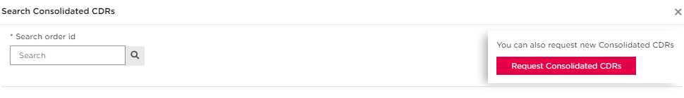
- After clicking “Search Consolidated CDRs”, you will then have the ability to request new consolidated CDRs by using the button in the top right, as well as being able to search an order ID in the top left to view consolidated CDRs for a particular order
2
2
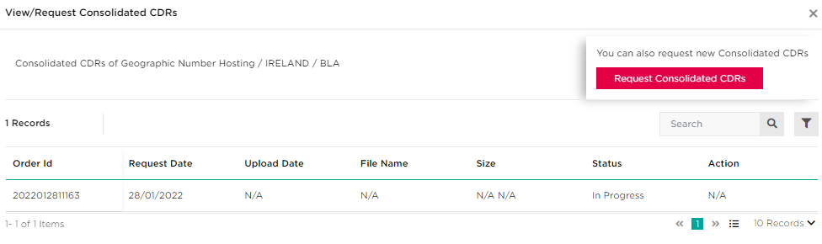
If you clicked “View/Request Consolidated CDRs”, then you will be presented with a similar screen, but will also be able to view the consolidated CDR for the order you clicked through.

- Select the relevant product, country, profile and preferred date range for your request then click “Submit” to continue
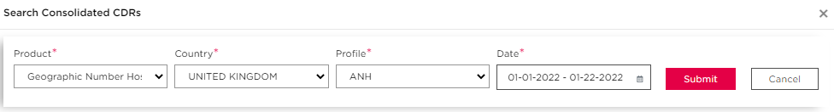

Your consolidated CDR request will then be processed, and you will be presented with an order ID for this request.

Please Note: When you wish to consolidate unrated CDRs, these CDRs will be delivered to Colt Online, FTP & API in a compressed/zipped format. If your twice daily CDR files are already over 5MB in size, then please allow time to download a consolidated file from Colt Online or you may find it easier to download files greater than 5MB directly from FTP or API.

5

2.4.5 Consolidated CDR Search
- Click on “Search Consolidated CDR” link in the top right of the Unrated CDRs page
7
8
9

1
Figure 12 Consolidated CDR Search
If you do not enter a Transaction ID at all and leave this blank, all successfully processed transactions for the last 5 calendar days will be displayed for the selected service profile.

Please note if you enter part of the transaction ID, a “No result found” message will be displayed.

- You will have the ability to search for your consolidated CDRs by order ID
2

Figure 13 Consolidated CDR Download (1)

Which will then provide you a summary of your consolidated CDR order

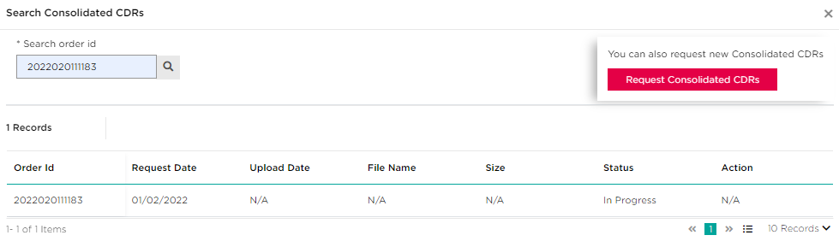

Please Note: The consolidated CDR file will be available to download from the Cocom server for 5 days, after that the file will be removed and you will need to submit a new request (if you have not downloaded it).

2.4.6 Consolidated CDR File Format:
All Consolidated CDR files delivered to Colt Online , FTP & API have a filename in the following format:-
<profile><transactionID>.cdr.zip.
Where:
- <profile> is up to 5 alphanumeric and is the applicable profile for the product
- <transactionID> is the combination of date and unique number, this can be used in Colt Online to search for Consolidated CDR
- .cdr is the extension
- .zip is where the file is zipped
Example: AM220120110182.cdr.zip

The content of the consolidated CDR file is the same as the standard twice daily delivered CDRs, as described in Appendix A.

Documents
You can find all product related documentation for your Colt Reseller and Service Provider Voice products at www.colt.net/cocom.
This includes FTP & API user guides and VPN access software and instructions.

MAINTENANCE AND SUPPORT
The Cocom B2B Gateway Server is available 24 x 7 x 365.

This allows you to retrieve files overnight and at times that suit your own IT processing needs, although help and support is only available during normal office hours.
Should we need to temporarily suspend access to the server, for planned maintenance, you will be notified at least 10 days in advance and be told how long it will be suspended for. Generally, this is an unusual occurrence (approximately once a month) and service interruptions are brief.
Customer Service is available during normal office hours, from Monday to Friday except during Public Holidays.

GLOSSARY
Term | Description
B2B | Business to Business:  typically takes the form of automated processes between trading partners and is performed in much higher volumes than business-to-consumer (B2C) applications.
CDR | Call Detail Record:  A record that contains the details of a call made on the Colt network. Normally used for end-customer billing purposes. In Cocom this will be unrated, i.e. contains no charges but indicates the service used during the call and the tariff band(s) that apply. If the CDR is rated, then it will include the charge due for the call. Rated CDR files can be found alongside your Colt invoices on Colt Online on a monthly or quarterly basis.
CLI | Calling Line Identifier:  A term used within Colt to mean an end-customer telephone number such as a Directory number.
Cocom | Colt Communications server:  The FTP server and internal applications that provide a file level interface allowing Resellers to download CDRs.
CSV | Character Separated Values or  Comma Separated Values:  file format is a tabular data format that has fields separated by the comma character and quoted by the double quote character. If a field’s value contains a double quote character it is escaped with a pair of double quote characters.  The CSV file format does not require a specific character encoding, byte order or line terminator format.
FTP | File Transfer Protocol:  is a software standard for transferring computer files between machines with widely different operating systems. It belongs to the application layer of the Internet protocol suite.
GB | Great Britain
HTML | Hyper Text Mark up Language:  is a markup language designed for the creation of web pages and other information viewable in a browser. HTML is used to structure information -denoting certain text as headings, paragraphs, lists etc.- and can be used to define the semantics of a document
HTTP | HyperText Transfer Protocol):  is the primary method used to convey information on the World Wide Web. The original purpose was to provide a way to publish and receive HTML pages. The default TCP port of HTTP is 80.
HTTPS | HyperText Transfer Protocol Secure:  is the secure version of HTTP, the communication protocol of the World Wide Web. It was invented by Netscape Communications Corporation to provide authentication and encrypted communication and is used in electronic commerce.  Instead of using plain text socket communication, HTTPS encrypts the session data using either a version of the SSL (Secure Socket Layer) protocol or the TLS (Transport Layer Security) protocol, thus ensuring reasonable protection from eavesdroppers, and man in the middle attacks. The default TCP port of HTTPS is 443.
SMTP | Simple Mail Transfer Protocol:  is a relatively simple, text-based protocol, where one or more recipients of a message are specified (and in most cases verified to exist). The message text is transferred to the specified recipients.  SMTP uses TCP port 25.
URL | Uniform Resource Locator:  or Web address, is a standardized address name layout for resources (such as documents or images) on the Internet (or elsewhere). First created by Tim Berners-Lee for use on the World Wide Web, the currently used forms are detailed by Internet standard RFC 1738.
WWW | World Wide Web:  is an information space in which the items of interest, referred to as resources, are identified by global identifiers called Uniform Resource Identifiers (URLs). The term is often mistakenly used as a synonym for the Internet, but the Web is actually a service that operates over the Internet.
XML | eXtensible Mark up Language:  is a W3C-recommended general-purpose markup language for creating special-purpose markup languages. It is a simplified subset of SGML, capable of describing many different kinds of data. Its primary purpose is to facilitate the sharing of data across different systems, particularly systems connected via the Internet.
- Call Data Record Format
The CDR file contains only CDR records in a fixed length format. A CDR file is made available twice per day – once in the morning and once in the afternoon. The files are delivered at approximately 9AM and 5PM CET.
- The 9 AM CET file contains calls from 4PM CET the previous day until 8AM CET on the current day
- The 5 PM CET file contains calls from 8AM CET to 4PM CET on the current day
Please note that CDR files are delivered to your directory 7 days a week and will vary in size depending on the level of traffic that your customers generate.
Please note the exception is for the Global SIP countries such as Luxembourg, the Czech Republic, Slovakia & Romania, where the unrated CDRs are delivered daily at approximately 9 AM CET.
  - CDR File Format
    - Character Coding
ASCII
    - File Mark-up Coding
- No structured Mark-Up used
- Fixed length records
- Fixed length fields, space filled
    - Compression/Decompression Algorithms
CDR files are delivered in Zip format (Unix GZip, MS Windows Zip). However, Colt recognizes that this can be difficult for certain companies to receive and the CDR files can be delivered in plain text if required. Please notify Colt Customer Services if you need the CDR files to be delivered as plain text (Uncompressed) files.

    - File Name
All unrated CDR files delivered to Colt Online and FTP have a filename in the following format:-
<countrycode>_<profile>_<productidentifier>_<sequence no>_<date>.cdr.gz

Where:
- <countrycode> in ISO 2 character format
- <profile> is up to 5 alphanumerics and is the applicable profile for the product
- <productidentifier> is the product identifier (1-2 alphanumerics) – see table below
- <sequence no> is a rolling four digit sequence per <profile>_<product> combination
- <date> is YYYYMMDDHHmmss
- .cdr is the extension
- .gz is where the file is zipped

Product Identifier | Product name
01 | Reseller Connect
00 | Voice Line
10 | SIP Trunking
11 | IP Voice Line (Voice Line (v))
12 | IN for Resellers
15 | Geographic Number Hosting
16 | IN Number Hosting

Example: DE_ABC_01_0001_20101208090122.cdr.gz
  - Call Detail Record Format
A standard format for unrated CDRs applies to our reseller and Service Provider voice services. This standard CDR format is harmonised across all Colt countries and applies to existing and new products going forward in Colt Online.

The data lines are 229 bytes in length and organised as:

Ref | Name | Bytes/  Length | Position | Alpha/  Numeric | Format & Description
1 | Origin | 20 | 1 | N | Originating CLI with leading 0. Filler spaces must be added to fill in the spaces designated for a field. In the case of IN, the last 4 digits are replaced with ‘x’.  In the case of LU,CZ,SK & RO for SIP Trunking, the Originating CLI starts with the country code  In the case of Global IN for Resellers ordered through the UK, the caller’s number will be in the international format, starting with 00 + the country code + the number (omitting the leading zero) e.g. caller calling from a mobile in Romania: 004074582xxxx
2 | Destination (Terminating) | 20 | 21 | N | Destination 0 = Domestic and National, Destination 00 = International  In the case of LU,CZ,SK & RO for SIP Trunking, the destination starts with the country code
3 | Product Type | 2 | 41 | N | ‘01’=Indirect Service  ‘00’ = Direct Service  '04' = Direct Service  ’06‘=NH Geo Premium  ‘07’=NH Geo Wholesale  '08'=NH Geo Retail  '09'=NH Geo Incoming  '10'=NH IN Incoming  '79' = SIP Trunking  ‘80’ = IP Voice Line (Voice Line (v))
4 | Date | 8 | 43 | N | YYYYMMDD
5 | Time | 8 | 51 | N | HHMMSSss . Time duration is broken up into tenths of a second. Fractions of a second will be ignored.
6 | Duration | 8 | 59 | N | Duration of the call to the nearest 1/10th of a second SSSSSSSs
7 | Continuation | 1 | 67 | N | ‘0’, ‘1’, ‘2’, ‘3’ or ‘5’ – normally a 0. To be used only if calls are greater than 6 hours
8 | Switch ID | 25 | 68 | N | Unique switch identifier
9 | Trunk incoming | 25 | 93 | N | Internal use only
10 | Trunk outgoing | 25 | 118 | N | Internal use only
11 | Account Code | 20 | 143 | A | Not in use
12 | Pulses in | 6 | 163 | N | Not in use
13 | Pulses generated | 6 | 169 | N | Not in use
14 | Pulses sent | 6 | 175 | A | In use for all IN, Voice & VoIP services in UK & France: the Charge Band defined by the Regulator (Ofcom UK/ Arcep FR) for calls to non-geographic numbers. If no Charge Band is available, the value is 000000 or blank.
15 | Service Indicator | 4 | 181 | N | 0000 for standard calls, 0001 for ISDN calls
16 | Charged (C-Num) | 20 | 185 | N | Trunk ID shown here for IP Voice Line (Voice Line (v)) and for SIP Trunking  In use for IN services – the number to which the IN service number is translated.  In the case of Global IN for Resellers ordered through the UK, this number will be in the international format, starting with 00 + the country code + the number (omitting the leading zero)
17 | Dialled (D-Num) | 20 | 205 | N | In use for IN services (IN service number)  In the case of Global IN for Resellers ordered through the UK, the IN service number will be in the international format, starting with 00 + the country code + the number (omitting the leading zero) e.g. Romania freephone number: 0040800890123
18 | Carrier | 3 | 225 | A | The Reseller profile of up to 3 alphanumerics
19 | End of Record | 1 | 228 | A | Value of zero is shown
20 | Line Feed | 1 | 229 | ASCII Control Character | Line Feed (ASCII Control Character not visible in plain text editors

Please note: There is an ASCII Control Character (Line Feed, HEX 0A) after the last field 19 “End of record”. This Control character generates a new line for the next CDR and shows that the actual CDR ends. Normally you can ignore this control character except you use a HEX-Editor to process your CDRs.

Please note: In Germany, the header and trailer records will no longer appear in the unrated CDR file. They will appear as a single file in the “jobout” FTP-folder

  - Sample Call Detail Record
Sample CDRs for Reseller Connect:-
06960621234 069566061234012011011911481500000000401 00067 6960621234 0000 069566061234AAX0
06960621234 017622211234012011011911514400000008401 00067 6960621234 0000 017622211234AAX0

Sample CDRs for Reseller Connect (UK):-
02085021011 08708989300012015082110382740000003510 01000 3066 4013 000000000000 SC0060000 8530 8531S
02089537800 08435047176012015082110351910000078520 01000 4123 4139 000000000000 SC0080000 8530 8531S

Sample unrated CDRs for Voice Line:-
06971041234 0368751234002011093007235400000007301 00063 OF3XBN33687512340 0000010000010000 0368751234 SV0
06971041234 038203731234002011093007225600000013201 00063 OF3XBN33855523484 0000010000010000 038203731234 SV0
06971041234 066311234002011093007250000000001101 00063 OF3EZLA663121234 0000010000010000 066311234 SV0

Sample unrated CDRs for Voice Line (FR):-
0982406525 0841118663002015082009134390000074070 03300 1088 1062 000000000000 A0050010 0033899108018PBW0 PBW2S
0494270512 0494107021002015082011415520000000540 03302 1503 1503 000000000000 A0050010 0033826106714PAC0 PAC2S

Sample unrated CDRs for SIP Trunking:-
038422001234 081010251234792011060314221108000000000 ZHA CXVIE013038422001234 0000 ABC0
038422001234 0517661234792011060314222708000022440 ZHA CXVIE013038422001234 0000 ABC0
0732388824321 0732771234792011060314261409000013790 ZHA CXVIE0130732388824321 0000 ABC0
0158031234 00351913231234792011060314323700000000210 ZHA CXMAD0130158031234 0000 ABC0

Sample unrated CDRs for SIP Trunking (CZ, FI, JP, LU, NO, RO & SK):-
352206099 442033535570792015091610405600 170 0000 ALB0
420296180311 442033535475792015100911120200 550 0000 AAX0
40312200237 40753086507792015070215113800 1480 0000 BKD0
421232335698 390321393652792015092110045300 90 0000 BKE0

Sample unrated CDRs for IN for Resellers (Freephone & shared cost):-
0129356xxxx 08003581234002011101923483510000008300 01001 3059 0129356xxxx 0000000000000000000000 01618361234 08003581234ADC0
0773777xxxx 08003581234002011101923455270000068380 01001 2702 0773777xxxx 0000000000000000000000 01618361234 08003581234ADC0
0755747xxxx 08003581234002011101923580620000008090 01001 2042 0755747xxxx 0000000000000000000000 01618361234 08003581234ADC0

Sample unrated CDRs for Geographic Number Hosting:-
0307870098 0230333517082012110610363380000005050 MIA SNCB0103 CXMIT0130307870098 0000 AJC0
0230333517 0307870098092012110610401400000002570 MIA CXMIT013 SNCB01010230333517 0000 AJC0

Sample unrated CDRs for IN Number Hosting:-
0230329xxx 800909395002012102610530410000000730 00225 10270230329xxx 0000000000000000000010 3483954697 39800909395AJB0

Sample unrated CDR for Global IN for reseller (CA, CZ, FI, HK, JP, NO, RO & US):-
004074582xxxx 0040800890020002018032308352100000000240 00000 004074582xxxx 0000 00 0040800890020DMP0
004074582xxxx 0040800890020002018032308394500000000240 00000 004074582xxxx 0000 00 0040800890020DMP0

Please Note: The first CDR file will appear in Colt Online after the first call has been made.

- Colt Error codes
Message Code | Message Type | Message Description | Explanation
0 | B2BGateway | Success Message/OK
-1 | B2BGateway | Unable to process your request [additional explanation] | Validation Failed, e.g. Infrastructure Error from Cocom, missing request file, wrong characters
0 | cocom | OK – Success
99 | Cocom | Cannot process your request! Please contact customer service support! | No connection between B2B Gateway and Cocom
Table – B2B Gateway error Codes

  - Country Codes
Country Code | Country Name
AT | Austria
BE | Belgium
DE | Germany
ES | Spain
FR | France
GB | Great Britain
IE | Ireland
IT | Italy
NL | Netherlands
SE | Sweden
PT | Portugal
DK | Denmark
CH | Switzerland
LU* | Luxembourg
CZ* | Czech Republic
SK* | Slovakia
RO* | Romania
*Unrated CDRs for e.g. LU, CZ, SK & RO are available for the SIP Trunking service only.

