Colt Wholesale SIP
Numbers on Demand User Guide

Disclosure / Confidentiality
Highly Confidential, not for distribution ☐
Distribution within Architecture & Design ☐
Distribution within Colt ☐
Distribution permitted external to Colt ☒

Copyright © Colt Group
No part of this document may be reproduced or adapted in any form, including photocopying or storing it by electronic means, except as is necessary for the purpose of the recipient's dealings with Colt, without the written permission of Colt.
Any copies made of any part of this document shall include the notice: © 2025 Colt Technology Services. The Colt name and logos are trademarks. All rights reserved.
No information contained in this document shall be disclosed to any third party without the written permission of Colt.

Document History
Soft copies of this document are maintained under change control, but hard copies are not. This may not be a printout of the latest version.
Document history
Revision | Date | Description
3.3 | 8th August 2025 | Updated in alignment to Wholesale SIP August 2025 upgrade release

Table of Contents

1 Introduction 5
1.1 Numbers on Demand overview 5
1.2 Premium Offer 7
1.3 Sub Reselling [subResellerID] 8
1.4 Number Format 8
1.5 Number Allocation Rules 9
1.5.1 Germany: 100+ Range Allocation 9
1.5.2 Portugal: Tri-Party Agreement 10
1.5.3 Hosted Customer Numbers in France 10
1.5.4 Spain: Sub-assignment Agreement 11
1.5.4.1 Number Type offerings 12
1.6 End-customer Details 13
1.7 Access to Numbers on Demand 13
1.8 Login to Numbers on Demand 14
2 My Orders 16
2.1 Number History 19
2.2 Order / Transaction status 20
My Telephone Numbers 22
2.3 Number Status 23
3 Number Details and History 26
4 Reserving Colt Numbers 27
4.1 How to reserve numbers 27
4.2 How to cancel a number reservation 32
5 Activating, deactivating & re-activating Colt Numbers 34
5.1 How to activate reserved numbers 34
5.2 How to deactivate numbers 40
6.3 How to reactivate numbers 42
7 Port In 44
7.1 Port-In Lifecycle 44
7.2 Port-In in the Netherlands 44
7.2.1 How to schedule a port 44
7.2.2 How to activate a port 46
7.2.3 NL 088 Numbers 47
7.3 Port-In in the Other Countries 49
7.4 How to port-in numbers 50
7.5 Digital LOA (DLOA) Port-In process 56
7.6 Porting order status 59
7.7 Modify Port 61
7.8 How to cancel a Port-In Request 62
7.9 How to change a Port-In Date 63
7.10 On the Porting Date 64
7.11 How to deactivate ported-in numbers 66
7.12 How to reactivate ported-in numbers 68
7.13 Pre-Order Validation (UK Only) 69
8 Address Update 73
9 Bulk Operations 75
9.1 Bulk Activation 75
9.2 Bulk Port-in 82
9.3 Bulk Address Update 87
9.4 Bulk Reservation 89
9.5 Bulk Cancel Reservation 90
9.6 Bulk Deactivation 91
10 Reports 93
11. Directory Service Update 96
12. Colt Migrations 98
12.1 Migrations using Migrate-In/Out flow 98
12.2 Inter Domain migration request and approval process 99
12.3 Number migrate In 102
12.4 Migrations using port-in/out flow 106
13. Documentation 108
14. GLOSSARY 109
15. Help 110
APPENDIX A Colt Voice APIs Service Matrix 111
APPENDIX B Country Code 111
APPENDIX C Spanish Numbering Plan for LACs starting with ‘8’ 113
Appendix B(ii): List of Spanish Provinces with LAC 114

Introduction

Numbers on Demand overview
Colt Technology Services provides you with an electronic B2B web interface, Numbers on Demand, to support your Wholesale SIP orders. Numbers on Demand is a standardized pan-European tool which enables you to manage your orders across the Colt country footprint.
Numbers on Demand is accessible with a single sign-on through Colt Online, our customer portal:
- Numbers on Demand: a web based interface which allows you to reserve, order & port-in phone numbers with ease and on demand, without needing to integrate your internal systems. You can easily view your order & number status/inventory across multiple countries and download reports. There is an online help function to help you get started!
Colt Wholesale SIP is order based: each order made via Numbers on Demand, such as reservation, activation, port-in, … generates a unique order ID.
You can track in real time your order status via the My Orders and My Telephone Numbers pages using the order ID status.
 | We have more Colt Wholesale SIP documentation https://developer.colt.net/wholesale-sip-documentation such as the Service Matrix which covers the business rules & fields details required for using Numbers on Demand & our B2B APIs. If you prefer to integrate your software with Numbers on Demand we also have an API Guide.

Document scope
This user guide describes how to use Numbers on Demand for Colt Wholesale SIP, including:
- How to reserve Colt numbers
- How to activate, deactivate & re-activate Colt numbers
- How to port-in end-customers’ existing numbers to Colt and how to respond to port-out requests
- How to validate an area code and your end-customer’s address for regulatory compliance reasons

Premium Offer
Premium offer allows you to get:
- Preactivated numbers
- Ability to update end-customer at sub-range level and to manage the aging/quarantine period.
- Partial deactivation of Colt activated numbers (except for AT, DE, IT, CH and Zone B countries)
Below picture summarizes the number life cycle for Premium offer:
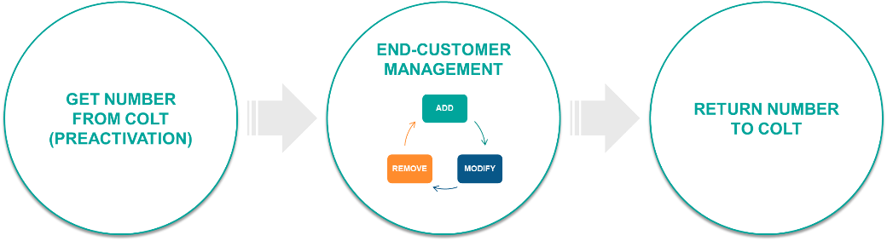

 | - Access to Premium offer is subject to Colt validation.  - Available in all countries except Germany (19).

Sub Reselling [subResellerID]
In some countries, you are allowed to provide numbers purchased from Colt using your indirect sales channel, but it is mandatory to report the 3rd party to Colt (sub reseller OCN), by identifying the sub-reseller at the order ID level.

- Sub-reselling is not available in FR, IT & PT, meaning you must own the relationship with the end-customer.

Number Format
We support numbers in the E164 international format.
Austria (+43), Belgium (+32), Denmark (+45), France (+33), Germany (+49), Ireland (+353), Italy Nomadic (+39), Netherlands (+31), Portugal (+351), Spain (+34), Sweden (+46), Switzerland (+41), United Kingdom (+44):
- startFullNumber = CC + areaCode (without leading 0) + areaCodeExtn + rangeStart
- endFullNumber = CC + areaCode (without leading 0) + areaCodeExtn + rangeEnd
Italy Geo (+39):
- startFullNumber = CC + areaCode (with leading 0) + areaCodeExtn + rangeStart
- endFullNumber = CC + areaCode (with leading 0) + areaCodeExtn + rangeEnd
Germany (+49)
- startFullNumber = CC + areaCode + rangeStart
- endFullNumber = CC + areaCode + rangeEnd

Location Independent (nomadic) Numbers
Austria (+43), Ireland (+353), Italy (+39), Netherlands (+31), Sweden (+46), Switzerland (+41), United Kingdom (+44):
- Range start = CC + areaCode (without leading 0) + areaCodeExtn + rangeStart
- Range end = CC + areaCode (without leading 0) + areaCodeExtn + rangeEnd
Spain (+34):
- Range start = CC + areaCode + areaCodeExtn + rangeStart
- Range end = CC + areaCode + areaCodeExtn + rangeEnd
Germany (+49)
- Range start = ‘+49’ + areaCode (without leading 0) + rangeStart
- Range end = ‘+49’ + areaCode (without leading 0) + rangeEnd

- In Italy, e164 format for geo number includes leading zero as well.
- For details of the nomadic/location independent LACs, please see the Service Matrix and/or the Number Coverage file.

Number Allocation Rules

Germany: 100+ Range Allocation
German Regulator Bundesnetzagentur (BNetzA) defines the maximum range sizes for new subscribers in the document ‘Struktur und Ausgestaltung des Nummernbereichs für Ortsnetzrufnummern‘.
A German and an English version are available on the homepage of BNetzA:
- Bestimmung der Anzahl zuzuteilender Rufnummern bei durchwahlfähigen VoIP-Anschlüssen
- http://www.bundesnetzagentur.de/cln_1431/DE/Sachgebiete/Telekommunikation/Unternehmen_Institutionen/Nummerierung/Rufnummern/ONRufnr/Ortsnetze_Basepage.html?nn=268384
(Struktur und Ausgestaltung des Nummernbereichs für Ortsnetzrufnummern)
- https://www.bundesnetzagentur.de/EN/Areas/Telecommunications/Companies/NumberManagement/GeographicNumbers/LocalNumbers_Basepage.html?nn=404520
(Structure and configuration of the number range for geographic numbers)
For a block greater than 100, the allocation must be approved by BNetzA before assigning numbers to the end-customer.
Process is as per the following:
- Customer signs the request form provided by Colt – please ask your Account Manager for a copy
- Colt sends the request form to BNetzA
- Official timeline for BNetzA to answer is 3 weeks, but less than 1 week in practice.
- Colt sends the approval to the customer
- Customer can assign the numbers.
The Request form is available in German/English. It can be filled out in both languages; the other language will be populated automatically.

Introduction of CIF/NIF/VAT ID check in Portugal, Spain & Finland
We have introduced an external check on the CIF/NIF/VAT/business ID in Portugal, Spain & Finland against the European Commission’s VAT Information Exchange System (VIES). – see: https://europa.eu/youreurope/business/taxation/vat/check-vat-number-vies/index_en.htm. The reason is to improve the accuracy and validity of orders for new numbers and ports as explained below:
  - The VAT ID/CIF is included in the CVP generated by Colt for an end-customer and is highly confidential. The CVP was introduced by the PT Regulator, Anacom, to give greater security to end-customers. End-customers must include their CVP in a future port order to prove their request is genuine.
  - As requested by the ES Regulator, CNMC, the VAT ID/CIF/NIF must be uploaded into the emergency database in Spain and be an exact match to the registered end-customer name
  - As requested by the Finnish Regulator, the business ID & legitimate signee’s name must be uploaded into the central database in Finland.
In Numbers on Demand you will see the extra validation step on the CIF/NIF/VAT/business ID in Portugal, Spain & Finland when activating a number, porting-in a number and updating an end-customer address, including bulk orders. If your end-customer has only recently registered for VAT and their details are not yet in VIES, then you can enter their VAT/business ID by selecting “NIF//CIF/VAT/business ID not registered” and your order will proceed as normal.

Please note: the Vies API doesn't not support the check of freelancers' DNI IDs as part of the VAT ID checker. Please select the VAT ID not registered option to bypass the check.

Please note: you can also use these external links to check the end-customer has a valid VAT/business ID & signee in Finland to ensure accuracy:
- www.ytj.fi
- www.finder.fi

Hosted Customer Numbers in France
There are 2 important Regulatory changes impacting the use of phone numbers in France, which came into effect on 1st January 2023:-
- The resale of geographic and location independent numbers for outbound voice services was forbidden
- France no longer has 400+ local area codes. 01-05 numbers are available for use throughout mainland France
ARCEP, the Regulator in France, has published further information on these changes here: https://www.arcep.fr/uploads/tx_gsavis/22-1583.pdf

If you are reselling Colt numbers to your end-customers under your own brand, then you need to take action to register with ARCEP and obtain your own numbers, which Colt can then host on your behalf. You can contact your Colt Account Manager to complete the order form to host your number blocks with Colt. For further information, please refer to these links to the Customer Q&A in English and in French.

Hosting your numbers
When we confirm your own numbers are available to use, you will be able to reserve and (pre)activate your own numbers, update addresses etc. As a result of the Regulatory changes above you will only need to search for numbers on the basis of the LAC: 01-05 and the LAC extension or search by city will no longer be available - should you need the historical reference, please refer to the Number Coverage file. Your own numbers will be available in ranges of 1, 10, 100 as requested in your order form. If you run out of single numbers, then our system will automatically take a range of 10 Free numbers and split this into 10 Free single numbers and similar logic applies if you run out of ranges of 10 etc. You can also view or query for your Free numbers in France and this enables you to monitor your own inventory and apply to ARCEP for new number blocks in good time – the E2E lead-time is 2-3 months depending on ARCEP, Orange & OLO availability during busy periods.

After you have obtained your own routing/porting prefix in France then you can select this when you port-in a number.

We will return deactivated numbers from your number blocks to your “free” pool of numbers at the end of the quarantine & frozen period. We will return numbers which were ported-out and which have been cancelled / deactivated by the end-customer into your “free” pool of numbers at the end of the quarantine & frozen period, using our established processes & system integration with APNF.

The responsibility to supply compliance reports or to comply with regulatory audits is yours. Colt will provide a clear view of your number inventory - the number status & end-customer data via our APIs & Numbers on Demand which you can use to meet these requests together with your own data.

Tri-partite agreement with Colt numbers
If you do not have your own numbers from ARCEP yet, then from 7th January 2023 you are responsible for submitting a tri-partite agreement with every order for new Colt number activations and every end-customer address update on your existing Colt numbers. The tri-partite agreement template can be found here. You are responsible for filling in your own company details, the numbers being ordered, entering the accurate address details of your end-customer and obtaining the end-customer’s signature.

The impacts of these Regulatory changes on your use of our Wholesale SIP (Number Hosting) APIs & Numbers on Demand is covered in the table below, which went live on 26th Nov 2023 ahead of the regulatory deadline:-
Functionality | Changes are highlighted
Number Enquiry | 2 options to search for Free Numbers:  - Geo Numbers:  Local area code: 1,2,3,4,5  Area code extension: no longer required  Number Type: Geo  Number Category: IPGEO  Block Size: 1,10,100  Quantity: 1,2,…9  - Location Independent Number: NEW  Number Type: Non Geo  Number Category: VOIP  Block Size: 1,10,100  Quantity: 1,2,…9
Number Enquiry | ‘IsCustomerOwned’ flag will be shown when the customer looks up a number
Number Enquiry | Search by City- disabled
LAC validation | No longer applicable
Address Validation | Yes – will continue to be supported, no change
Emergency Call Routing | Yes – will continue to be supported, no change
Number Reservation | Allowed for  - Geo and Location independent numbers  - Colt Owned or Customer Owned Numbers
Number Activation | Allowed for  - Geo and Location independent numbers  - Colt Owned or Customer Owned Numbers
Tri-party Agreement | If the customer has opted for Colt Owned Numbers, then the Tri-party Agreement must be provided by the customer for these transaction types:  - number Activation  - Bulk Activation  - Address Update  - Bulk Address Update  isTriPartyAvailable = YES/NO will be available in the Order details screen in NOD  File size: max 5MB  Accepted file formats: .doc/.DOC, .docx/.DOCX, .pdf/.PDF
Address Update | Allowed for  - Colt Owned Activated Numbers  - Ported-In Numbers on Colt prefix  - Customer Owned Activated Numbers  - Ported-In Numbers on customer owned prefix  Below combination will be supported for customer owned numbers  - Customer owned Activated /Ported-In Numbers (Full Range) & Standard/Premium Offer  - Customer owned Activated/Ported-In Numbers (Partial/ Sub-Range) & Standard/Premium Offer  - Bulk Address Update (Full Range)  - Bulk Address Update (Partial/ Sub-Range)
Port-In | Optional field ‘Porting prefix’ to be provided while raising a portin request. If not provided, Colt’s prefix will be mapped to the requested numbers.  Porting Prefix will be available in the order details screen in NOD
Number Deactivation and Reactivation | Allowed for  - Colt Owned Activated Numbers  - Customer Owned Activated Numbers  Quarantine period is updated to 90 days  Number reactivation is possible within these 90 days  Post expiry of quarantine period, numbers will move to ‘Free’ status
Port-In Deactivation and Port-in Reactivation | Allowed for  - Ported-In Numbers on Colt prefix  - Ported-In Numbers on customer owned prefix  Quarantine period is updated to 90 days  Number reactivation is possible within these 90 days  Post expiry of quarantine period, numbers will move to ‘Returned’ status
Number Report | Customers who have their own number can request for their ‘Free’ number inventory along with other status.  Customers who will use Colt Owned numbers, will be able to request the number report inventory for all status except ‘Free’
Order Report | Customers will be able to see the Porting Prefix.

Introduction of RIO codes for the wider business market in France
There are some changes to the use of RIO codes in France, which came into effect from 1st December 2023, pursuant to Arcep’s decision no 2022-2148.

A RIO code is a unique identifier associated to a telephone number, which is created when a consumer or small business request a new telephone number in France and its purpose is to facilitate the portability process. If they wish to move / port numbers to a new operator, then the new operator will request the RIO code provided by the current operator for each single telephone number from the consumer / small business in order to validate that the port order is legitimate and to implement the porting order. These RIO codes are not yet mandatory in the wider business market but this will gradually change.

The changes are:
- Colt, as a technical operator, must define a unique RIO code for every:
  - Colt geographic or location independent number
  - Geographic or location independent number ported-in to Colt
  - Geographic or location independent number hosted by Colt on your behalf – this includes both new and ported-in numbers where you have mandated Colt as your OPTA (i.e. where we technically manage the porting of your numbers on your behalf)
- Colt made these RIO codes available to you via a secure portal, which is our Numbers on Demand portal and over API
It is not foreseen that RIO codes will be required for number portability in the wider business market until 2025, due to the complexity of inter-operator process & system integration work and pursuant to Arcep’s decision.

In a wider context, if you currently support consumers, we would like to remind you that consumer-specific obligations apply pursuant to the regulations, including the provision of an IVR service through which you provide the RIO code associated to a specific number.

As an operator providing voice services in France, you are responsible for portability to your end-customers and other operators, even where Colt is technically managing portability for you as your OPTA. Obligations regarding how the RIO codes should be shared with your subscribers apply, as well as other obligations related to portability (i.e. additional information to be provided to your subscribers, contractual provisions, etc.). Obligations may vary depending on the customer type (business, small business, consumer) and the kind of service you provide (OTT, single-number or multi-number offers, etc.).
For further information please see this decision from ARCEP: https://information.colt.net/hubfs/22-2148_FR_Published%20document_22Mar2023%20en-GB.pdf

The RIO code will be present against each CLI in the Numbers on Demand portal when viewing the ‘Number Details’ and will be returned in the B2B API response (SOAP/HTTPs: getNumberDetails and REST: GET/CLIDetails) as well.

You can also request and download a Number Report of all of your activated numbers with their associated RIO codes at CLI level from the Numbers on Demand portal.

Impacts to port-in orders
- No impact - from 1st July 2025 RIO codes will remain non-mandatory for a port-in order of a geographic or location independent number when assigned to a business. These numbers are not classed as single numbers, they are classed as group numbers
- Optional impact – You have an option to upload a csv file containing the information in the table below to your port-in order. This information will then be checked with the losing/donor operator and improve the accuracy of the port.

RIO code file format as defined by APNF:-

Name | Description | Format | Mandatory / Optional /Conditional | Example
Numéro | Number | Numeric (10) with leading ‘0’. | M | 0123456789
RIO | RIO | Alphanumeric (12) | C
RIO | RIO | OO Q RRRRR CCC | C
NDI | Group Main Number | Numeric (10) with leading ‘0’ | M | 0123456789
RS | Customer Name | Alphanumeric (64) | C | XYZ bank
SIRET | Customer Site registration number | Numeric (14) | C | 98765432101234
NUMERO DE LA VOIE | Address: Street Nb | Alphanumeric (10) | C | 2
LIBELLE DE LA VOIE | Address: Street Name | Alphanumeric (124) | C | Rue de Charonne
CODE POSTAL | Address: Postal Code | Numeric (5) | C | 75011
COMMUNE | Address: City Name | Alphanumeric (64) | C | PARIS
DATE QUARANTAINE | Date of quarantine | YYYYMMDD | O | 20241128

Rules

- RIO code is mandatory if the Number is a non-geo IN number, else it should be empty
- RS, SIRET and the Address fields are optional if the Number is a non-geo IN number, and mandatory for all geographic / location independent numbers
- DATE QUARANTAINE : empty if the Number is activated, optional if the Number is in quarantine status.

Port-in order pre-validation (UK only)
Customers can formally request a pre-order validation (POV) check of their port orders in the UK via the Numbers on Demand (NOD) portal. A customer’s pre-order validation requests will get ‘auto-submitted’ via email to the listed losing providers and upon receiving the response from losing providers, Colt UK Porting team will manually share the feedback via the NOD portal. We believe this will improve the customer’s experience by enabling faster port order submission, better tracking & accurate documentation. We want to encourage customers to use this feature and therefore it is free of charge. More information can be found in the July 2024 release note here:- https://developer.colt.net/wholesale-sip-documentation

Austria
There is a private numbering plan in Austria. When you assign a single main number to an end-customer, the end-customer can configure or add digits/extensions (0-9 or 00-99 or 000-999 or 0000-9999) to the main number in their PBX, as per their needs. You do not need to inform Colt of the range of extensions/digits when (de/re) activating a number, submitting a port-in order or sending an address update – these transactions require the main number only. The end-customer’s emergency address is entered and stored at the main number level, and not at the extension level.

Spain: Sub-assignment Agreement
The consultation was approved by the Regulator in Spain (CNMC) see here: (NUM/DTSA/3186/23 - SUBASIGNACIONES | CNMC), which simplifies the sub-allocation of numbers to resellers.

If you are not already notified or authorized in Spain by CNMC to provide electronic communication services, then you must do so by using this link:
https://sede.cnmc.gob.es/tramites/telecomunicaciones/registro-de-operadores-de-redes-y-servicios-de-comunicaciones

Once you are notified with CNMC, and if you have not already done so, please complete and sign the Spanish language version of the joint application form here.

An English version of the joint application form can be found here, for your guidance only.

This joint application form is signed by you & Colt and it permits you to sub-assign Colt’s numbers to your end-customers with no regulatory limit on the volume of numbers. You will be able to reserve and/or activate Colt numbers within minutes through our portal or using our APIs.

In NOD you can now reserve/activate numbers with blocksize =1, 10 or 100.

Number Type offerings
Number Type offerings | ‘Geo’ | ‘Geo-nomadic’ | ‘Nomadic’
Description | LAC can be used only for the applicable city / town | LAC can be used within the province for any city / town | LAC can be used across entire country of Spain
Local Area Codes (LACs) | LACs starting with 8- Please refer to Number Coverage file present in https://developer.colt.net/wholesale-sip-documentation  Numbers highlighted in Amber are Geo LACs in APPENDIX B: Spain Regulatory Number Management | LACs starting with 8- Please refer to Number Coverage file present in https://developer.colt.net/wholesale-sip-documentation  Numbers highlighted in Green are Geo-Nomadic LACs in APPENDIX B: Spain Regulatory Number Management | 512/516
Free Number Search | Yes | Yes | Yes
LAC Validation | Yes | Yes | No
Port-in/ Port-Out | Yes | No | No
Quarantine Period | 30 calender days | 30 calender days | 30 calender days
numberCategory (used for ‘Free’ number search) | Normal | IPGEO | VOIP
numberType (used for ‘Free’ number search | Geo | Geo | Non Geo

End-customer Details
Colt supports the below customerType:

- Business end-customer in all countries
- Residential end-customer in BE, DE, IE, IT, NL, SE (6)

Access to Numbers on Demand

No additional software or customer development is required to use Numbers on Demand - a browser and an Internet connection are sufficient.
Web browser compatibility - the below browser versions are recommended:
- Safari
- Mozilla Firefox 40
- Google Chrome 45
Numbers on Demand is not supported on:
- Internet Explorer
Numbers on Demand is fully integrated into Colt’s customer portal Colt Online. You can access Numbers on Demand with the same Colt Online single login via the below URL:
- Colt Online: http://dcp.colt.net/

Login to Numbers on Demand
Login from Colt Online
Please proceed with the following steps:
- Enter your Username (Authenticated by Colt in your Welcome letter)
- Enter your Password (Authenticated by Colt in your Password letter)
- Click on the button ‘Login’ to access Colt Online. Please note that during your first login, you will be requested to change your password.
- If you have forgotten your password, please click on ‘Forgotten your password’. You are then requested to enter your ‘Login ID’ and your ‘E-Mail’ address.
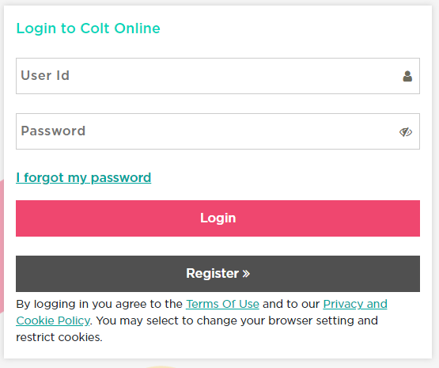
3
2
1
4
You can access Numbers on Demand via Services in the top navigation bar.
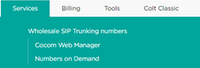
1
2
- Place the mouse over the ‘Services’ Main menu
- The ‘Numbers on Demand’ Sub menu item with link is displayed if you are an authorized user to access Numbers on Demand. Click the ‘Numbers on Demand’ Sub menu link.
Numbers on Demand Sub menu item with link is displayed only if the user is authorized to access Numbers on Demand. If you do not have access and are a Wholesale SIP customer, then please contact your Account Manager who can request your access.

Numbers on Demand Profile Selection
If you have more than one profile with Colt, then you will be presented with the screen below, which will allow you to select the profile you would like to log-in with, as well as the options to go to ‘View Reseller Data’ and ‘Number Hosting Report’ pages.
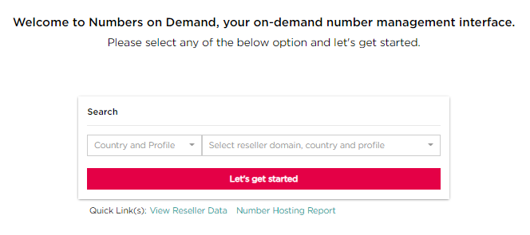
If you only have one profile with Colt, then you will automatically skip this page and go into Numbers on Demand.

My Orders
Order details older than 365 days are archived. To gather information for these older orders you must raise an ‘Order Report’ request using the Reporting Functionality.

When you enter Numbers on Demand you will arrive on the ‘My Orders’ page, which presents you information on all your pending Colt Wholesale SIP orders from the last 365 days, under an adjustable set of headings, which are described below:
- Order ID: The identification for each order you have with Colt
- Order Type: A description of what each order is
- Order Creation Date: When the order was created
- Order Update Date: When the order was last updated
- Range Start and Range End: The number range contained in the order
- SLA: The order completion time, applicable for number activation, deactivation and reactivation
- Quantity: The amount of numbers/number ranges in the order
- User: The user who submitted the order
- Country: The country in which the order was placed
- Service Profile: The profile you used to place your order
- Reseller Domain: Your customer domain in which the order was placed
- Order Status: The progress of your orders based on their status
- Actions: Under My Orders are a selection of available actions depending on the port-in order status, including: cancel port-in, change the port-in date or add a quick note to an existing port-in request (Note - if you want to edit a Colt or ported-in number then you must go to the My Telephone Numbers screen)
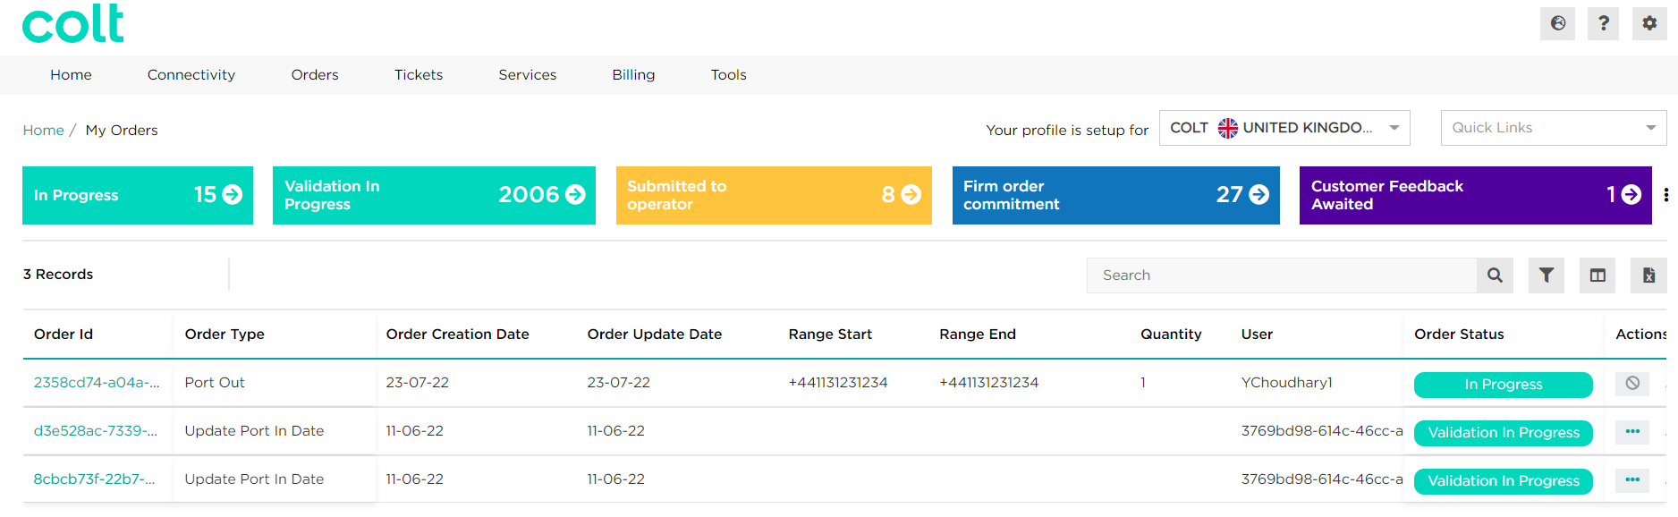

On this page you can view all pending orders by order type that you have placed with Colt. This presents you with all of the information you need to review each order, including: status, order creation date, numbers in scope, the quantity of numbers and more.
There is a plain search feature to find a specific order you are looking for.

By clicking the Filter icon you can select one or multiple filters for your orders, based on: country and profile (this allows you to add results from your other profiles into this list), order type, order status, order creation (which is a mandatory filtering option, and we suggest to filter across a range of dates to get the clearest view of your orders) and update date (there is a limit on the number of Order IDs that will be shown, if you need to see historical Order IDs then it is recommended to filter again (e.g. order creation date) to get a complete view)

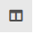
By clicking the Column Customiser icon you can adjust the display by changing the columns/key information you see for your orders
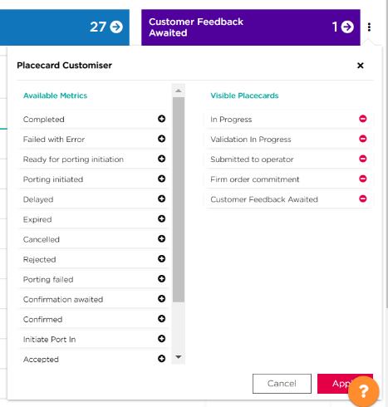
By clicking on Excel Download icon you can export the My Orders data that are listed into an Excel document
The placecards at the top of the page shows your records for numbers in a customisable set of statuses, you can adjust the visibile placecards using the ‘placecard customiser’ symbol and then selecting the metrics you would like to see. Additionally, by clicking on a placecard, the records shown will reflect the status of the placecard you have clicked.

- Using the ‘Quick Links’ menu you can navigate between the features available in Numbers on Demand. This can be found in the same location on every page.
- If you have more than one profile with Colt, you can change which profile you are logged in with by selecting from the drop-down list.
- You can move through your orders, as well as adjusting the number of orders visible on one page

By clicking on an Order ID, you can get a detailed breakdown of your order. As per the screenshot below, you can see your order details (including end-customer details), number details (which shows your number ranges), history/conversation (which shows the history & linked orders e.g. a port-in request followed by a change to the port-in date etc…) and number history (which enables you to search for details on a specific number in your order).
Order Details
On the Order Details page, the following information is now available to view:
- In all countries: Existing porting fields, The Rejection or Exception (CFA-Customer Feedback Awaited) reason for both Port-in and Port-Out orders, Notes for both Port-in and Port-Out orders, and ‘Customer reference’ details
- In Belgium, Germany, Italy, Portugal, Spain and Sweden: Address ID for orders from these countries
- In the Netherlands: First Port Date (FPD) at a range level, overall First Port Date (Overall FPD), actual porting date/time, and the automated Porting Performed (automated PP- Yes/No) displayed against the Order ID
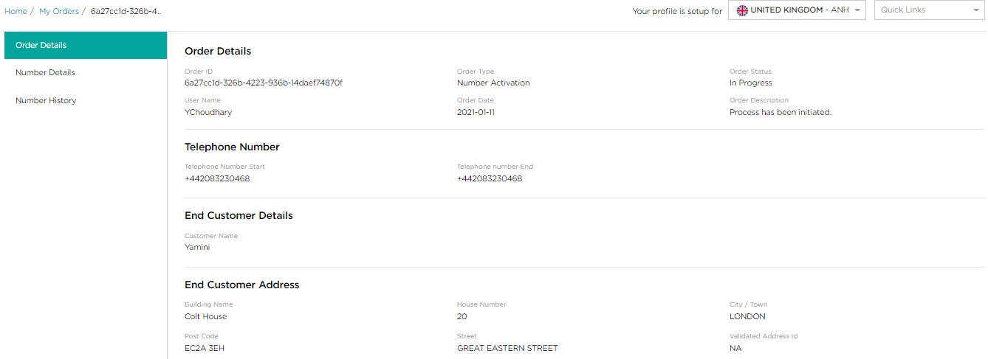
Below you can find which links are available to explore for each order ‘transaction type’:
Transaction Type | Number history | History / Conversation | Number Details
Number Activation | Yes | No | Yes
Number Deactivation | Yes | No | Yes
Number Reservation Cancellation | Yes | No | Yes
Number Reservation | Yes | No | Yes
New Port In | Yes | Yes | Yes
Update End Customer Detail | Yes | No | Yes
Cancel Port In | No | Yes | No
Cancel Port Out | No | Yes | No
Number Reactivation | Yes | No | Yes
Port In Reactivation | Yes | Yes | Yes
Port Out | Yes | Yes | Yes
Port Transaction Update | No | Yes | No
Update Directory Services | Yes | No | Yes
Update Port In Date | No | Yes | No

Number History
You can search for a number in the E164 format (‘+’ is automatically added) within a number range , to see the order history of that number.

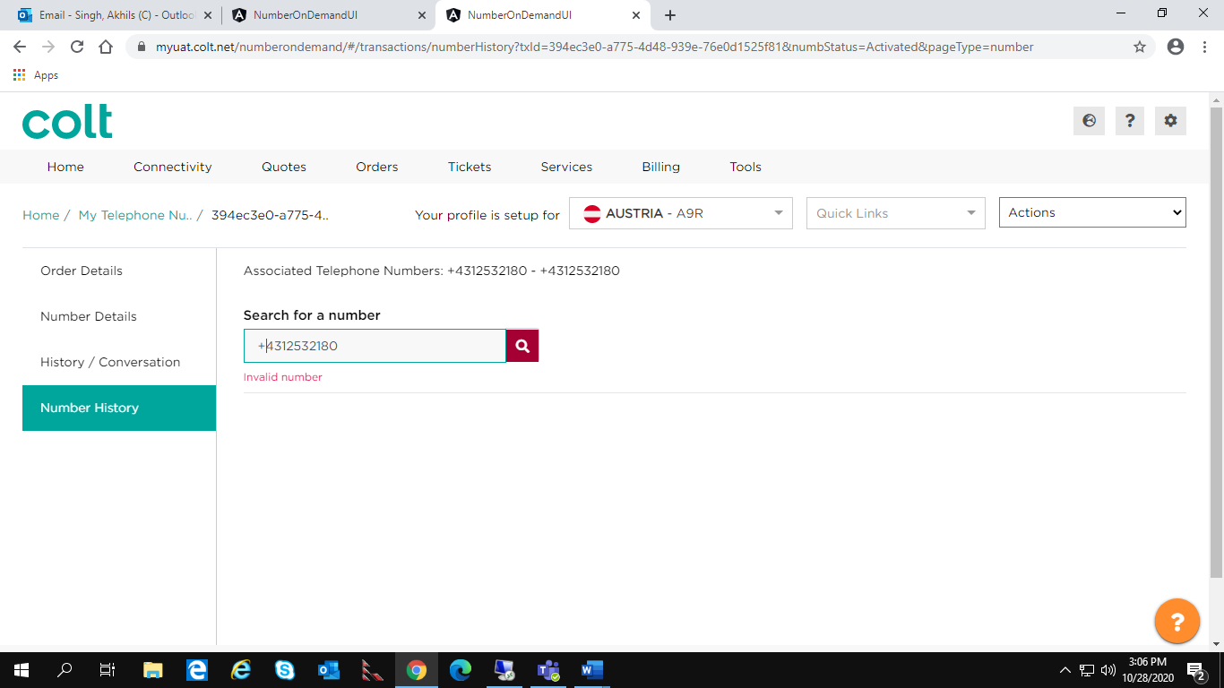

After the results are loaded, you can check the order history by clicking on the Order ID to navigate to that particular order detail, and by clicking the label (e.g. Completed) you can expand or hide the list of your Number History results.

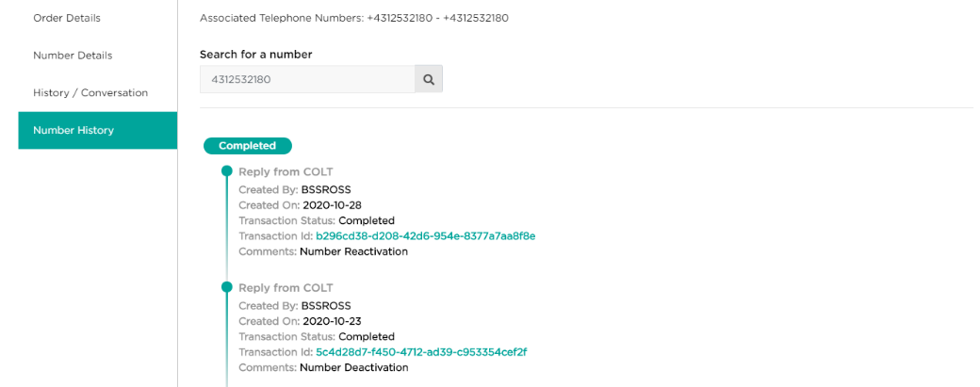

If you search incorrectly or there is an error, then you will be presented with the following screen.
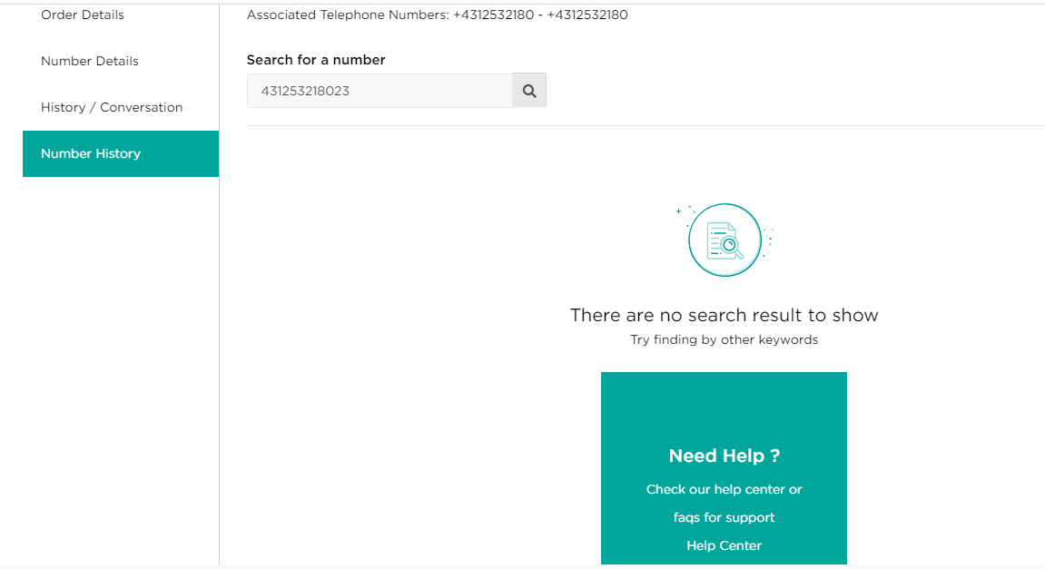

Order / Transaction status
Your order status will change over time and depending on the scenario. Non porting related orders have 2 statuses:
- ‘In progress’ from order creation until completion, and
- the final status
You will receive notifications (email and callback) for all order status updates

Please find below Order status, the description & any action that needs to be taken:

Order status | Description | Next action
In progress | Your order is in progress, usually the first step. | No action required.
Completed | Your order has been completed. | No action required.
Failed with error | This error, also known as a business error, occurs when you have submitted incorrect information. | Please have a look at the error message, correct your order and resubmit it.
Failed | This error, also known as a technical error, occurs when an unexpected error occurred during the order process. | No action is required from you, Colt will correct and resubmit the order.

The status of porting orders changes multiple times during the process flow. Please refer to porting sections for more information.

My Telephone Numbers
My Telephone Numbers offers you a simple way to manage your numbers and is
accessible from the Quick Links menu.
You will not find your numbers on this page if they have been rejected, cancelled or expired, for these orders you must search for them in the ‘My Orders’ page.

My Telephone Numbers provides information on all your Colt Wholesale SIP numbers, under an adjustable set of headings, which are described below:
- Range Start and Range End: to see the number range status.
- Date: The expiry/activation/planned date of the number range in the order
- Order ID: To view the order status and number range details of a particular order .
- Customer reference: To see the number range status based on your customer reference you have added against an order
- User: The user who submitted the order
- Service Profile: The profile you used to place your order
- Domain Name: The customer domain in which the order was placed
- Country: The country in which the order was placed
- Number Status: To find numbers based on their status. Please find below the status:
  - Reserved, Activated, Quarantined, Allocated
  - Port in Activated, Port in Allocated, Port in Quarantined
  - Port Out, Returned, All
  - Reservation Pending
- Actions: Under My Telephone Numbers are a selection of available actions depending on the Colt & ported-in number status, including: Cancel reservation, Activate, Address Update & Deactivate. Note if you want to edit a porting order then you must go to the My Orders screen.
- Using the ‘Quick Links’ menu you can navigate between the features available in Numbers on Demand. This can be found in the same location on every page.
- If you have more than one profile with Colt, you can change which profile you are logged in with by selecting from the drop-down list.
- You can search through your records by entering the Number, Customer Reference or OrderID in the search bar
- You can customise the placecards presented to show your preferred metrics, as done on the ‘My Orders’ page
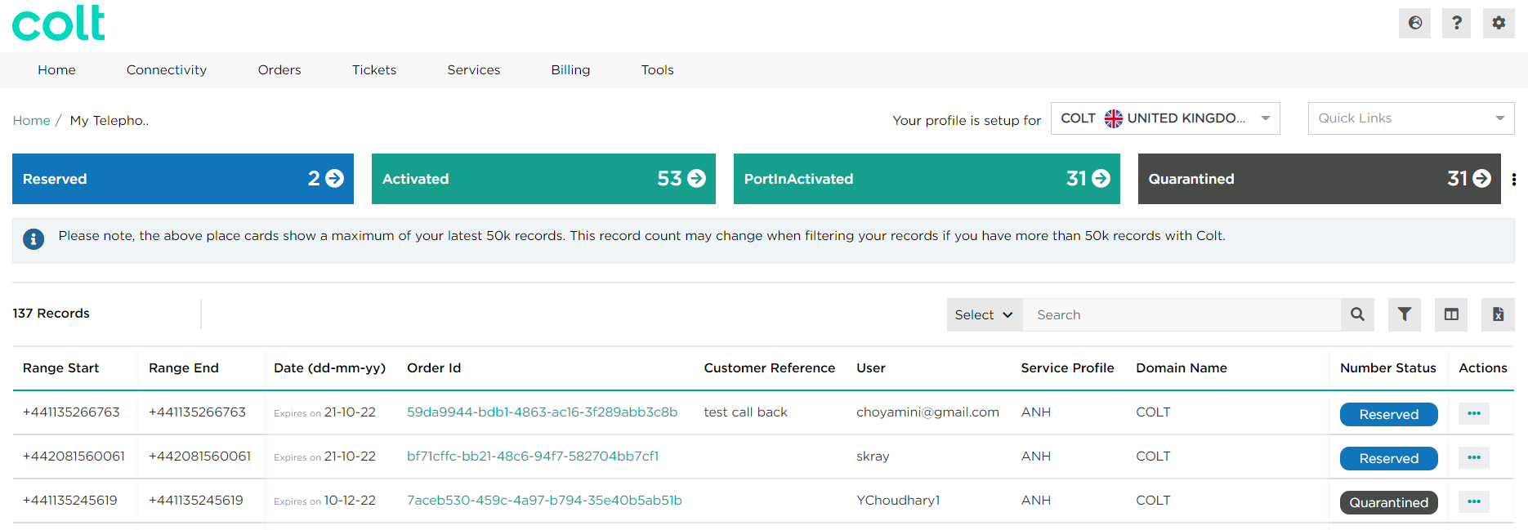
1
4
2
3

By clicking the Filter icon you can filter based on the number status (there is a limit on the number of Order IDs that will be shown, if you need to see historical Order IDs then it is recommended to filter again (e.g. order creation date) to get a complete view)
By clicking the Column Customiser icon you are able to adjust the columns you see for your number ranges, so you can change it depending on which information you want to see for your telephone numbers on this page
By clicking on Excel Download icon you can export the data from the page into an Excel document

Number Status

Please find below a description of what action can be taken depending on the number status, with associated country availability.
Number status | Country | Description
Free | All (20) | Colt free number you can search and acquire
Reserved | All (20) | Colt Number in your stock.  Network is not configured & no end-customer assigned.  Reservation period = 90 days.
Allocated | All (20) | Intermediate status for Colt number during activation process.  No action possible.
Activated | All (20) | Colt number in your stock.  Network is configured & end-customer assigned (variance applicable for Premium offer).
Quarantined | All (20) | Following a deactivation, Colt number stays in your stock during quarantine period as Quarantined.  Network is not configured & no end-customer assigned.  Quarantine period varies per country.
PortIn_Allocated | All except DE (19) | After port-in order has been confirmed (transactionStatus = Firm order commitment), ported-In number will appear in your stock as PortedIn_Allocated.  Network is not configured & no end-customer assigned.  No action possible.
PortIn_Activated | All (20) | Ported-In number in your stock.  Network is configured & end-customer assigned.
PortIn Deactivation in Progress | All (20) | When port-in deactivation request is raised, the number status for the requested range will be updated, and once completed the number status will return to Port-in quarantine / returned (as per the current country rules)
PortIn Reactivation in Progress | All (20) | When port-in reactivation request is raised, the number status for the requested range will be updated, and once completed the number status will return to Port-In Activated
PortIn_Quarantined | FR, NL, PT, ES, SE, CH (6) | Following a deactivation, Ported-In number stays in your stock during quarantine period as PortIn_Quarantined.  Network is not configured & no end-customer assigned.  Quarantine period varies per country.
Back to Regulator | IT (1) | Covers the following scenarios:  - A Colt Range is returned to the Regulator  - A Colt Range is re-assigned to another OLO by the Regulator

Number Details and History

Number Details and History provides you a quick way to view the details or history of your numbers and is accessible from the Quick Links menu.

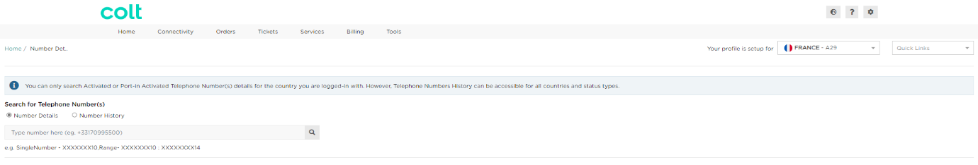
The Number Details and History page allows you to seach for the number details of your Activated and Port-in Activated numbers for the country you are logged in with, and the telephone number history of all your numbers across all countries and status types.

Once you have searched your Activated or Port-in Activated number(s) under the Number Details option, you will be presented with the below information.
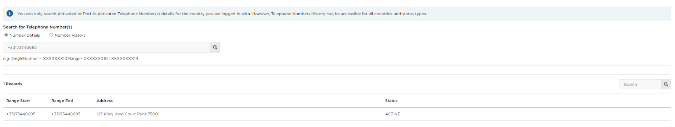

While, when you search for your number(s) under the Number History option, you will be presented with the below information.

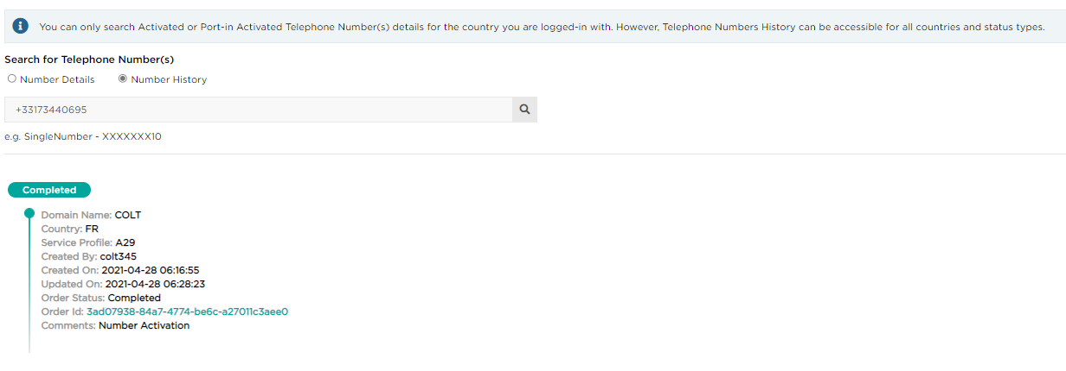
You must click on the label heading (e.g. Completed) to expand or hide the list of results for your number history under that field

Reserving Colt Numbers
In Denmark there is no concept of a “local” area code (LAC). Please use the national LACs available in Numbers on Demand for any location.
In Sweden, 010 numbers are very popular and should be used. They are available under ‘Location Independent Number’.
In Austria there is a private numbering plan. If your customer wants new geographic or location independent numbers, then you only need to reserve & activate one number for them. This single number can be extended by your customer into a range of 0-9, 00-99 or 000-999 numbers.

This section describes how to proceed with the below transactions:
- Reserve numbers.
- Cancel a number/number range reservation.
To reserve numbers you need to go to ‘Reservation’ in the Quick Links menu, ensuring you are logged into the Service Profile you wish to use for this.

How to reserve numbers
- First you need to select the type of number to be reserved, these are either: Geographic Numbers, Location Independent Numbers, or country specific numbers (see APPENDIX A for details on additional number types available)
- You will then need to enter the required information, using the drop down lists provided for your selection
- Click on Provide Numbers once completed to proceed
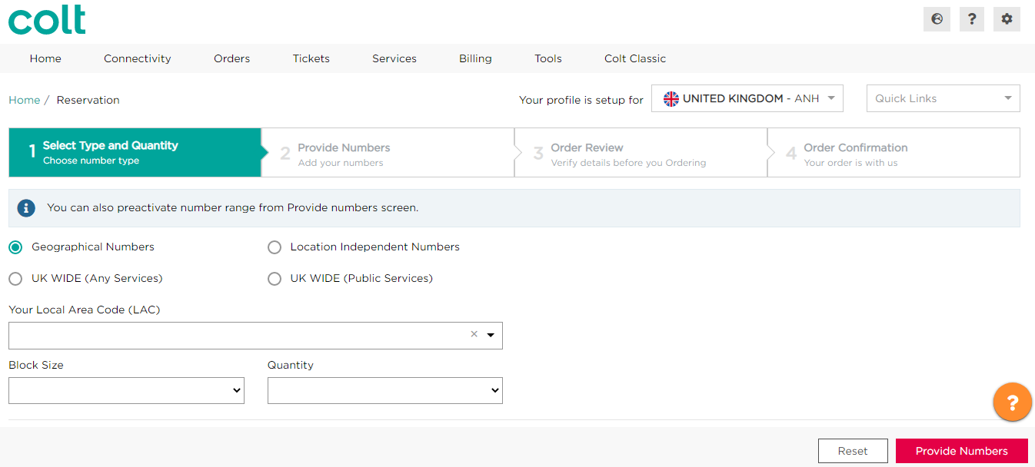Example to choose number type screen for UK Geographical numbers
1
2
3
(i): Colt does not offer Location Independent Numbers (Nomadic Numbers) in all countries, please check APPENDIX A for service availability.
(ii): Colt does offer full geographic coverage in all countries, please check ‘Colt Wholesale SIP coverage’ file for service availability at https://developer.colt.net/wholesale-sip-documentation.
(iii): please check APPENDIX A for ‘search by city’ feature availability.
(iv): you need to activate the complete range of reserved numbers at the same time, for the same end-customer.

Select the relevant number(s) that you want to reserve, then proceed to order review.
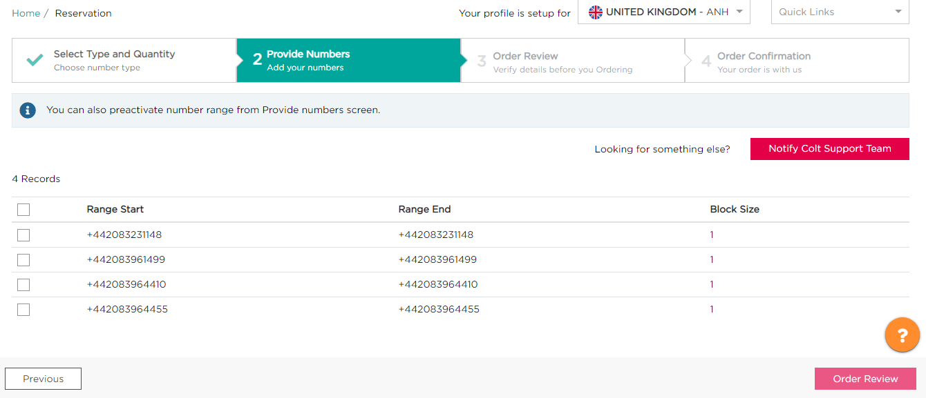
If you have the Premium Offer, then you will see an option to pre-activate the numbers on the above page. After you have preactivated the numbers you must perform an end-customer address update – see later section.

If no numbers or no exact quantity can be returned in the response then you will see a ‘Request Numbers’ option. Please click on this option to provide details of your request and submit the order. An Order ID will be returned to you for tracking purposes.
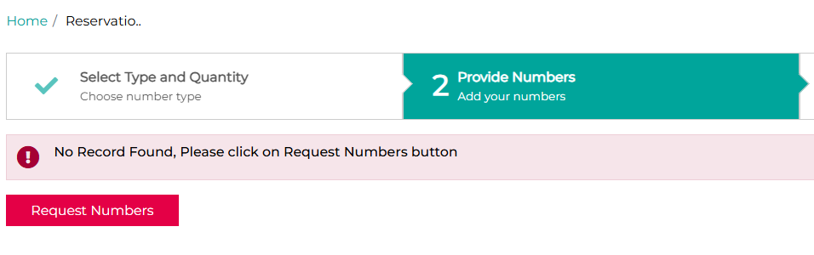
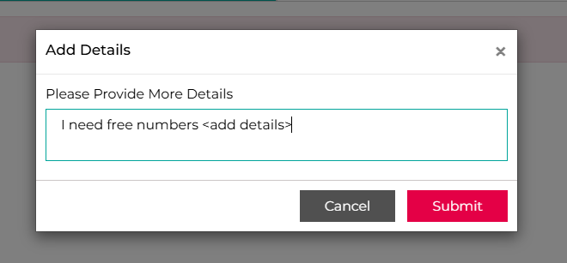
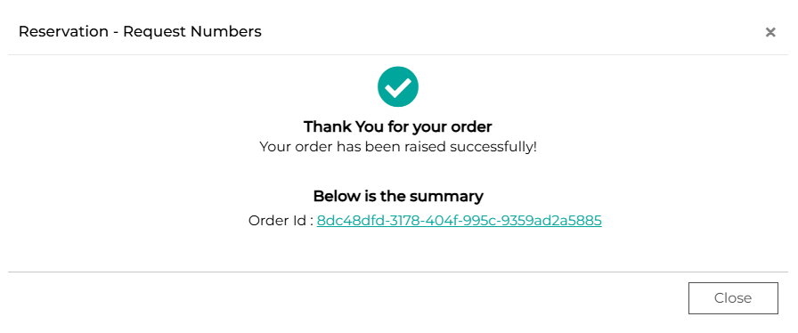
For France (FR)- this feature will not be available if you’re using your own numbers.
For Germany (DE)- it is mandatory that you attach a document with your order (the BnetzA Approval Form) if the block size is bigger than 100. This document is available from your Colt Account Manager.
For Denmark (DK)- In Denmark there is no concept of geographic numbers – effectively all numbers are location independent/nomadic numbers . Please check for free numbers in all LACs before placing an order for free numbers.
For Netherlands (NL), the following additional fields are mandatory:
- End Customer Name
- Request reason (E.g.: Existing end customer is expanding their operations and needs XXX numbers for new sites, and provide the company size (e.g. number of staff) as proof)
- The end customer’s installation address for these additional numbers (all address fields to be provided for NL). LAC/address validation will not be done as it will be manually verified by Colt’s local country number manager.

This new automated order flow captures your request and you will receive updates directly from Colt’s local country number manager.
You can track this order ID and see the details of your order as shown below: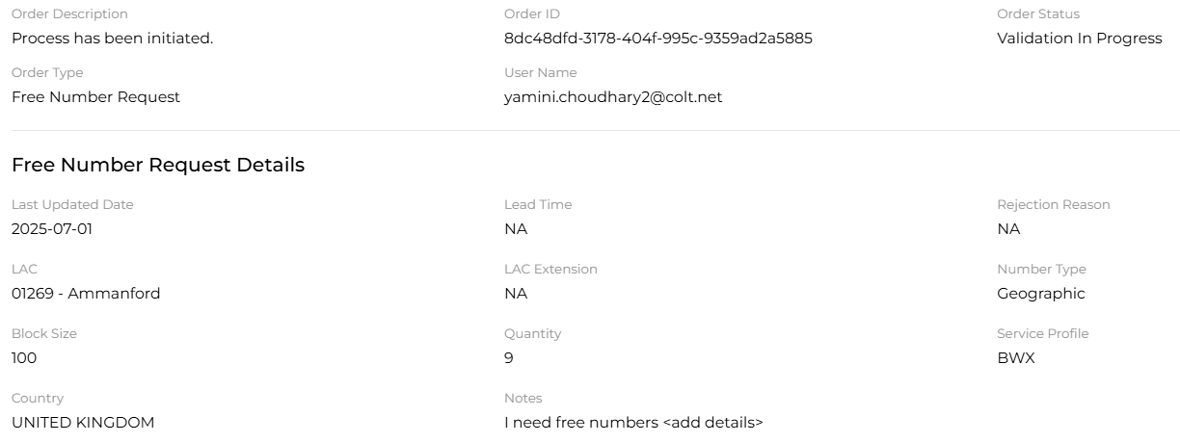
- Colt’s local country number manager will receive the ‘Free Number Request’ and they will either Accept (and provide a lead time) or Reject this request (with a rejection reason). You will be notified via email regarding the status of your request.
- You can cancel the request if the order is in ‘Validation In Progress’ or ‘Accepted’ status.
- Once numbers are ready, Colt’s local country number manager will ‘Complete’ the request and you will be notified via email. You can then search for the free numbers like today and reserve/activate them.
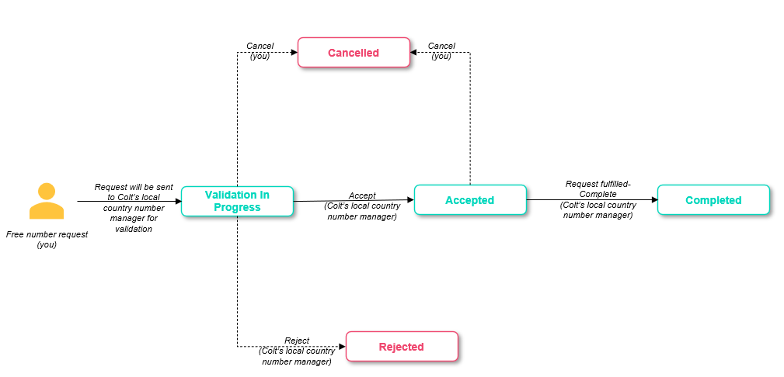

Back to number reservation…
In the Order Review step you can see all the details of the reservation you are about to place, as well as being able to add a reference to your order.
You can return to the previous step if you have any changes, and once you are happy you can click on Order Confirmation to place your reservation.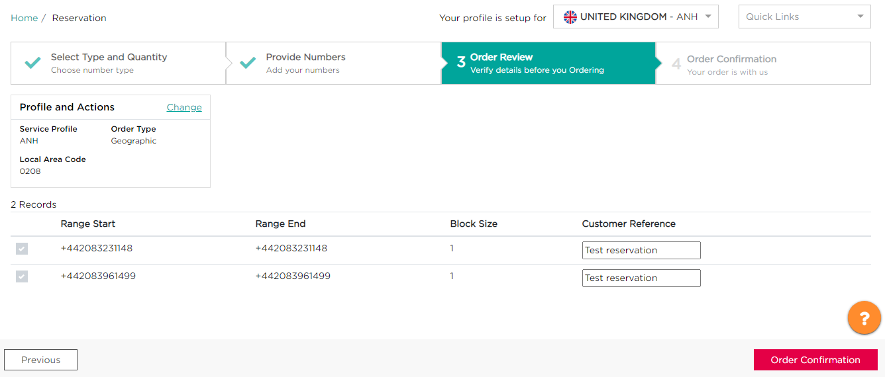
Your will then be presented with an order confirmation screen, from here you can see a summary of your order and can directly go the ‘My Orders’ or ‘My Telephone Numbers’ page, where you will see the updates and take further action.
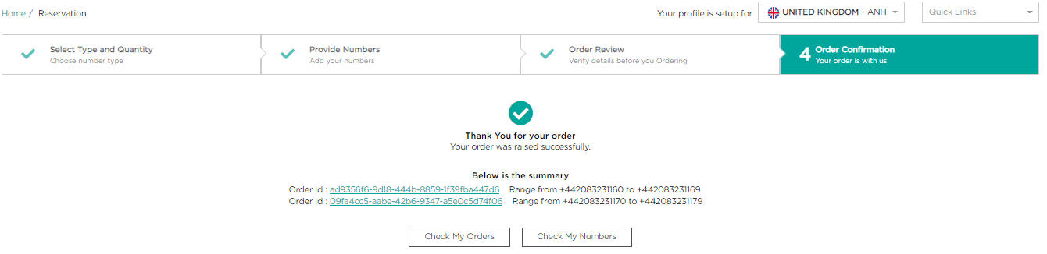
Order ID for your number reservation
- Number status: the numbers are now reserved for 90 days. Numbers can be activated at any time during the reservation period.
- If a number reservation approaches its expiry date, then a notification of this is sent via email to the email address used for your account setup

How to cancel a number reservation
Only reserved numbers can be cancelled.

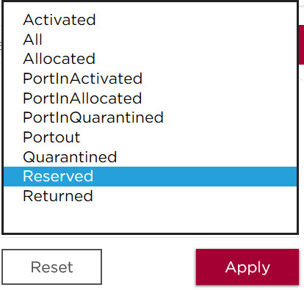
To cancel a Colt Number / number range reservation, from ‘My Telephone Numbers’ page:
- Select the filter icon:
- Click on Reserved
- Click on Apply

This will then present you with a list of your Reserved numbers, and from here you can cancel your number reservation(s) by:
- Select the three dots under the actions column for the number you want to cancel the reservation for
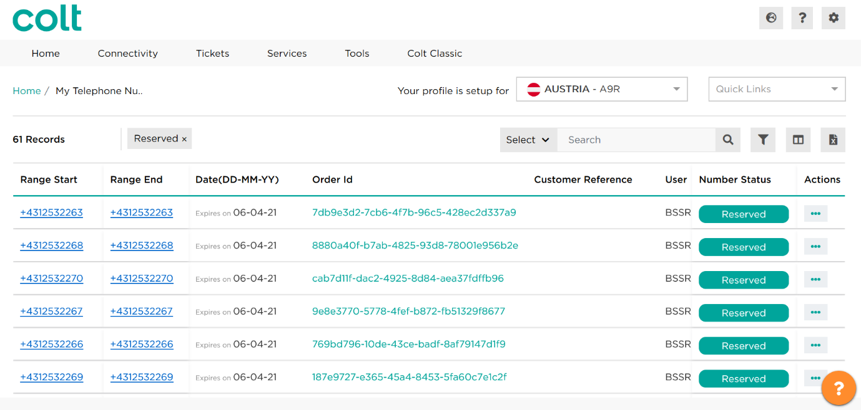
1
- Select Cancel Reservation in user action button.
2

- Click on Return Numbers.
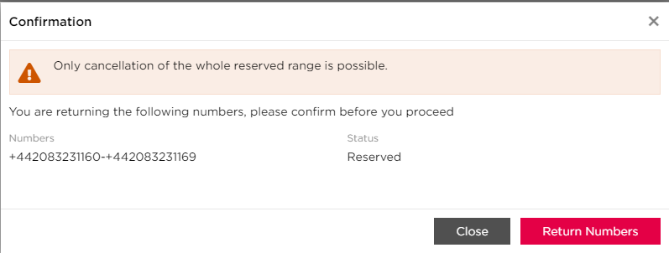
3

You will then be presented with this screen as confrmation of the Cancellation, and your Number Status will be updated accordingly in the ‘My Telephone Numbers’ page.
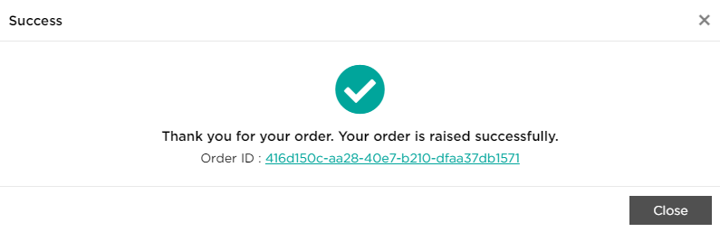
- Number status: After reserved numbers are cancelled they become free and available to all Wholesale SIP customers to reserve or activate directly.
- Cancellation of part of a reserved range is not allowed. The complete range will be cancelled.
- Please check APPENDIX A for country rules regarding Colt numbers reservation.

Activating, deactivating & re-activating Colt Numbers
This section explains you how to:
- Activate Colt numbers
- Deactivate & re-activate Colt numbers
These transactions are made from ‘My Telephone Numbers page, available under Quick Links.
LAC & end-customer address validation
With respect to the national numbering plans, it is mandatory to activate a geographic number in the Local Area that it belongs to in most countries.
Colt has implemented system rules to fulfil this regulatory requirement, known as Local Area Code (LAC) validation. It is simply a mapping table between components of an address and the LAC.

(i): The full list of available LACs to can be found in the ‘Colt Wholesale SIP Geographic Coverage’ file, available in https://developer.colt.net/wholesale-sip-documentation.

(iii): Please check APPENDIX A for additional information about end-customer addresses & LAC validation.

In Austria there is a private numbering plan. If your customer wants new geographic or location independent numbers, then you only need to reserve & activate one number for them. This single number can be extended by your customer into a range of 0-9, 00-99 or 000-999 numbers.

How to activate reserved numbers or directly activate numbers
To activate Colt reserved Numbers, you have to search for reserved numbers first.

There are 2 ways to activate Colt Numbers:-
- Under My Telephone Numbers, select your reserved numbers and activate from there
- Under My Telephone Numbers, go directly to activation and activate free numbers
Under My Telephone Numbers:
- Click the filter icon to set the Number Status to Reserved.
- Click the 3 dots icon next to the Reserved number you want to activate in the Actions column
- Select Activate.
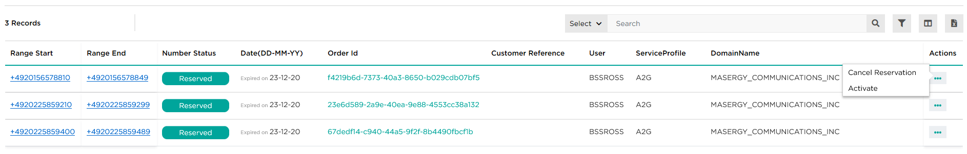
1
3
2

This will then take you to the ‘Add End-Customer details’ page. Here you will need to add the end-customer information for the number range(s) being activated. This includes their address, which will also be used as an emergency address (this can be changed later by going to My Telephone Numbers and selecting Address Update).
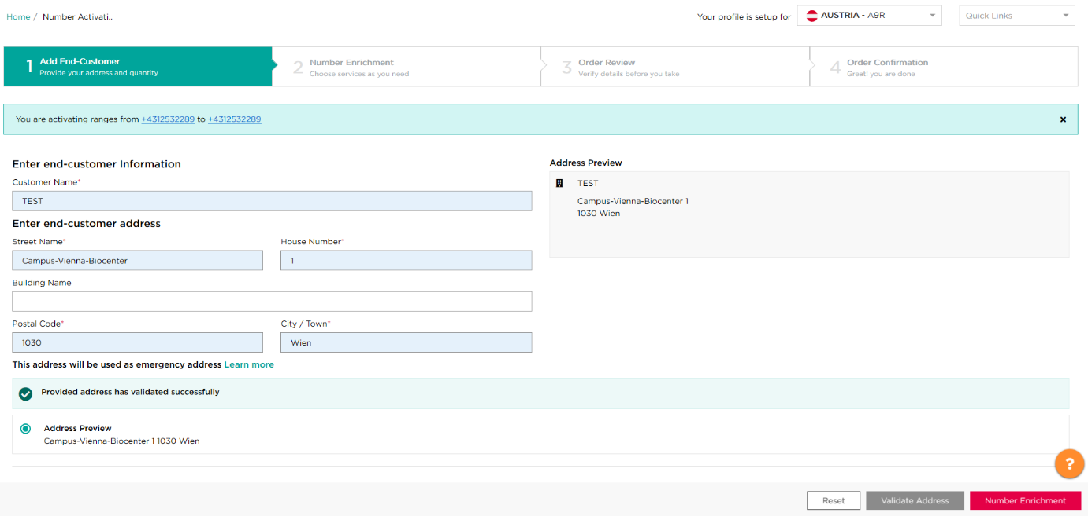
Example of add end-customer details screen for an Austrian profile
Once you enter the address you will need to validate it by clicking the ‘Validate Address’ button, and you will then be able to go to the next screen ‘Number Enrichment’.
If an exact match of the address cannot be found, then a list of suggested addresses will be presented for you to select from.
In the Number Enrichment step, you will have the option to add the numbers into the national Directory Services based on the end-customer requirement. This will provide a simple data entry (or block) the entry of information into a national Directory Services’ database.
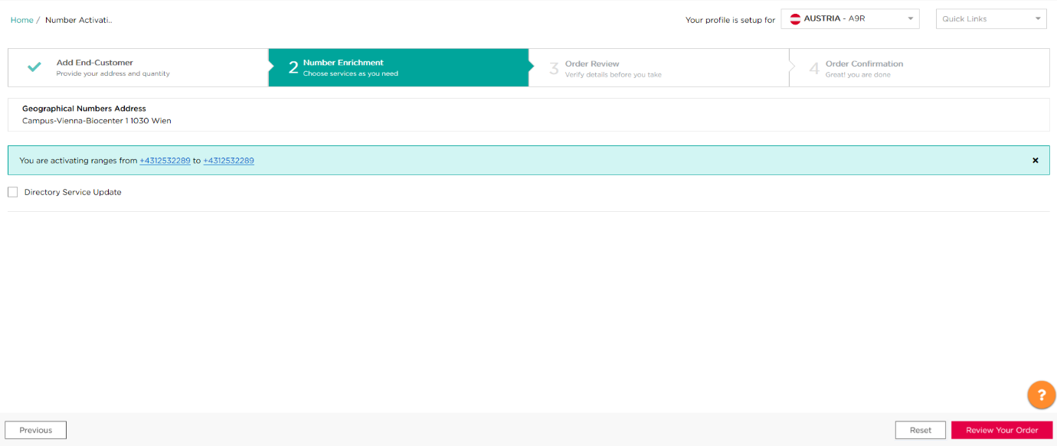
Otherwise, you can skip this step and Review your Order.
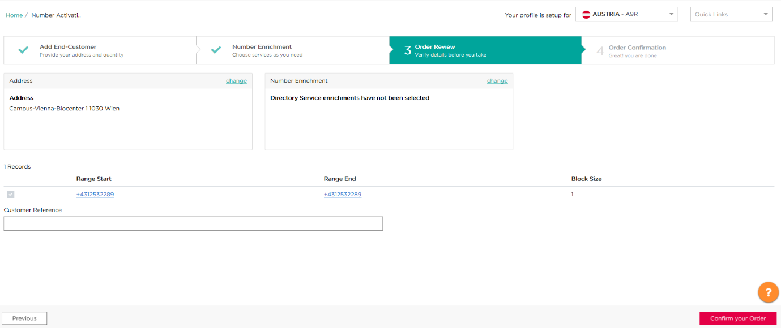
From here you can review the details of your number activation, and can go back to any of the steps to make any required changes. You can also add a customer reference to easily identify this number range in the ‘My Telephone Numbers’ & ‘My Orders’ summary, to use as a filter later on.

Once you are happy with your order, you can confirm it by clicking the ‘Confirm your Order’ button in the bottom right and then you have activated your number range(s)!

From this screen you can: add more numbers, check your numbers in the My Telephone Numbers page or check your order status in your updated Order ID.
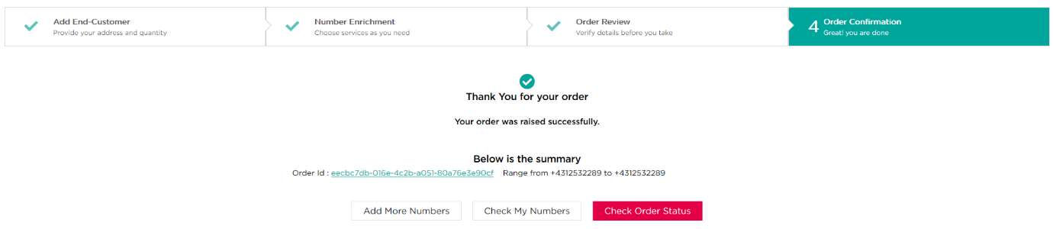
If there is an error then you will be taken to the screen below, which will allow you to retry activating your number, add a new number instead, or notify the Colt support team.
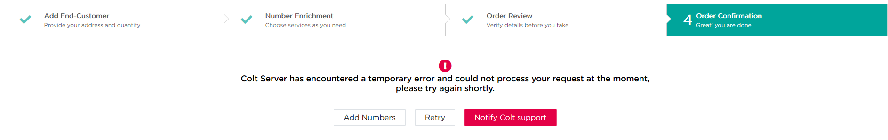
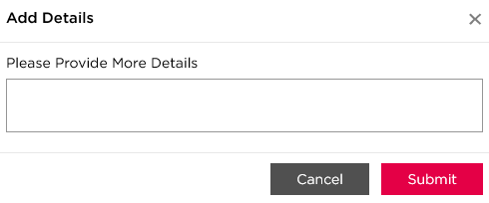
If you choose to ‘Notify Colt Support’ you will have the option to add some details to the error, which will then be sent to the Reseller Support Voice team.

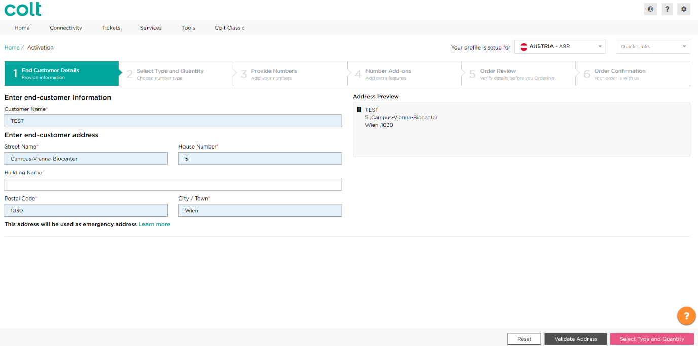
The second way to activate your number range(s) is to go to ‘Activation’ in the Quick Links menu. This will take you to a different flow, starting with adding the end customer details.

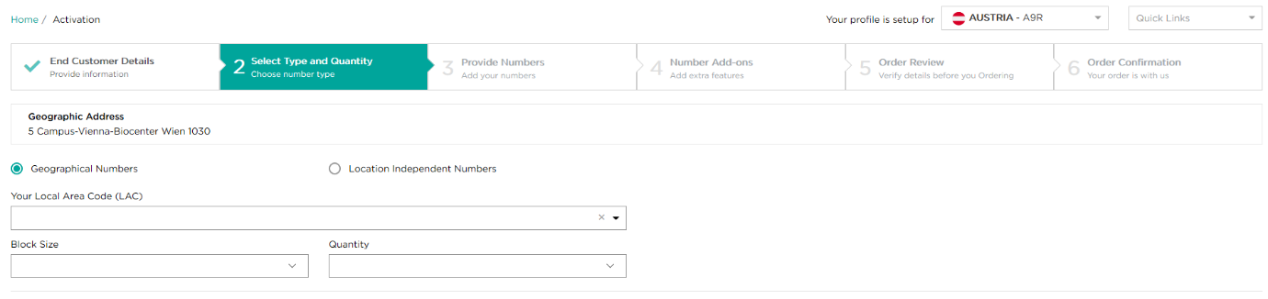
After you validate the end-customer address, you will then need to select the type of number and quantity of number ranges you wish to activate. For geographic numbers you must provide your Local Area Code (LAC), block size and quantity.
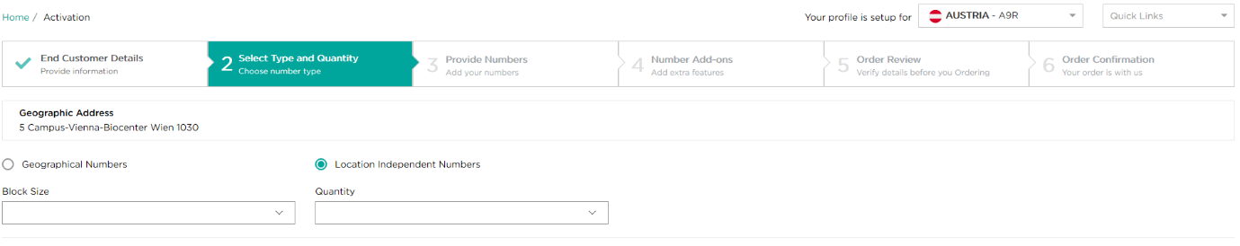
For Location Independent Numbers you just need to provide the block size and quantity required.

Once you have made this selection, you will then need to add the numbers associated with the address you would like to activate.
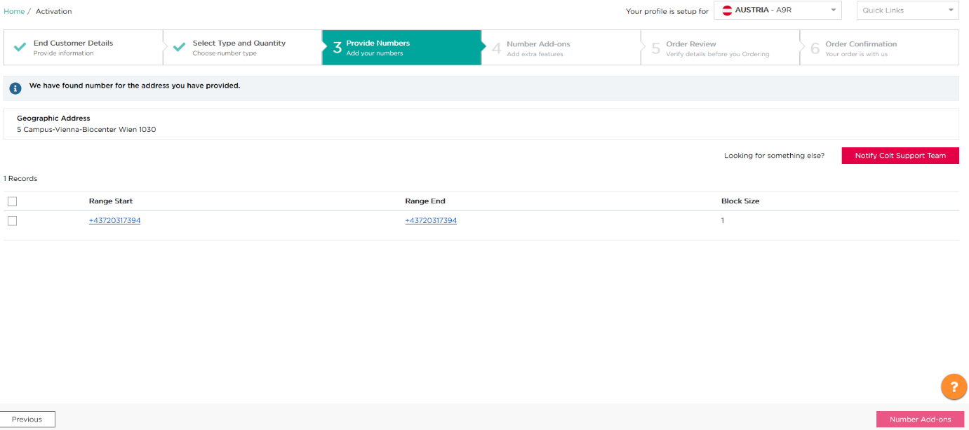
Once you have chosen the number(s) you would like to activate, then you will proceed to the remaining steps following the flow that is outlined above for activating your numbers from the ‘My Telephone Numbers’ page.
Or if no numbers or no exact quantity can be returned in the response then you will see a ‘Request Numbers’ option. Please click on this option to provide details of your request and submit the order. An Order ID will be returned to you for tracking purposes.
For France (FR)- this feature will not be available if you’re using your own numbers.
For Germany (DE)- it is mandatory that you attach a document with your order (the BnetzA Approval Form) if the block size is bigger than 100. This document is available from your Colt Account Manager.
For Denmark (DK)- In Denmark there is no concept of geographic numbers – effectively all numbers are location independent/nomadic numbers . Please check for free numbers in all LACs before placing an order for free numbers.
For Netherlands (NL), the following additional fields are mandatory:
- End Customer Name
- Request reason (E.g.: Existing end customer is expanding their operations and needs XXX numbers for new sites, and provide the company size (e.g. number of staff) as proof)
- The end customer’s installation address for these additional numbers (all address fields to be provided for NL). LAC/address validation will not be done as it will be manually verified by Colt’s local country number manager.

This new automated order flow captures your request and you will receive updates directly from Colt’s local country number manager.
You can track this order ID and see the details of your order as shown below:
- Colt’s local country number manager will receive the ‘Free Number Request’ and they will either Accept (and provide a lead time) or Reject this request (with a rejection reason). You will be notified via email regarding the status of your request.
- You can cancel the request if the order is in ‘Validation In Progress’ or ‘Accepted’ status.
- Once numbers are ready, Colt’s local country number manager will ‘Complete’ the request and you will be notified via email. You can then search for the free numbers like today and reserve/activate them.

Back to number activation…
On the Order Result page, you will find the Order ID associated to the transaction. To check order status, please refer to the My Telephone Numbers section.
It is your responsibility as described in the Number Hosting Service Description and Service Specific Terms (Colt’s contract with you) to provide accurate and up to date end-customer’ information in order to fulfil your & our regulatory obligations to ensure accurate and successful emergency call routing, Emergency Database (EDB) updates and Lawful Intercept requests.

Number status:
- Activation in progress: number status is Allocated. It’s a temporary status between reserved and activated and is visible only during the number activation process.
- Activation completed: number status is Activated.
- Activation failed: number status reverts back to Reserved

How to deactivate numbers
To deactivate Colt Numbers, you have to search for activated numbers first.
Only activated numbers can be deactivated.
When a deactivation request is in progress then no further action is allowed for the same full/partial range (e.g. actions like address update/ port-out/ duplicate deactivation will fail)
There is a new error message "There is already an order in progress for the number xxxxxxxxxxxxx" (The number/s which are duplicate in the new request will be displayed)
A new number status 'Deactivation in progress' will be available on 'My Telephone Number' Page under the 'Number Status' column.
No action can be taken via My Telephone Number Page if the number is in 'Deactivation in progress' status.
This new status 'Deactivation in progress' will be also be available in the Number Report.
Only for NL- If a port-out request comes in for the same partial/ full range for which a deactivation/ port-in deactivation request is in progress, the port-out request goes on hold and resumes (i.e. goes to Customer Feedback Awaited (CFA) status) immediately after the port-in deactivation is completed (i.e. the number status becomes port-in quarantine).

To deactivate Colt Numbers, from ‘My Telephone Numbers’ page:
Using the filter icon, change the number status to ‘Activated’ and click apply.
This will then give you a list of your activated numbers. To continue:
- Select the three dots next to the numbers you want to deactivate under the Actions column.
- Select Deactivate.
- Click on Deactivate Numbers.
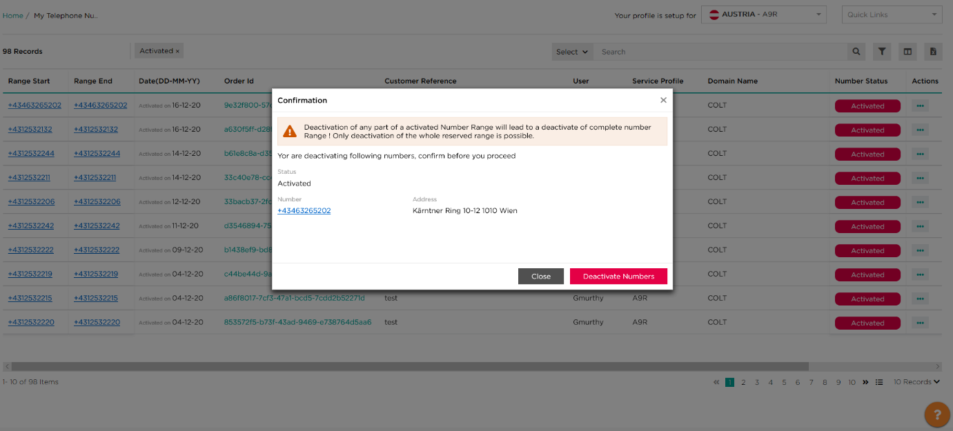
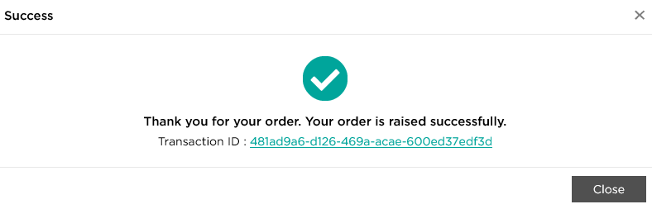
Once this is completed, your Order ID will be created.

(i): please check APPENDIX A for ‘partial deactivation’ service availability.

Number status:
- Numbers are quarantined. They can be reactivated only by you during the country quarantine period, for the same end-customer and at the same address.
- After the quarantine period expires, the numbers will automatically be free again and can be reserved by any Wholesale SIP Customer.
Please check APPENDIX A for the ‘quarantine period duration’.

How to reactivate numbers
To reactivate Colt Numbers, you have to search for quarantined numbers first.
Only quarantined numbers can be reactivated, for the same end-customer, at the same address.

To reactivate Colt Numbers, from ‘My Telephone Numbers’ page:
Using the filter icon, change the number status to ‘Quarantined’ and click apply.
This will then give you a list of your quarantined numbers. To continue:
- Select the three dots next to the numbers you want to reactivate under the Actions column and select Reactivate.
1
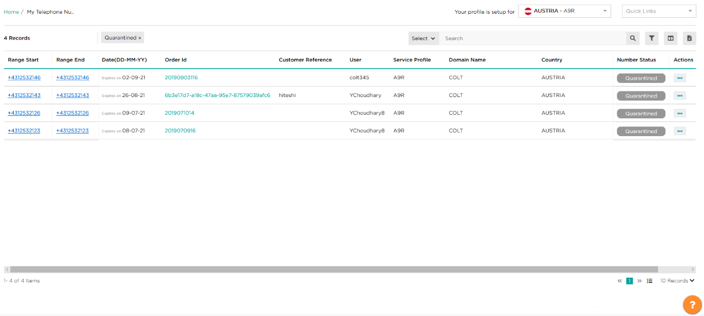
This will then take you to a confirmation screen to confirm that you want to reactivate your chosen quarantined number range.
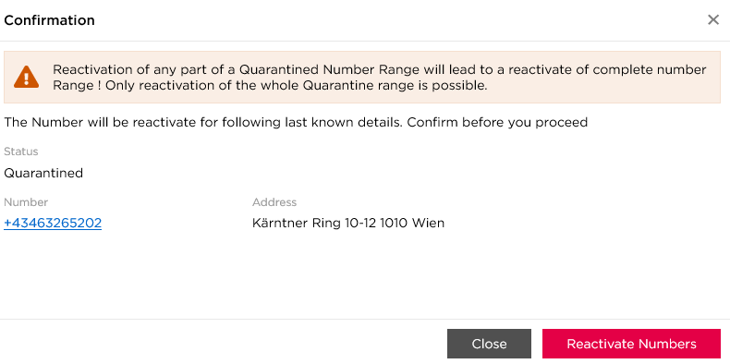

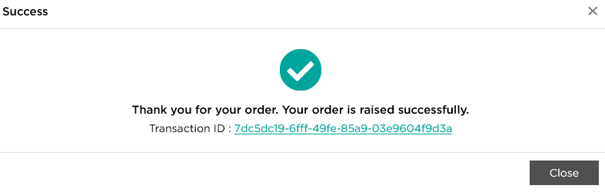
Once successfully reactivated, you will receive confirmation that this has been completed and your order ID will be created.

On the Order Result page, you will find the order ID. To check the order status, either click on the order ID or refer to My Telephone Numbers page.
Number status:
- Reactivation in progress: number status is Allocated. It is a temporary status between quarantined and activated and is visible only during number reactivation process.
- Reactivation completed: number status is Activated.
- Reactivation failed: numbers status is back to Quarantined, please contact Error! Reference source not found. Support via the online Help for support
Please check APPENDIX A for country rules regarding Colt numbers reactivation and quarantine period.

Port In

Port-In Lifecycle

High level process, from submission to completion, can be summarized as per the below image:
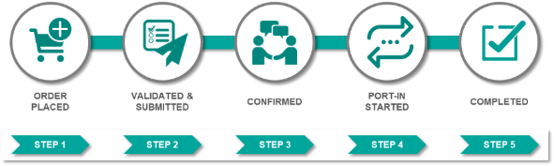

Port-In in the Netherlands
The below diagram provides a view of how the order status changes as a port-in order is progressed in the Netherlands:
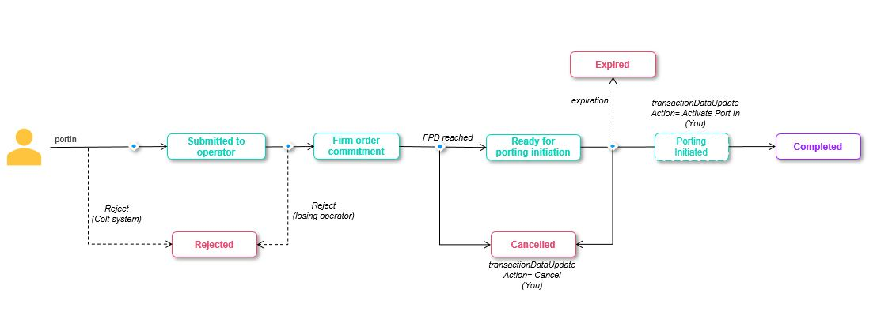
Please note that the port-In process is fully automated with direct connection to National Porting Database (COIN) in the Netherlands. The Colt Porting Desk only manages complex and Out of Hours orders.

How to schedule a port
- When order is in ‘Firm order commitment’ or ‘Ready for porting initiation’, select action as ‘Schedule porting’ from the action drop down
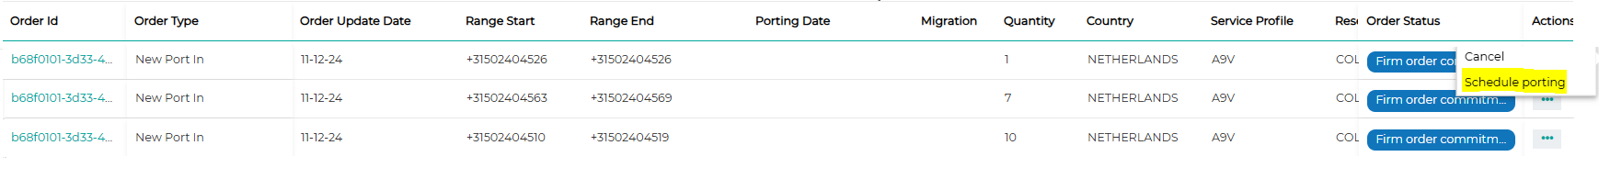
- Schedule Porting pop-up will appear
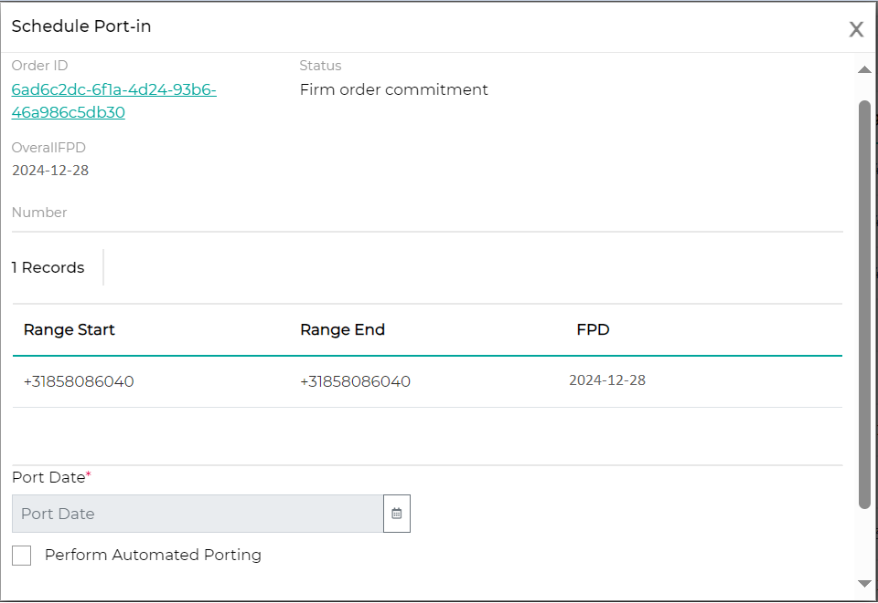
- Provide porting date and window.
- If you wish to Automate your request (i.e. Colt will automatically perform port activation on provided porting date/window) then select the check box ‘Perform Automated Porting’.
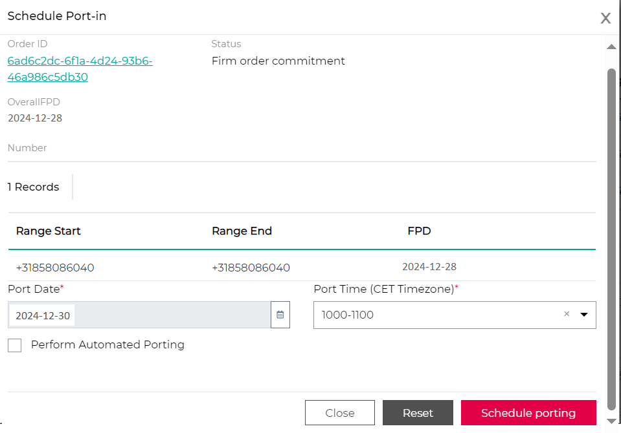

- Click on ‘Schedule porting’. You’ll receive an orderID in response.
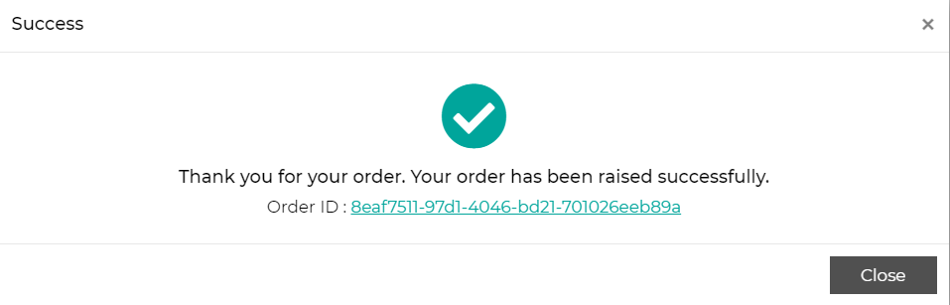

How to activate a port
- Your order should be in ‘Ready for porting initiation’ status.
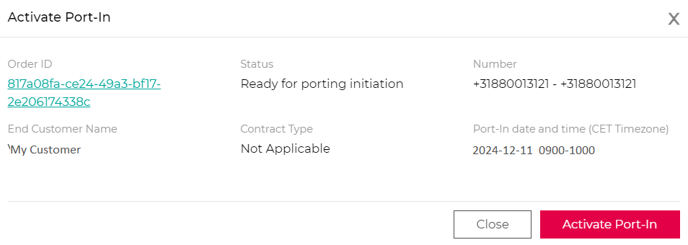
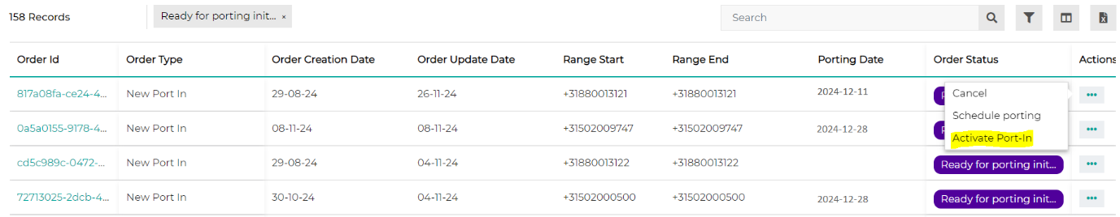
- If you have not requested for automated porting, then on the day of your desired porting date, perform ‘Activate Port-In’.

- This action can be performed on/before/after the porting date provided by you during the scheduling.
- Warning: When you select “Activate Port-in”, the porting will happen within minutes, so please ensure this aligns with your end-customer’s expectations.
- No action will be taken from Colt.
- Click on ‘Activate Port-In’ . You’ll receive an orderID in response.
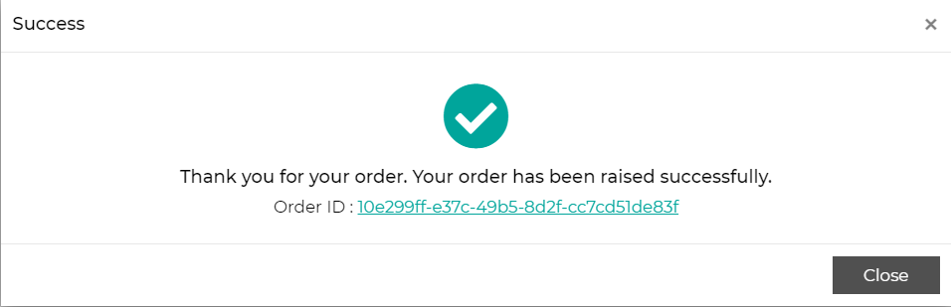

NL 088 Numbers
We have automated the ability for you to port-in your own / your end-customers’ own 088 Nomadic Numbers in the Netherlands using our NOD portal or via our Port-in/out APIs. 088 numbers give you and your end-customers full country coverage.
Port-In/Out journey :
The porting journey for 088 numbers is similar to the existing journey for geographic numbers, with a few exceptions. To Port-In 088 numbers:-
- It is mandatory that you provide the ACM document in addition to the mandatory LOA document.
  - The ACM document must be provided in the Regulatory Assignment Form field
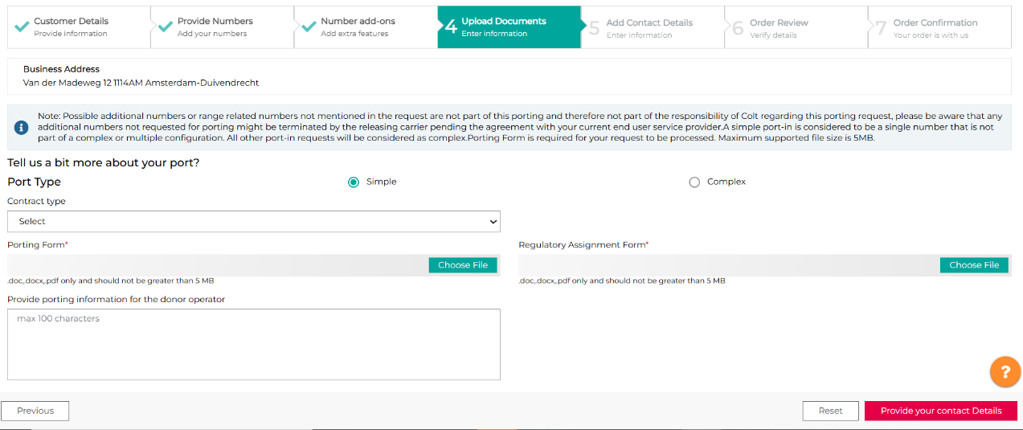

- LAC validation will not be applicable for orders with 088 numbers
- Address validation will be done
- A combination of 088 numbers and other numbers with a different LAC in the same order will be rejected
- There is no change to the address fields or Directory Services update

Please note:
- The Porting Desk may receive a direct notice from the Regulator in the Netherlands (ACM/COIN) that 088 numbers under your account have been revoked. Colt NL porting desk will notify you of this revoke notification and inform you on the next steps to undertake and timelines.
- In case of no response or adequate actions, Colt NL Porting Desk will deactivate the affected numbers in the local registry and on the Colt network as per regulatory obligations.
- 088 Local DB Activation checkbox does not need to be ticked when in the Customer Details step

Activation journey:
Activation of 088 numbers should be placed using the Port-In page from the quick links menu.

To Activate 088 numbers:-
- 088 Local DB Activation checkbox must be ticked when in the Customer Details step
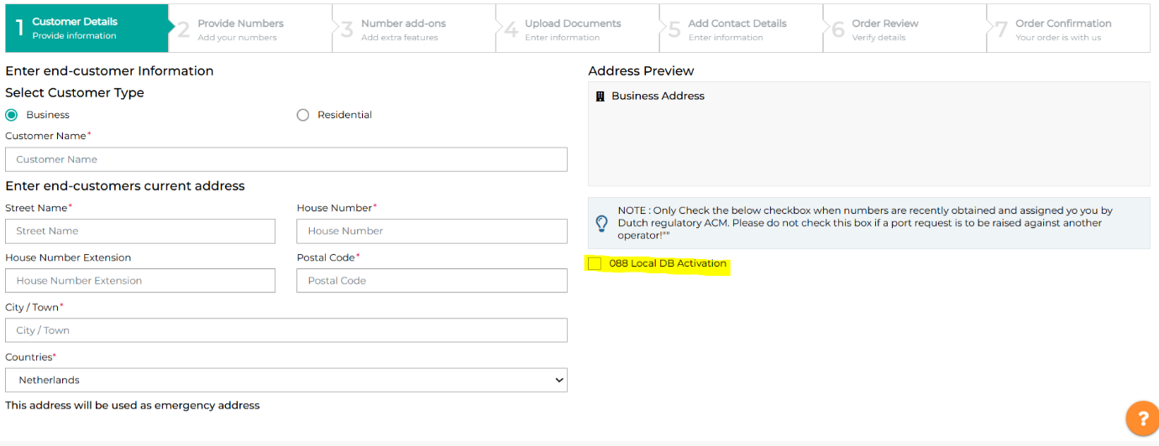
- It is mandatory that you provide the ACM document.
  - The ACM document must be provided in the Regulatory Assignment Form field

- LAC validation will not be applicable for orders with 088 numbers
- Address validation will be done
- A combination of 088 numbers and other numbers with a different LAC in the same order will be rejected
- There is no change to the address fields or Directory Services update
- Contract details are not required in activation journey.
- Post successful activation, you’ll be notified.

The Activation request will move from In Progress status to ‘Submitted to Local DB’ and number status will be ‘Port In Reserved’ and will be sent to PTXS. PTXS will either accept or reject the request within 3 working days.
If Rejected, order will move from In Progress to Rejected. Possible ejection reasons are:
- Blocking code 10 - Numbers already active please raise a port request for this!
- Blocking code 11: No valid ACM assignment exists for these numbers please contact Dutch regulatory ACM to sort this. (11)
- Blocking code 99: Other- please refer to the notes section
If Accepted, Colt will process the activation automatically and order will move from ‘Submitted to Local DB’ to ‘Completed’ and number status will be updated from ‘Port In Reserved’ to ‘Port In Allocated’ to ‘Port In Activated’.

Port-In in the Other Countries
The below diagram provides a view of how the order status changes as a port-in order is progressed in all other countries (exc NL):
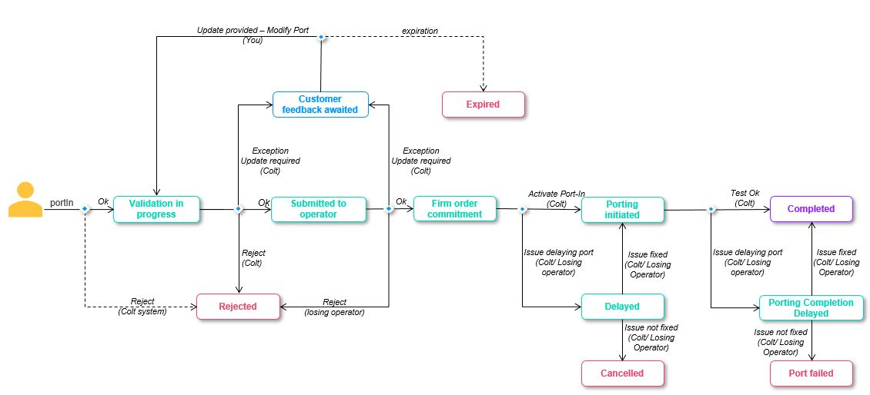

- Applicable in Austria, Belgium, Denmark, France, Germany, Ireland, Italy, Portugal, Spain, Sweden, Switzerland, United Kingdom, Czech Republic, Finland, Luxemborug, Norway, Poland, Romania, and Sweden (19).

How to port-in numbers
The Porting process and rules vary by country. Please check the Colt Voice APIs Service Matrix APPENDIX A and also www.colt.net/porting-information for information about porting process, documentation and lead time and country specifics.
Please note that after submitting a port-in request in Numbers on Demand, an Order ID is created in the ‘My Telephone Numbers’ section. Please check your Order ID for status updates of your port-in request.
For Belgium, there is a new optional checkbox ‘auto Portin’ in the Port-in request:
- If ‘Yes’ is passed in the request, then on the day of the port the request will be automatically picked up by our system for provisioning.
- If ‘No’ or it’s blank, then on the day of the port, the Colt porting desk will manually proceed to process the Port-In request.

To Port In numbers, go to the Port In page from the Quick Links menu:
- Select the customer type – business or residential (if applicable for the country)
- Enter the requested end-customer address information, which will be shown in the preview box
- Validate your end-customer’s address, which will check the address details you have entered . If an exact match for the address you have entered cannot be found then a selection of the addresses with the closest match will be provided to you to select from. If you still cannot see your required address then use the online help for support.
- If needed, you can add a second address following the same steps as outlined previously
- Once you have chosen the address, click on Provide Numbers to proceed
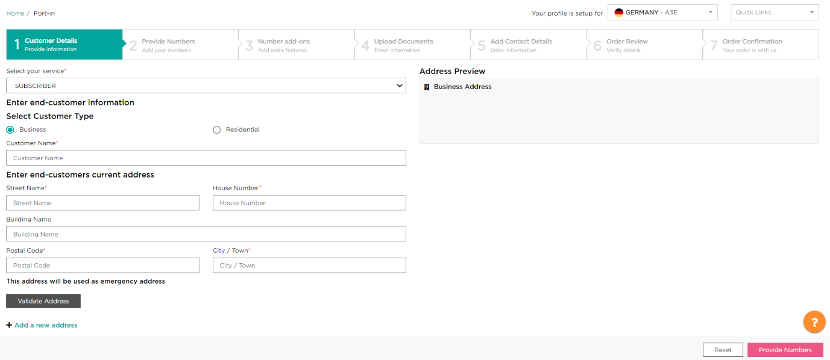
2
1
3
5
4
Next, you will need to input the numbers / number ranges you would like to port, which can be entered manually or uploaded with an excel file (.xls or .xlsx smaller than 5 MB), using the sample provided.

You must then validate your numbers and select which one(s) you would like to port-in using the checkboxes. Once you have selected them you can click on Number Enrichment to proceed.

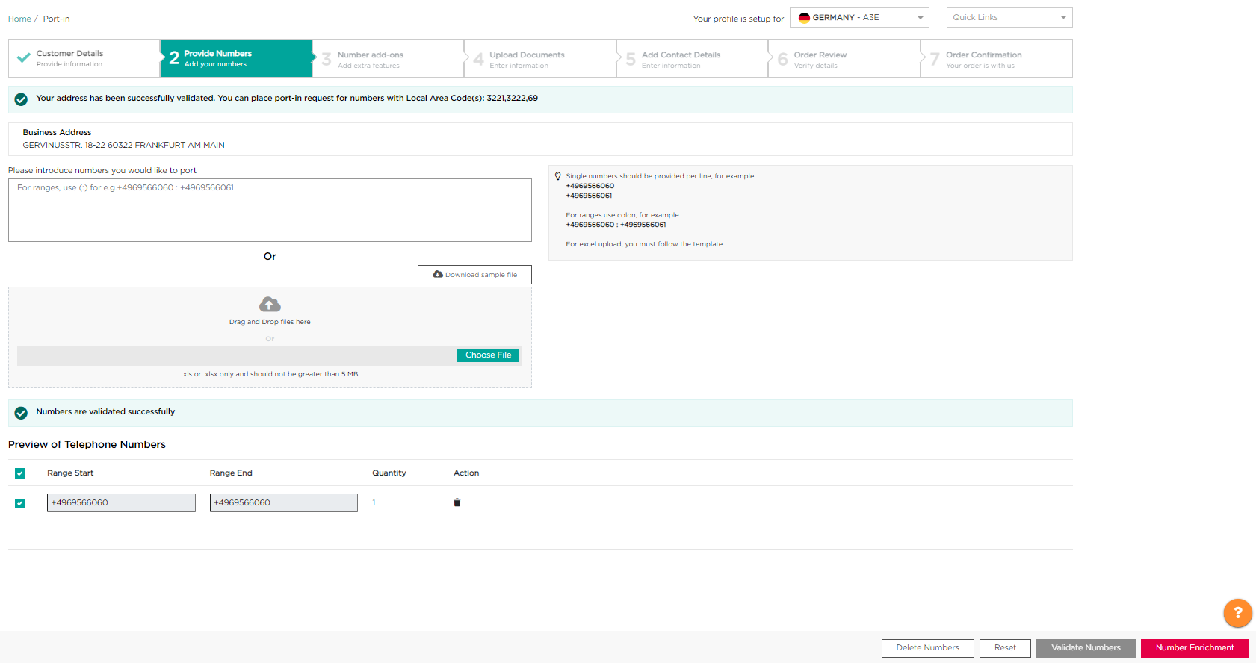

Next, you are able to add the Directory Service Update feature to your validated numbers if desired, by ticking the checkbox and providing the requested information.
Once this has been provided or if you do not need any additional features that are listed, you can click on Provide Porting Documents to proceed.
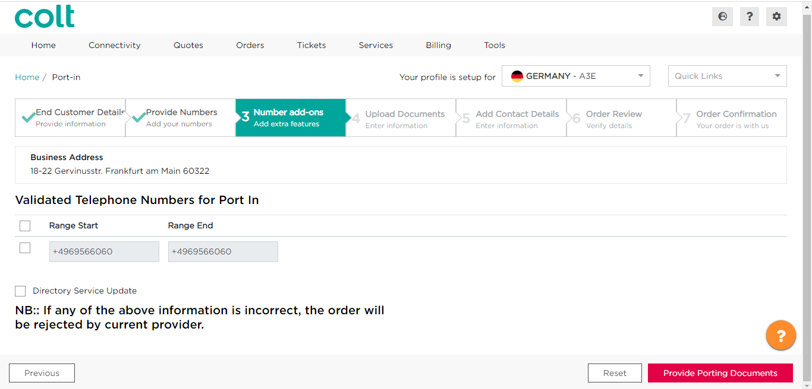

- You will need to provide the associated porting documentation by uploading it, or if you are unable to upload it then you can email it to the relevant email address provided, using your Order ID as a reference. The Letter of Authorization is mandatory to proceed, while the invoice document and any supplementary document you would like to share with the Colt porting desk are optional
- Select the desired porting date using the calendar, which displays the earliest porting date available based on the regulatory defined porting lead-times in a given country which allows you to choose a date.
- Choose the Porting Window from the list of times and the current operator from the available options in the drop-down list (if an OOH porting window is selected, then a message will be displayed to notify you of this and the implications for charging and availability).
- Click reset to clear the page if there are any changes needed, otherwise click ‘Provide your contact details to proceed’.
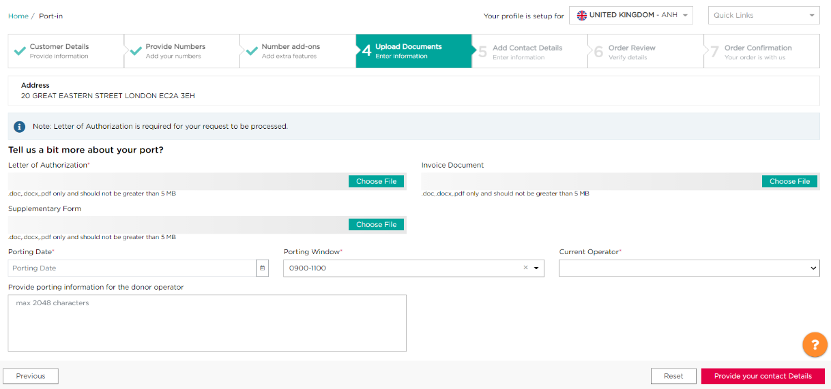

1

3
2

4

Next you must provide your or your team’s contact details, so that we are able to provide you with updates on your port-in request. You can pre-configure different email ids (up to 5) to receive port-in and port-out update notifications. You can either update this information on your own using ‘View Reseller Data’ functionality and click on the hyperlink of your service profile to edit, or please reach out to ResellerSupport.Voice@colt.net to modify the details for your service profile.
Once you have provided this information you can proceed to order review by clicking the ‘Review your Order’ button.
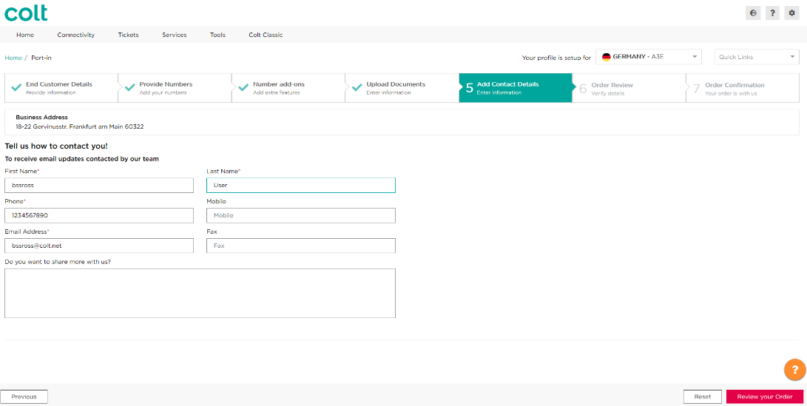

You will then be presented with a recap of your order, allowing you to review the address, porting details, contact details and number(s) you have provided. If you need to make any changes you can do so for each step by clicking on the numbered steps, and you can also add a customer reference which will appear in the My Orders summary page.
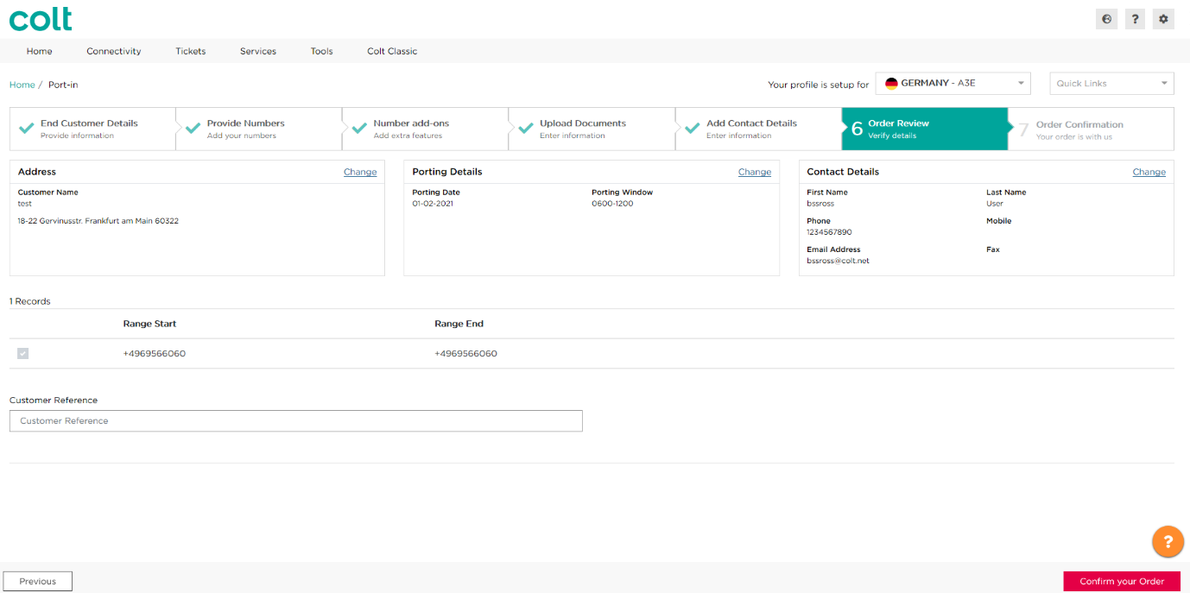
Once you are happy with your order, you can confirm it using the ‘Confirm your Order’ button.

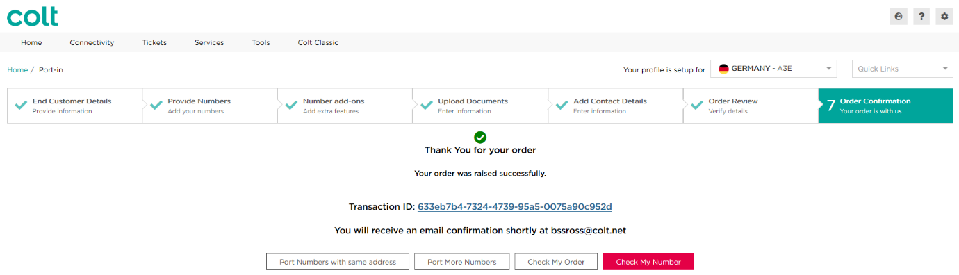
Once your order is confirmed, an email will be sent to the email address you provided in the port-in order. You will be provided with an Order ID, which you can check in the My Orders or My Telephone Numbers pages. You will also have the option to port more numbers immediately after this, either using the same address or a new address.

(i): in some countries, additional information is required, see APPENDIX A:
(ii): additional ranges can be added into the porting request by clicking the ‘add’ button. check APPENDIX A for maximum ranges per transaction. If you need to port more ranges, please use our API.
(iii): format varies per country, please check APPENDIX A for ‘number presentation’.
(iv): in some countries, porting might be subject to agreement with the losing carrier. Please check www.colt.net/porting-information for country status and list of providers with whom Colt has porting agreements.
(v): Please check APPENDIX A or www.colt.net/porting-information for country lead time. Please note that the date you have selected is not the final porting date. This will be confirmed by Colt Porting Desk. Date & Porting window are not applicable in the Netherlands.
(vi): Please check www.colt.net/porting-information for the porting documentation needed per country:
(vii): Directory Service Update service is an optional service you have to subscribe. Please check APPENDIX A for ‘Directory Service Update’ service availability.
Allowed characters: please check APPENDIX A.
The main billing number (also called Main Number) – Excluding DE and NL:
- This is a geographic number assigned by Operators to their customers against which their services (features) are built & billed.
- This is mandatory information which the porting team submits in the order to the losing provider for ‘port-out’ validation.
- This field will now accept only an E164 (+44XXXXXXX) number and the country code should match with the requested CLI country code.Note the main billing number will usually be one of the numbers within the number range. It may not be the same as the switchboard number.

On the Order Result page, you will find the order ID. To check the order status, please click on the order ID or go to My Orders page.
Number status: after port-in transaction completion, the number status is port in (activated).
The order ID is called the ‘original order ID’. Please always track the original order ID for the status update of your porting request.
It is your responsibility as described in the Number Hosting Service Description and Service Specific Terms (Colt’s contract with you) to provide accurate and up to date end-customer’ information in order to fulfil your & our regulatory obligations to ensure accurate and successful emergency call routing, Emergency Database (EDB) updates and Lawful Intercept requests.

Digital LOA (DLOA) Port-In process
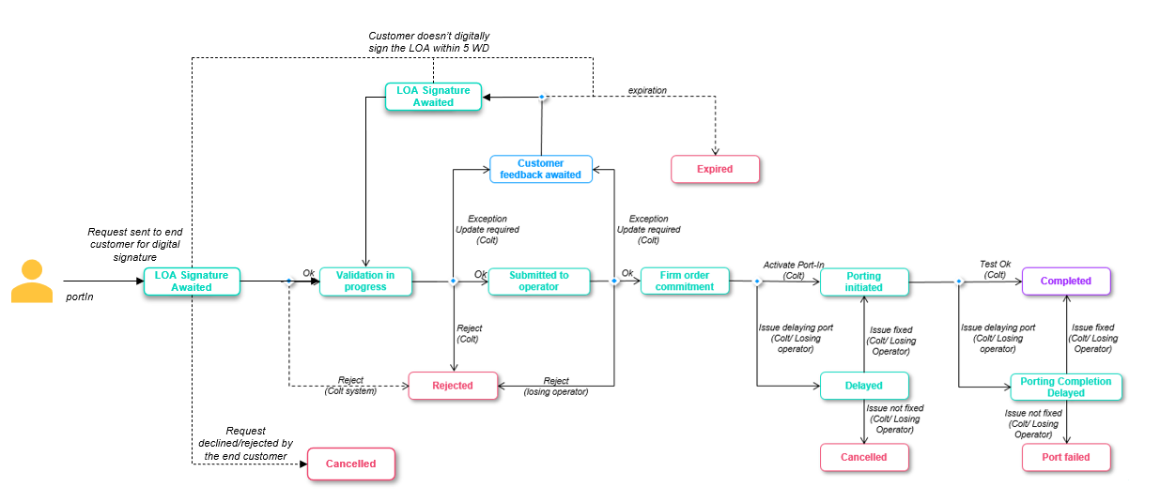

The digital LOA is an optional feature, which is an electronic version of the traditional Letter of Authorization for port in requests that will allow your end customers to electronically sign the LOA using Docusign. The DLOA is generated based on the information provided by you in the port-in order. We will then generate the DLOA with the information you have populated in the order and send it to your end customer who must then sign it digitally. The signed DLOA will then be stored against the port in order for future reference.

When you submit the portIn request with DLOA then
  - The request will move to ‘LOA Signature Awaited’ status which will be shown in the Order details
  - Your end customer will receive the port-in request for digital signature, using the end-customer’s email ID you provided in the port-in order.
The DLOA must be signed within 5 working days otherwise it will expire
  - If signed successfully, Colt will move the order to ‘Validation In progress’ status and our porting desk will receive the order for validation.
    - You will be notified by email regarding this
    - We will automatically update the porting date if we see that the porting date no longer adheres to the porting lead time (e.g. if the end customer is taking time to sign the DLOA) and you’ll find the details in the email notification and order details.
  - If the DLOA is not signed by the end customer and the link expires after 5 days, then the port-in order will move to ‘Expired’ status.
    - You will be notified by email regarding this
  - An end customer can also decline/reject the DLOA signature request from their end. In this case the port-in order will move to ‘Cancelled’ status.
    - You will be notified by email regarding this
The Porting Desk can put the order into ‘Customer Feedback Awaited’ status like today to get more details from you. If you update the telephone number (Add new numbers, modify/remove existing numbers) in the ‘Modify Port’ request, the request will again go to your end customer for DLOA signature and the order status will be ‘LOA Signature Awaited’.
The Digital LOA is currently available in the UK and France, and will be rolled out in future phases.
Belgium, Spain and Italy are targeted to be added next in the release of Nov’25

Sample emails
DLOA Signature:
- Email to reseller-
Subject line: Porting Letter of Authorization - Order ID : {orderId}
Email content:
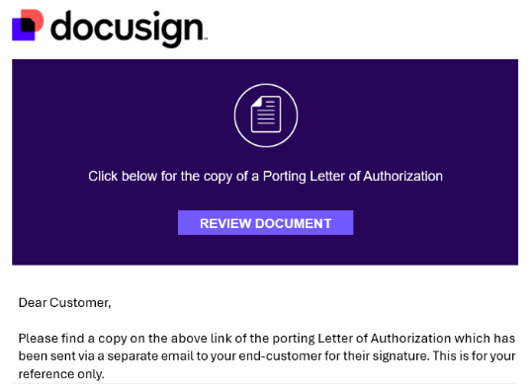
- Email to end customer-
Subject line: Porting Letter of Authorization - Order ID : {orderId}
Email content:
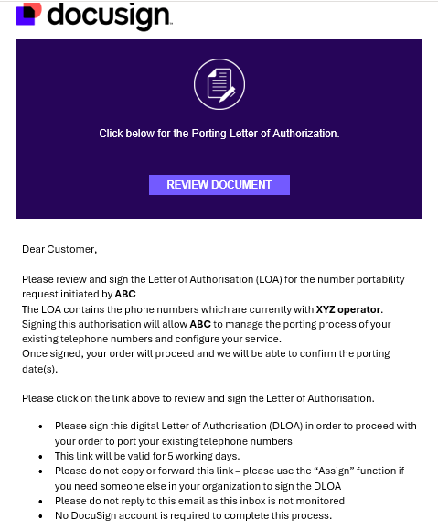

DLOA successfully signed by the end customer
- Email to reseller and end customer-
Subject line: Completed: Porting Letter of Authorization - Order ID : {orderId}
Email content:
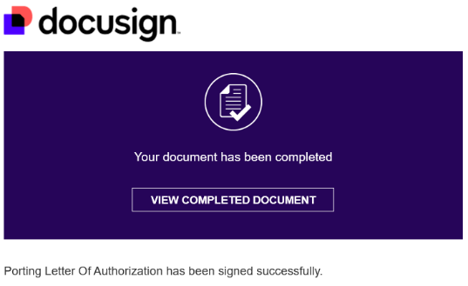

DLOA declined by the end customer
- Email to reseller and end customer-
Subject line: Declined: Porting Letter of Authorization - Order ID : {orderId}
Email content:
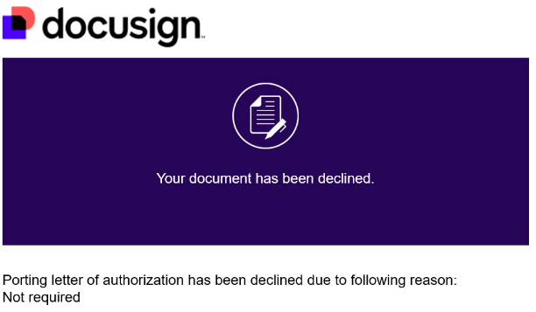

DLOA link expired after 5WD
- Email to reseller and end customer-
Subject line: Voided: Porting Letter of Authorization - Order ID : {orderId}
Email content:
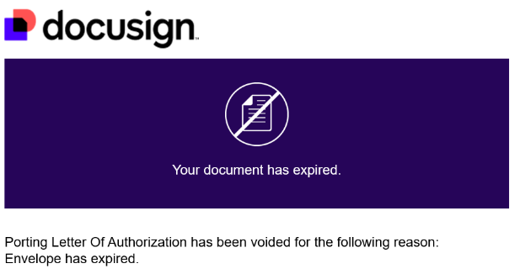

DLOA email and link
Email Link Expiry: Links in the email notifications will expire after 48 hours or after more than 5 consecutive clicks
If a link expires, the end customer/signee gets an option to ‘Send New Link’. The end customer/signee will receive a new email with the new link
DLOA expiry: The DLOA will expire 5 working days after it is sent to the end customer/signee. If the DLOA is not actioned by the end customer within 5 working days, the port-in order will be ‘Expired’ and the DLOA will also expire. An expired DLOA cannot be viewed or signed.
How the DLOA works is shown below:-
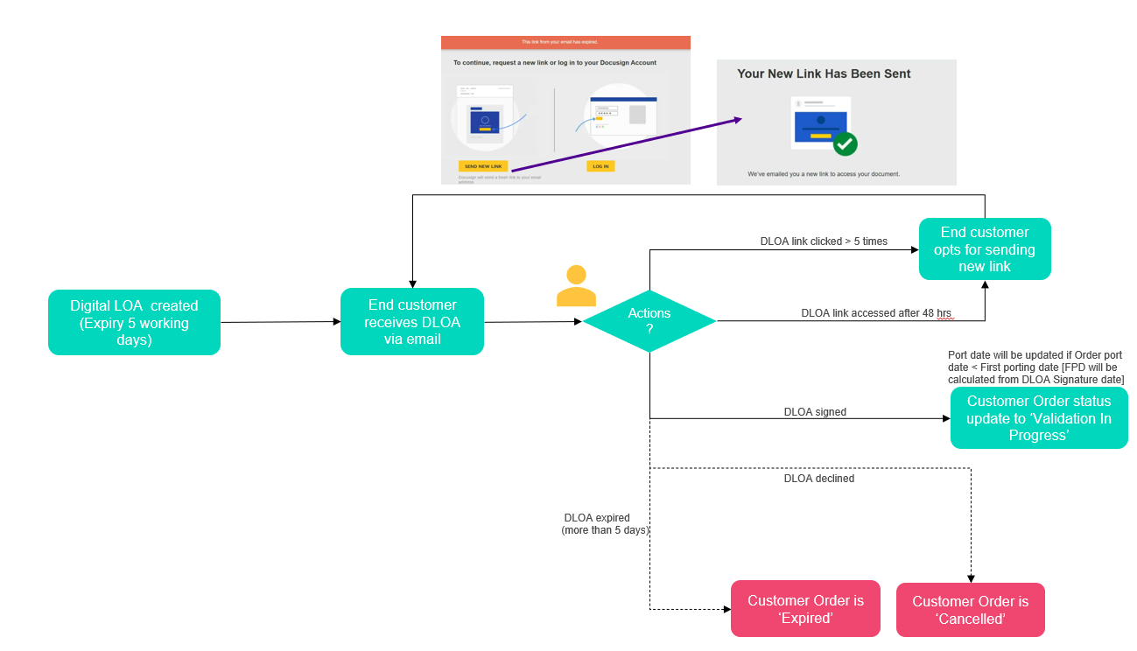

As previously stated, you can continue to use the manual process or use the new DLOA journey, with the differences in the porting process via the Port-in flow outlined below:

There is a new checkbox for the Digital LOA when adding the customer details for your port-in, which needs to be selected
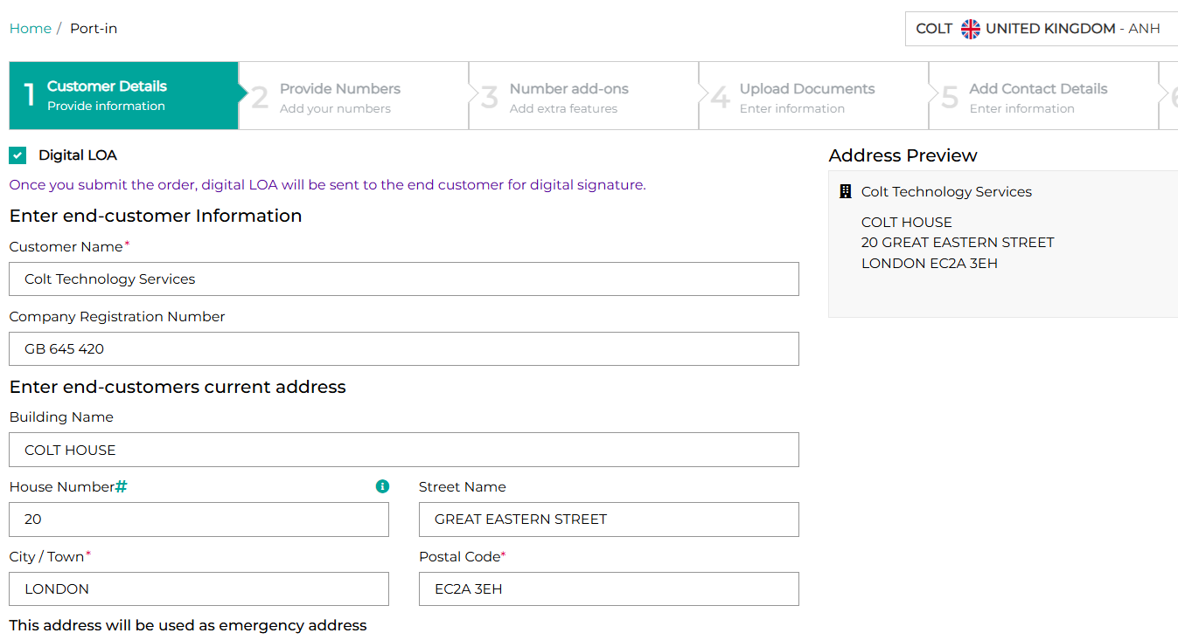
In the UK, you can then select if the Billing address is the same as the end customer current address or not:
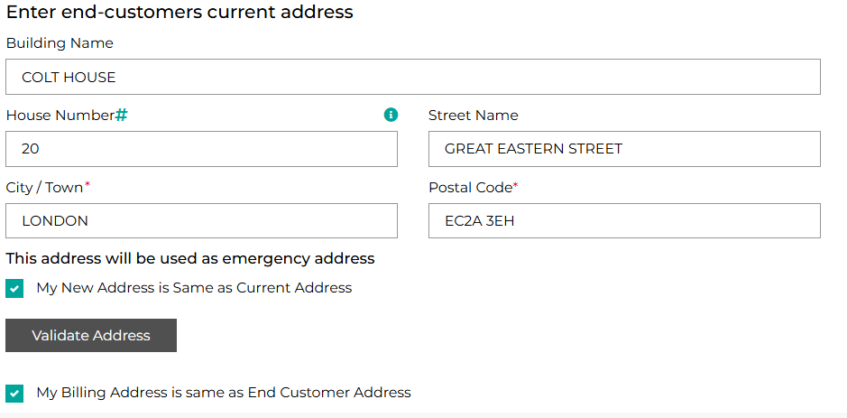

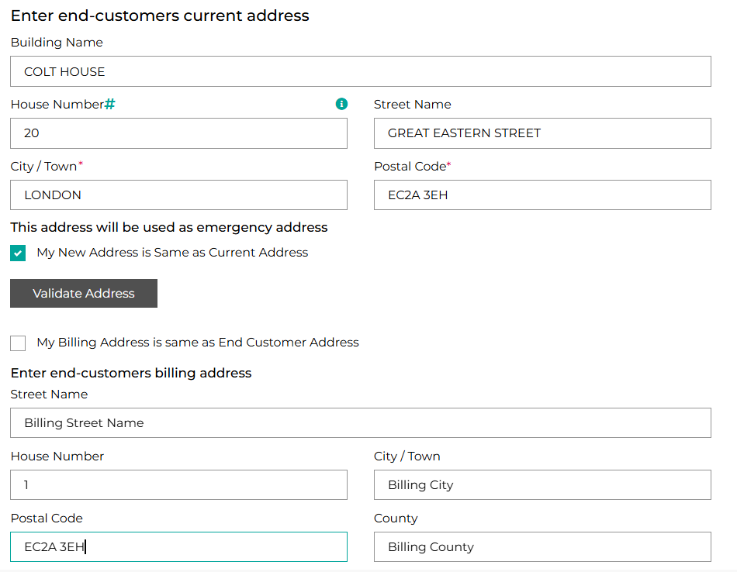
In the UK, for Geographic numbers, the Main Billing Number is required:
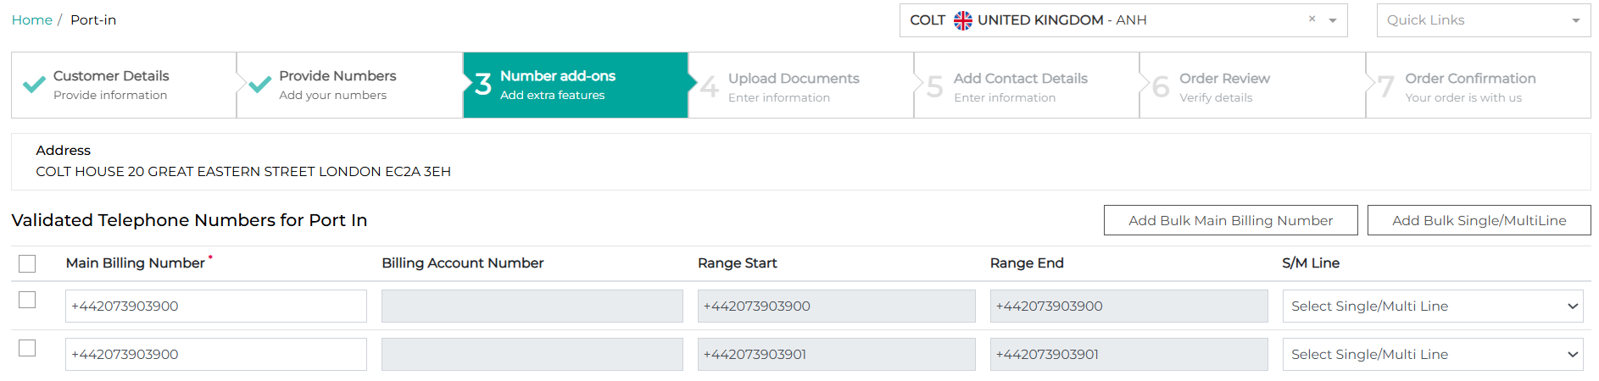
In the UK for Non-Geographic numbers, the Billing Account Number is required:
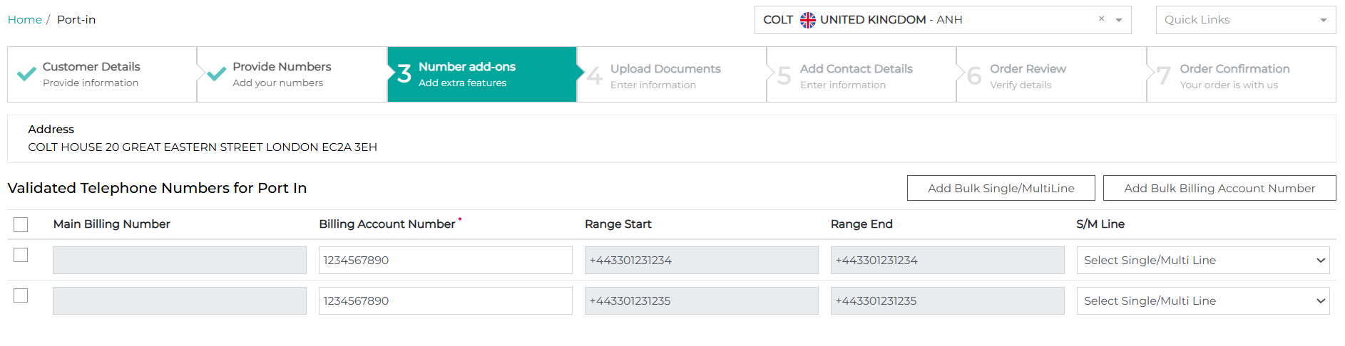

A combination of Geographic and Non-Geographic numbers are not allowed in the same request

Following this, a new field of ‘Operator Email Address’ is required:
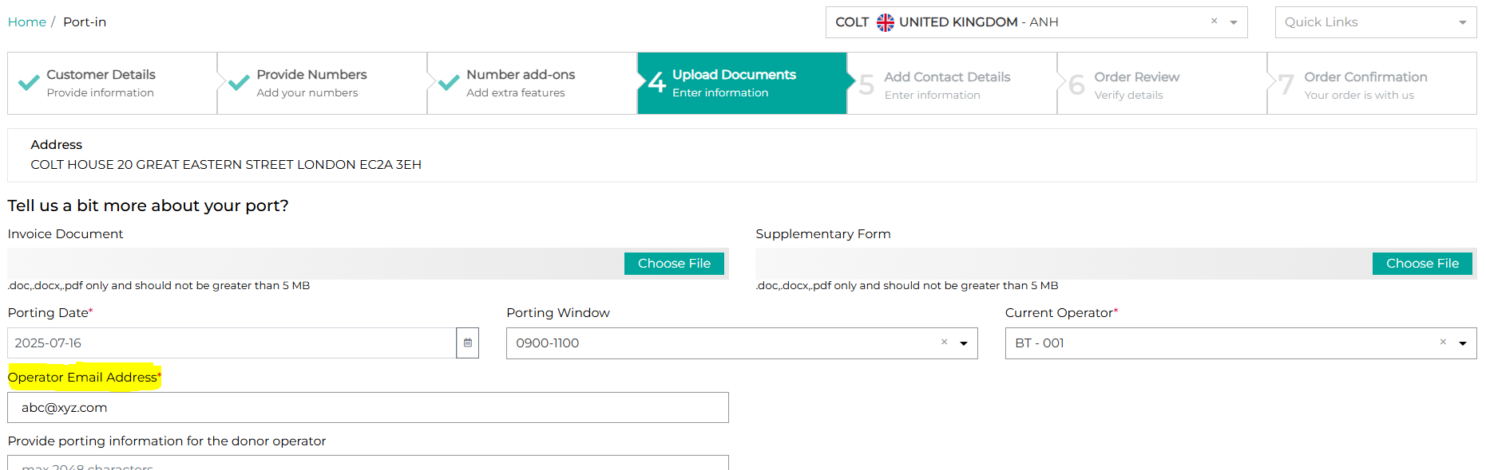

In France, there are new fields in the Number add-ons screen: Portability Type + RIO Code. The Main Billing Number will also be required at range level:
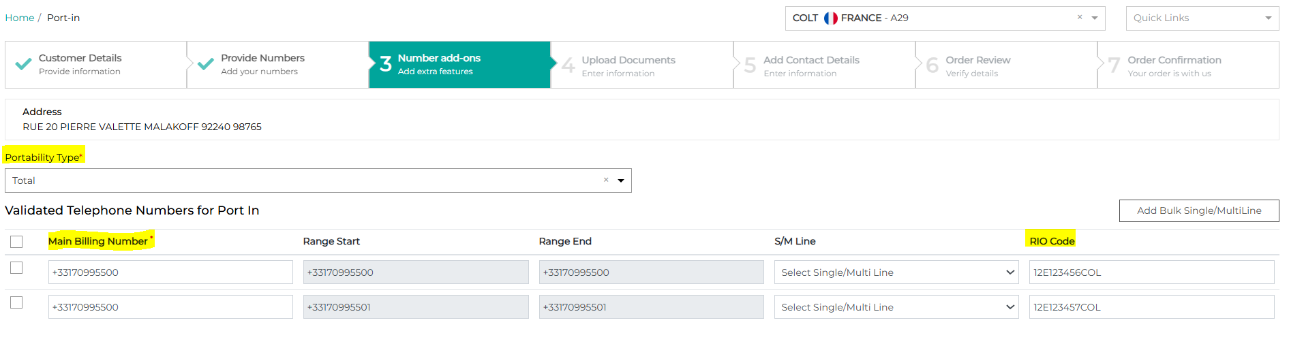

You will need to provide your details as the sender (which your end-customer will see) and also the details of your end-customer who is the recipient & signs the Digital LOA. Your end customer will receive the DLOA for signature via DocuSign- the email ID must be of the customer’s signatory because the docusign email cannot be forwarded on by the end-customer.

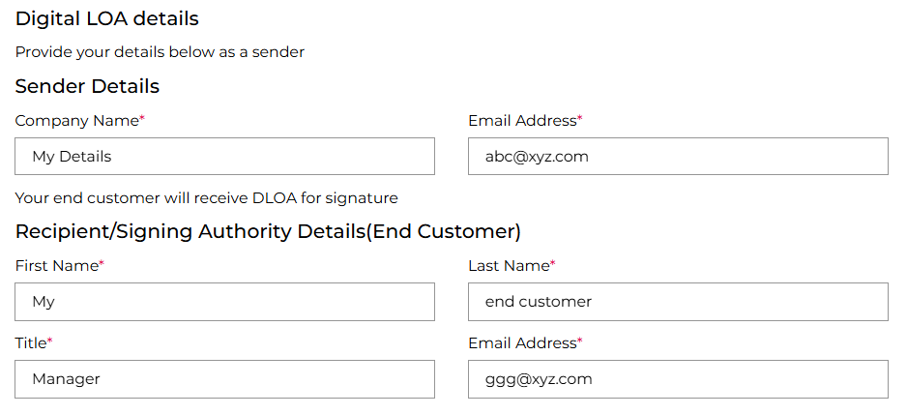

If you use the tri-party LOA in France, then an email will be sent to you and to your end-customer for signature.
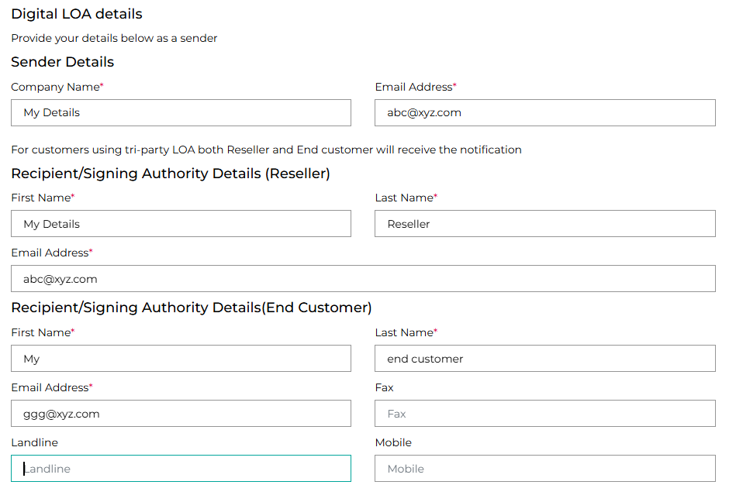

Your end customer will receive the Digital LOA and you’ll receive a copy of it. Your end customer then needs to open the link to review and sign the LOA.

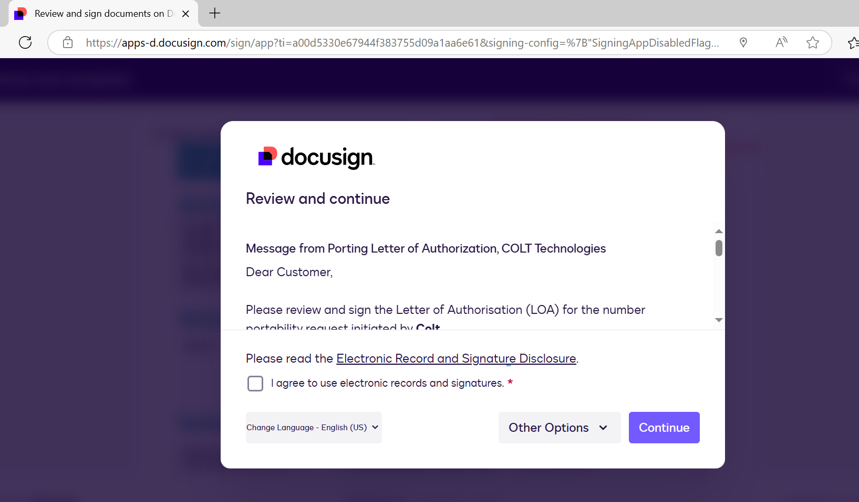

Porting order status
Port-In orders may indicate a different status to the number status described under My Telephone Numbers in an earlier section. Please find below the statuses applicable to port-in orders:
Order Status | Country | Description
Validation In Progress | All except NL (19) | Order validation is pending at Colt end. Status is applicable:  - As first status after order submission.  - After customer has provided additional, i.e. after ‘Customer feedback awaited’
Submitted to operator | All (20) | The order has been sent to releasing operator for port negotiation.
Firm order commitment | All (20) | Order has been confirmed by the losing operator with:  - The First Possible Date (FPD) in the Netherlands (usually within the next 48 hours).  - FPD is the soonest date numbers can be ported-in. It can be any day within the next 120 calendar days.  - Please note that an overall FPD will be returned for order with multiple ranges and different FPD.  - You can schedule the port (optional).  - Agreed port date & window in the other countries.
Ready for porting Initiation | NL (1) | Once the FPD is reached, order status will change automatically to ‘Ready for Porting Initiation’. You can initiate or schedule the Port within the next 90 calendar days.  Please note that order will automatically expire 90 calendar days after FPD if port has not been initiated. Email notification will be sent 10 days before expiration, every day until expiration.
Porting initiated | All except NL (19) | Port has been initiated by Colt.
Completed | All (20) | Port has been completed.  No further action possible.
Customer feedback awaited | All except NL (19) | Additional information are required by Colt and/or the releasing operator.  Please note order will expire after 72 hours if no update provided by customer.
Delayed | All except NL (19) | Port has been delayed. Colt will provide the reason.
Expired | All (20) | Order automatically expires after:  - 90 calendar days after the FPD if initiation has not been performed in the Netherlands.  - 72 hours for order in ‘Customer Feedback Awaited’ status (i.e. if you have not provided updates to the order) in the other countries.  No further action will be possible.
Cancelled | All (20) | Order has been cancelled. No further action will be possible.
Rejected | All (20) | Order has been rejected by Colt. Rejection code and reason will be shared.  No further action will be possible.
Porting Failed | All except NL (19) | The port has been rolled back to the releasing operator.  No further action will be possible.
Porting Completion Delayed | All except NL (19) | Order is in Porting initiated status and there’s a delay from the losing operator/Colt, which means the provisioning is completed from Colt but due to delays at the losing operator’s end/technical challenges at Colt’s end, the porting transaction is yet to be completed  QuickNote can be sent to Colt Porting Desk

Modify Port
You are able to modify your port when the order moves to the ‘Customer feedback awaited’ status. This includes, modify porting date, update main billing number, add new attachments, and more as shown in the below screen.

If you raise a duplicate port-in change porting date and port update (Action=’Modify Port’) request, then this will be blocked with an upfront error message

To access Modify Port:
- Go to My Orders page
- Enter the original order ID of the porting request you want to modify using the search feature or filter your orders to find those in the ‘Customer feedback awaited’ status
- Click the 3 dots in the action column and select Modify Port
You will then be presented with the below screen which has a summary of your order, and you can update the information in any of these fields.

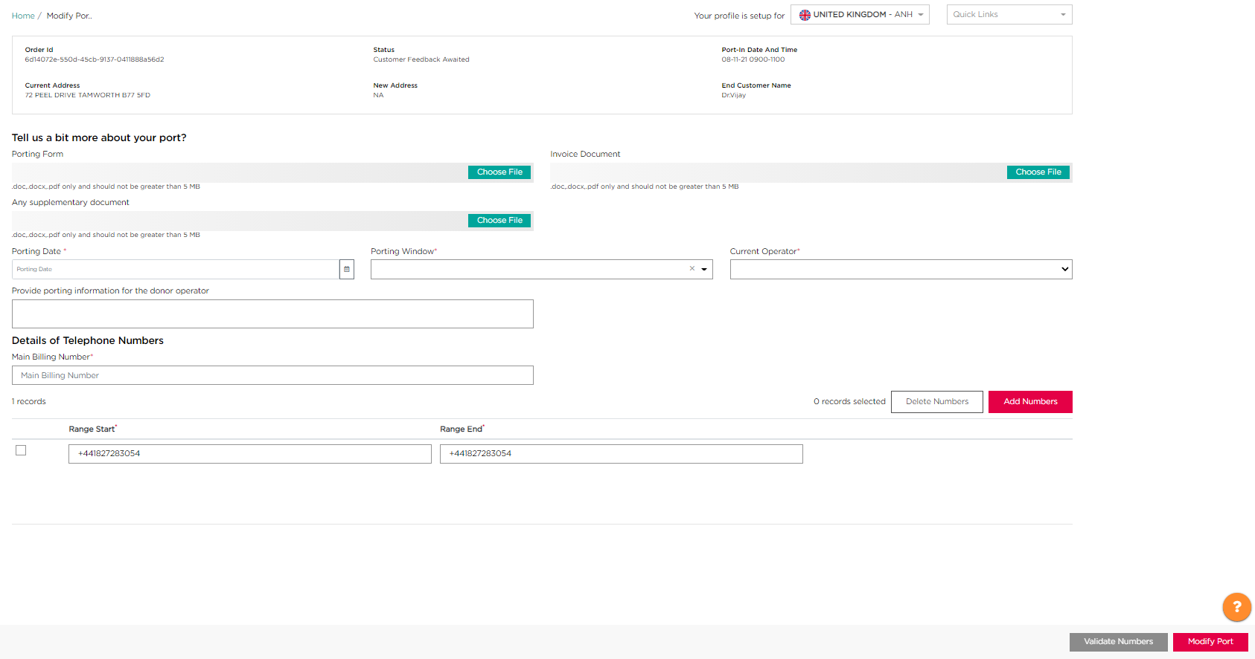

How to cancel a Port-In Request
Please check APPENDIX A for ‘Cancel port-in request’ service availability and the associated lead time.

To cancel a numbers port-in request:
- Go to ‘My Orders’ page
- Enter the original order ID of the porting request you want to cancel using the search feature
- Under the Actions column, click the 3 dots icon and select Cancel
You will then be presented with the below screen, to provide a summary of your order before you click Cancel to confirm your port-in cancellation.
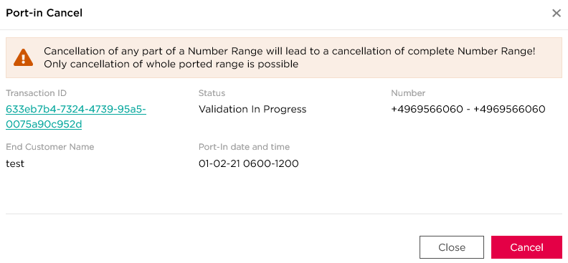
1
3
2

Once you have cancelled your order, you will receive confirmation this has been completed, and you will be presented with your order ID, which will be updated.

In the Netherlands, the ‘notes’ field is mandatory to be filled in to cancel a port-in

How to change a Port-In Date
Please check APPENDIX A for ‘Change port-in Date service availability and associated lead time.

To change a port-in date:
- Go to ‘My Orders’ page
- Enter the order ID of the port-in request where you want to change the date, using the search feature
- Under the Actions column, click the 3 dots icon and select Date Change
You will then be presented with the below screen, to provide a summary of your order and this allows you to change the port date and port time of your order.
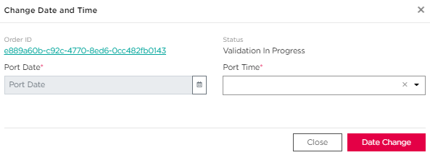

Once you have changed the date of your port-in request, you will receive confirmation this has been completed, and you will be presented with your order ID.

On the Porting Date
On the agreed date and time of the port-in, the steps below will be followed to port and activate numbers:
Country | Steps
Netherlands | - Colt will automatically initiate activation as soon as Customer initiates the Port. No call from customer is required.  - Colt will automatically contact the losing operator and get the numbers ported-in to Colt & then configure the numbers to customer service.  - When the Port-In is completed, the order status will be automatically changed to Completed. An automated notification will be sent to the customer.
Other Countries | - Colt Porting Desk will initiate activation on agreed schedule date and window. No call from customer is required.  - transaction status will be changed to Porting Initiated. An automated update will be sent to the customer.  - Colt Porting Desk will contact the losing operator and get the numbers ported-in to Colt & then configure the numbers to customer service.  - When the Port-In is completed, and test calls successful, transactionStatus will be change to Completed.  - An automated update will be sent to the customer.

Following successful completion of the porting, the parent order ID status will be updated to Completed.
If the porting fails for any reason, the parent order ID status will be updated to Porting Failed. A new order will be required.

How to deactivate ported-in numbers
?V
Quarantine period for ported-in numbers does not applies in all countries.
- In the countries without a quarantine period: numbers will be returned immediately to the number range owner after deactivation (no reactivation is possible).
- In the countries with a quarantine period: numbers can be reactivated during the quarantine period. At the end of the in the quarantine period, numbers will be returned immediately to the number range owner..
Please check APPENDIX A for ‘port in quarantine period availability and duration’.
When a deactivation request is in progress then no further action is allowed for the same full/partial range (e.g. actions like address update/ port-out/ duplicate deactivation will fail)
There is a new error message "There is already an order in progress for the number xxxxxxxxxxxxx" (The number/s which are duplicate in the new request will be displayed)
A new number status 'Deactivation in progress' will be available on 'My Telephone Number' Page under the 'Number Status' column.
No action can be taken via My Telephone Number Page if the number is in 'Deactivation in progress' status.
This new status 'Deactivation in progress' will be also be available in the Number Report.
Only for NL- If a port-out request comes in for the same partial/ full range for which a deactivation/ port-in deactivation request is in progress, the port-out request goes on hold and resumes (i.e. goes to Customer Feedback Awaited (CFA) status) immediately after the port-in deactivation is completed (i.e. the number status becomes port-in quarantine).

To deactivate Ported-in Numbers, you must go to the My Telephone Numbers page:
- Using the filter icon, set the Number Status to PortInActivated and click Apply
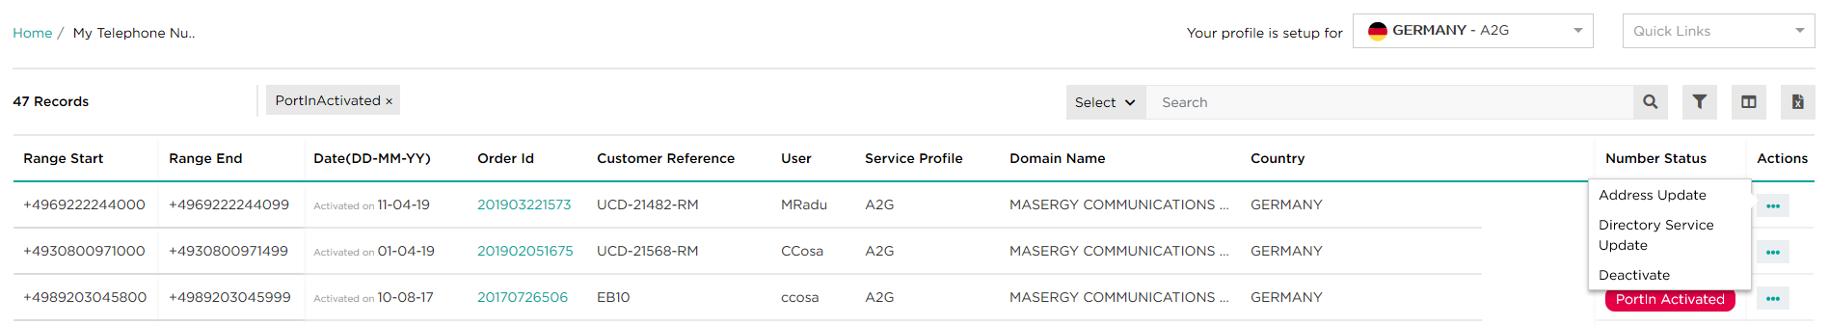
- Select the three dots under the Actions column next to the numbers you want to deactivate.
3
1
2
- Click the Deactivate button.

(i): please check APPENDIX A for ‘port in (activated) number partial deactivation’ service availability.
(ii): Directory Service Update service is an optional service you have to subscribe. Please check APPENDIX A for ‘Directory Service Update’ service availability.
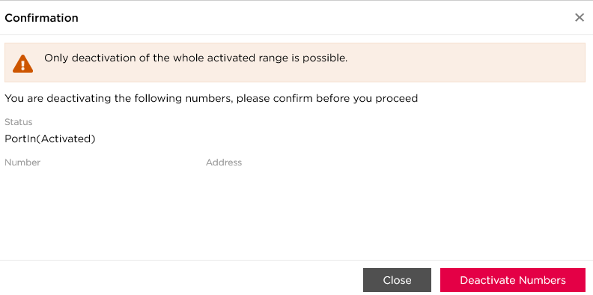
You will then be presented with a confirmation screen to verify if you want to deactivate the whole range, showing the number status, number, and address of the Order ID.
Click the Deactivate Numbers button to confirm the deactivation.

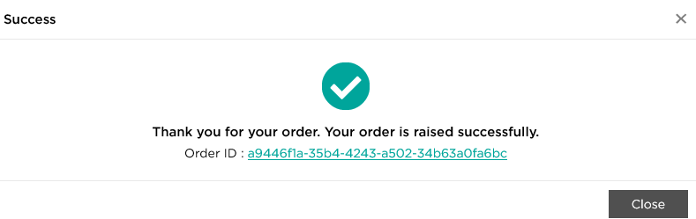
When this has been completed you will be presented with the below completion screen, and you can view the update to your order by clicking on the Order ID.

Number status:
- If Quarantine applies: numbers are in Port In (quarantined). They can be reactivated only by you during the country quarantine period, for the same end-customer and at the same address. After the quarantine period ends, they will be Returned to the range owner and cannot be reactivated by you nor Colt.
- If Quarantine does not apply: numbers are returned to the range owner and cannot be reactivated by you nor Colt.

How to reactivate ported-in numbers
Only Port In (quarantined) numbers can be reactivated, for the same end-customer, at the same address.

To reactivate Ported-In quarantined Numbers, you must go to the ‘My Telephone Numbers’ page:
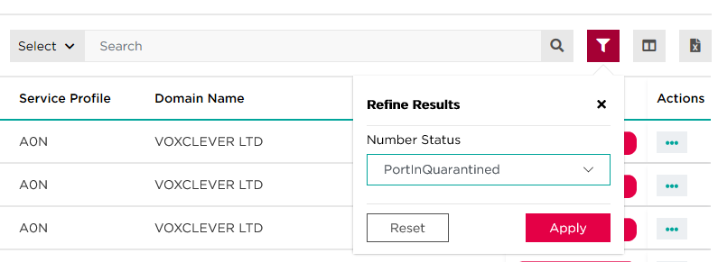
- Using the filter icon, set the Number Status to PortInQuarantined and click Apply

Once the filter is applied, you then need to:
- Select the three dots under the Actions column in front of the numbers you want to reactivate.
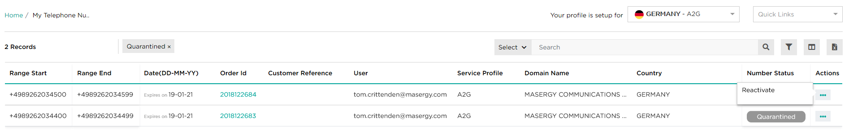
- Click the Reactivate button.
2
1

You will then be presented with a confirmation screen to verify you want to reactivate the whole range, showing the number status, number, and address of the Order ID

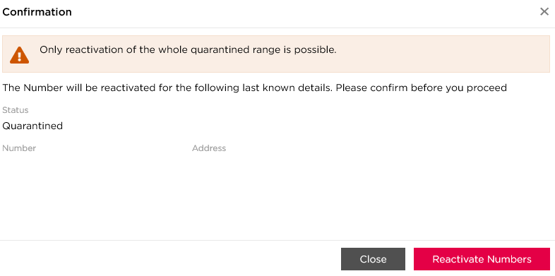

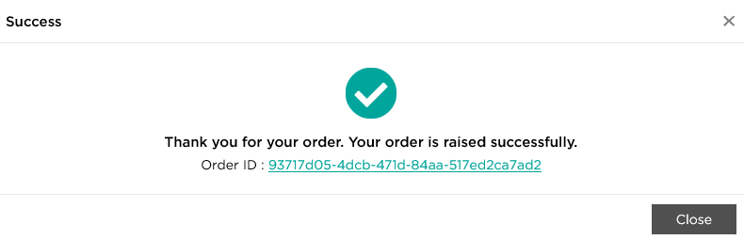
When this has been completed you will be presented with the below completion screen, and you can view the update to your order by clicking on the Order ID.

Pre-Order Validation (UK Only)

We have enabled the ability in the UK for you to formally request a pre-order validation check of your port orders via Numbers on Demand
- Once the order is submitted to the losing operator, they have up to 5 working days to respond, and in case of delays, Colt’s UK Porting desk will follow-up with the operator using the existing channels.
- Any POV order requiring manual intervention will be treated in a similar manner as we handle BAU porting orders.

- Select Pre Order Validation the ‘Quick Links’ menu
- Provide the End Customer Name, Main Billing number, and the numbers you would like to have pre-validated
- Validate the numbers
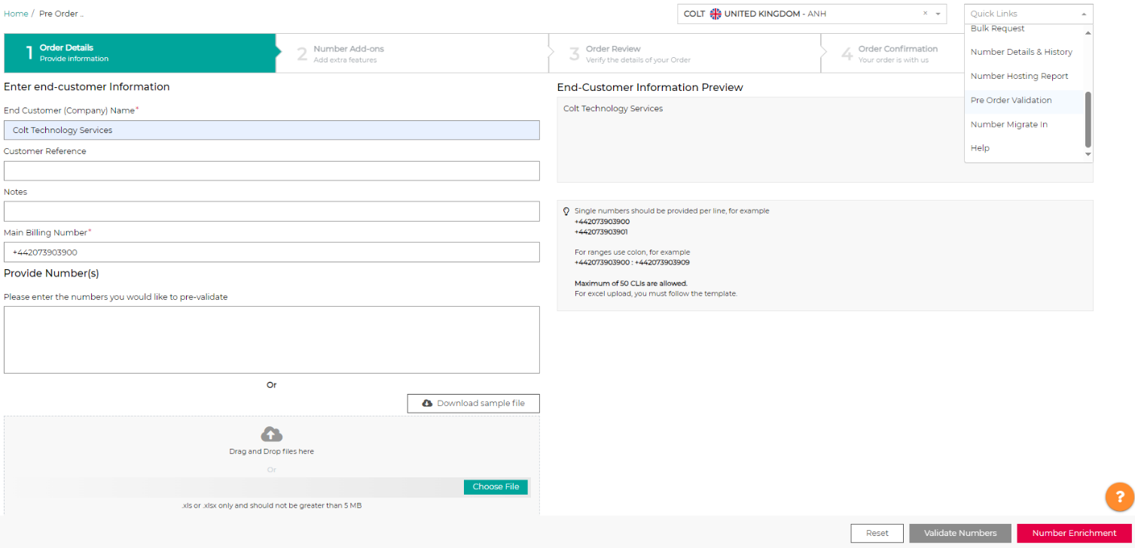
3
2
1

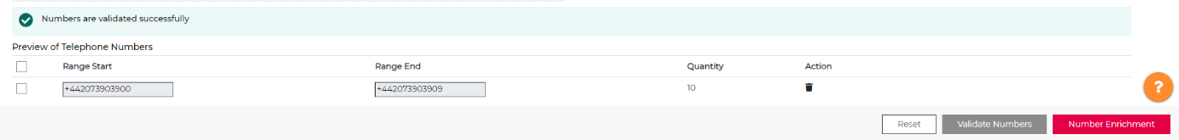
- Once the numbers are validated, select ‘Number Enrichment’ to move onto the next step

      - Provide the signed LOA and select the current provider from the drop list
      - Click ‘Review your Order’ to proceed to the next step

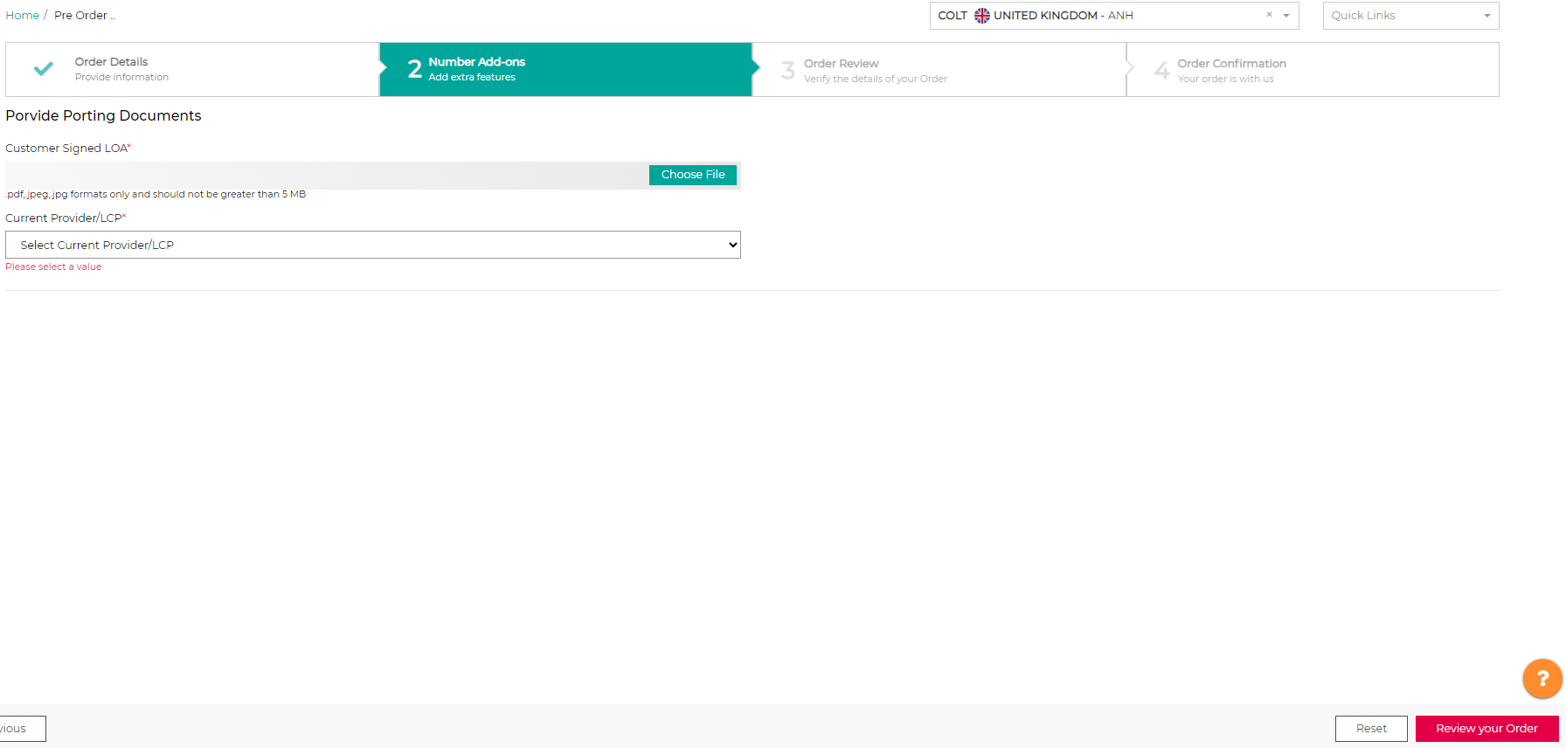
1
2

Review your pre order validation request details, and when click ‘Confirm your Order’

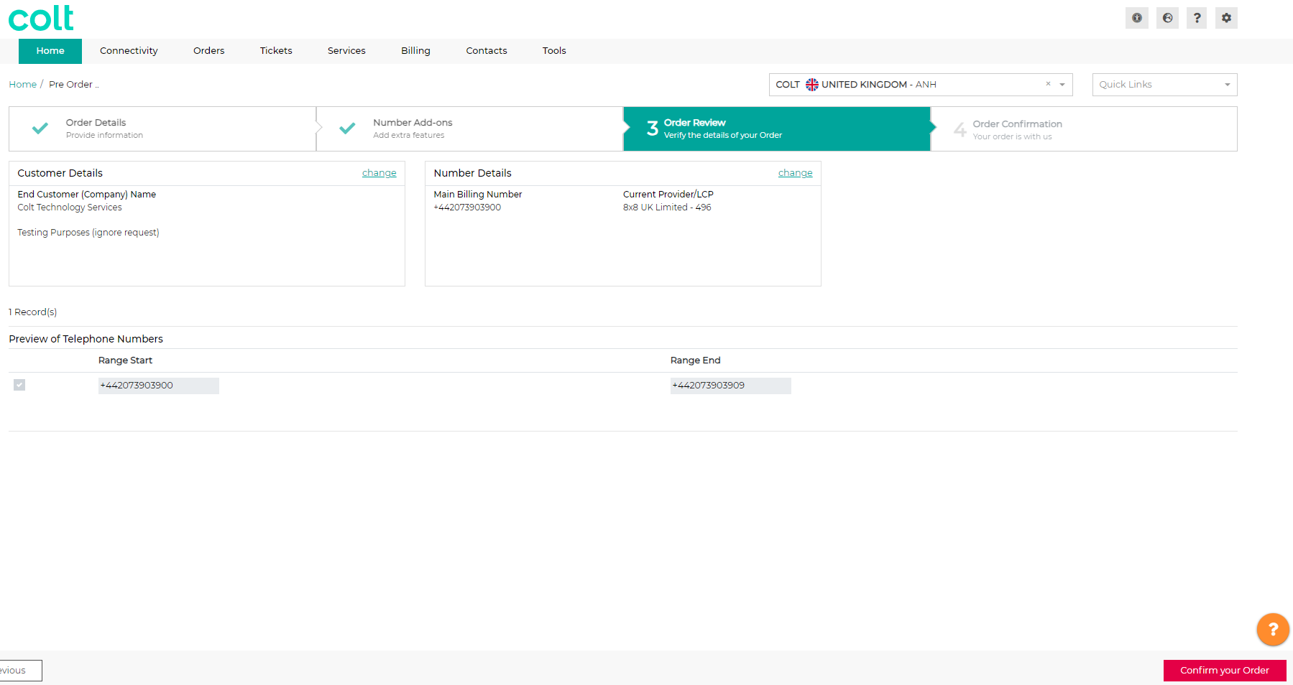

You will then be provided an order ID to confirm the successful completion of your request, which you can find in the My Orders page

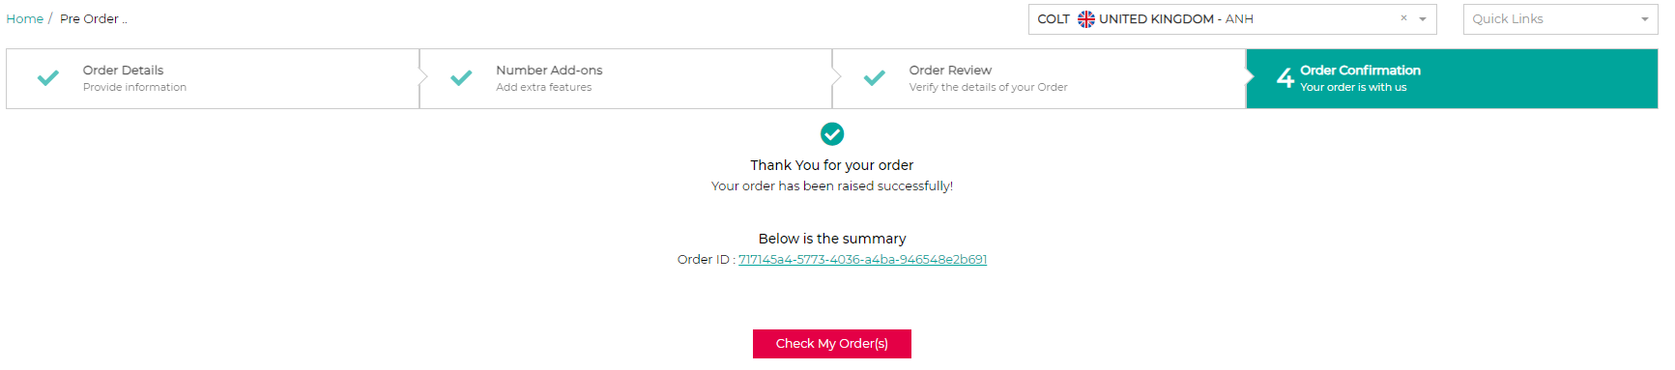

Your request will then be ‘auto-submitted’ submitted’ via email to the listed losing provider and upon receiving the response from losing providers, Colt UK Porting team will manually share the feedback to you via the NOD portal, which you can track through your order ID

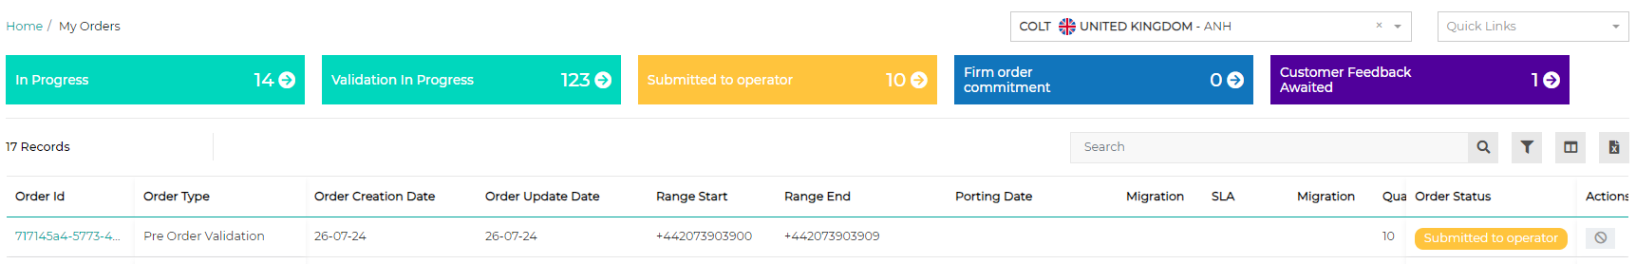

Address Update
Address update is available for activated (Colt and ported-in) numbers.

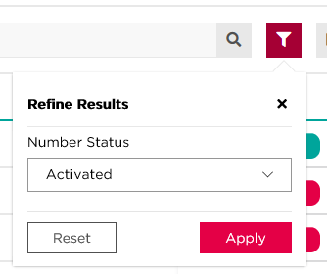
To update an address, from ‘My Telephone Numbers’ page:
- Filter the Number Status to Activated or PortIn Activated, then click Apply:
- Click on Search.
Once the results are listed:
- Select the three dots icon next to the numbers where you want to update the address. You can only do this for one range / one row at a time.
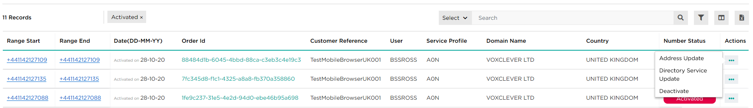
- Select the Address update button.
2
1

Then you must enter the new address in the required fields which you want associared with the selected number/number range.

- Once you have entered this then click the Validate Address button
- Select the appropriate address that is listed
- Validate your request by clicking on Update Address
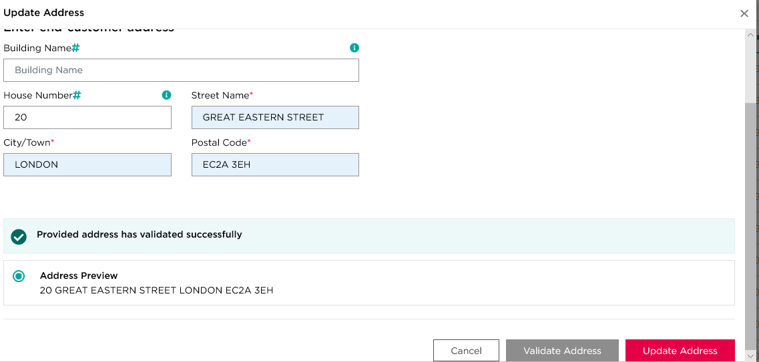
2
3
1

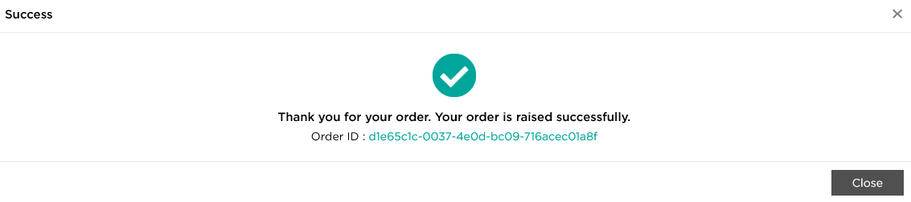
Once confirmed, you will be presented with the screen below to show the success of your address update, and you can check the update using the Order ID.

In Austria there is a private numbering plan. If your customer wants new geographic or location independent numbers, then you only need to reserve & activate one number for them. This single number can be extended by your customer into a range of 0-9, 00-99 or 000-999 numbers.

(i): same information as Number Activation is required. Please check How to activate reserved numbers section for additional information.
It is your responsibility as described in the Number Hosting Service Description and Service Specific Terms (Colt’s contract with you) to provide accurate and up to date end-customer’ information in order to fulfil your & our regulatory obligations to ensure accurate and successful emergency call routing, Emergency Database (EDB) updates and Lawful Intercept requests.
- Numbers status: numbers are still activated, only address has been updated.
- It is allowed to update address part of an activated range if you have the premium offer. If you do not have the premium offer then the address update will be for the whole range.
- Allowed characters: please check APPENDIX A.
- Please contact ResellerSupport.Voice@colt.net, if you need address detail for activated numbers.

Bulk Operations
Bulk Activation and Bulk Port-in is available for all countries except Austria
Bulk Address Update is available in all countries.
Partial address update is available for all countries except DE, AT, CH, IT and FI
Bulk operations currently have a maximum limit of 20 orders in one request

To access Bulk Operations, you need to select ‘Bulk Request’ fromm the Quick Links menu, and then choose which request you would like to proceed with.

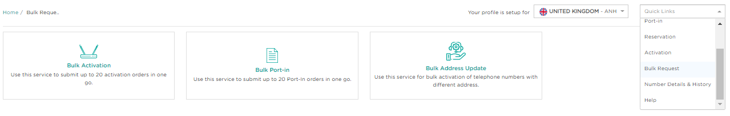

Bulk Activation
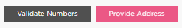
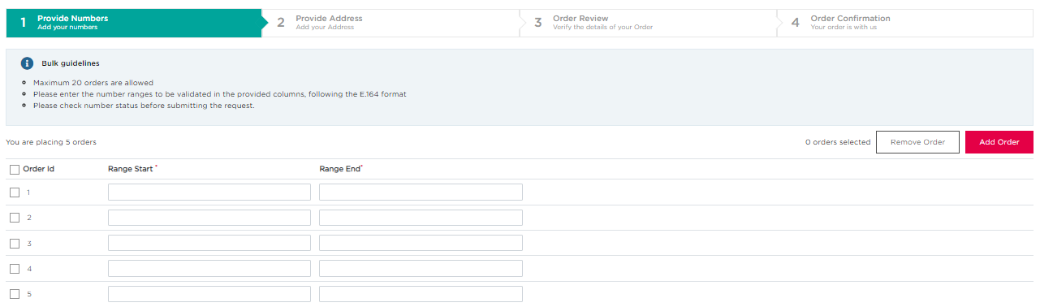
To begin Bulk Activation, you need to provide the numbers you want to activate
1
4
3
2
1

- You can add orders by clicking the ‘Add Order’ button, or remove orders by highlighting the orders you want to remove (by using the tick boxes next to the orders) and then clicking ‘Remove Order’
- Enter the number ranges you want to activate for each order, starting with the country code (‘+..’ and then the numeric digits)
- Once all the required information is entered, then validate your numbers using the ‘Validate Numbers’ button
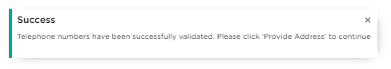
- Once successfully validated, you will see the following message in the bottom left corner of your screen:
Then you can click the ‘Provide Address’ button to proceed
Next, you will need to add an address for each number range to be activated, for this there are 2 methods, you can addresses individually or in bulk

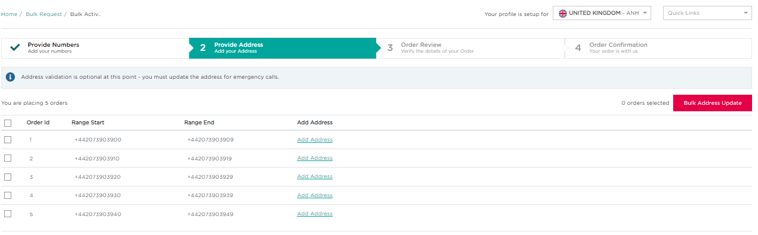

Individual addition:

To enter an address for an individual order, you need to:

- Click the ‘Add Address’ text in the row of the order you want to add the address for
1
You will then be asked to enter the address information, per the standard flow in Numbers on Demand, you will add the customer name, address, and Directory Service information (please refer to the Number Activation flow for further details on this).

In NL for example, you can also add more than one address.
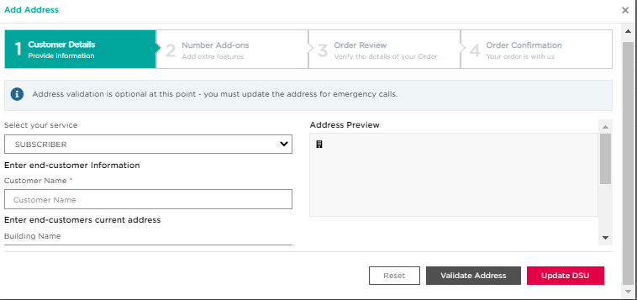

Once this flow is completed, the entered address will be added to the selected order.

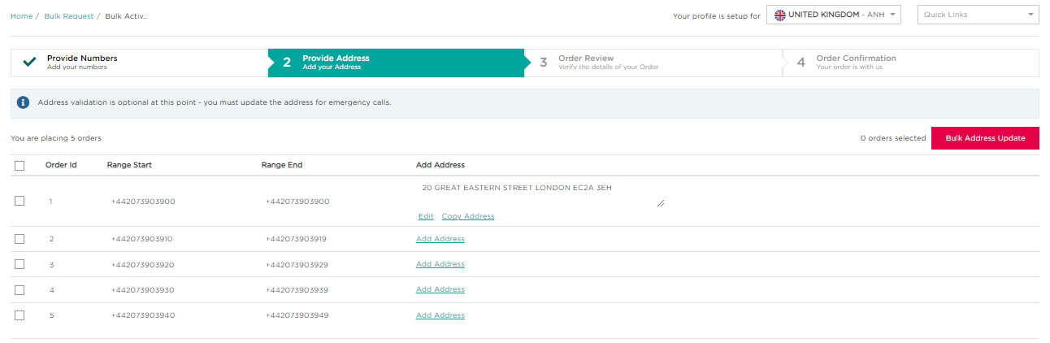

Bulk addition:

To add addresses in bulk, you need to:

- Tick the orders you want to add the same address to
- Click ‘Bulk Address Update’

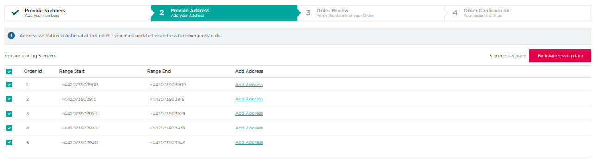
1
2
You will then be asked to enter the address information, per the standard flow in Numbers on Demand, you will add the customer name, address, and Directory Service information (please refer to the Number Activation flow for further details on this).

In NL for example, you can also add more than one address.

Once this flow is completed, the entered address will be added to the selected orders.

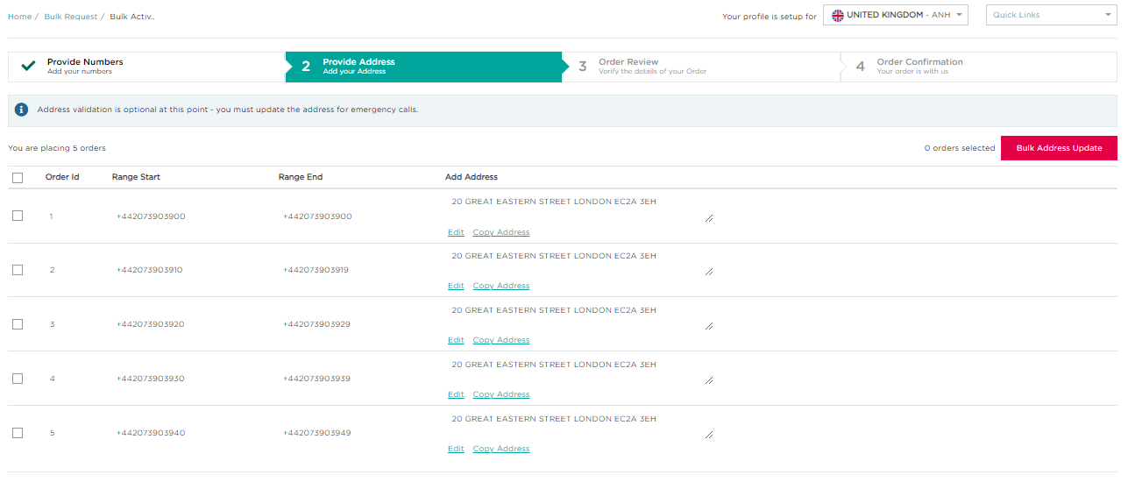

Editing an Address

After you add an address to your order(s), you have the capability edit the address you had inputted.

- You can edit an address by clicking the ‘Edit’ button for the selected record and updating the address information per the standard flow
- You can change multiple address by checking the tick boxes for the orders you want to change the address of

- Then click ‘Bulk Address Update’ and complete the flow to change the addresses of those chosen orders

3
2
1

Copy and Pasting an Address

There is also the ability to copy an address from one order and paste it to another

Copy and pasting an address is not available for Italy

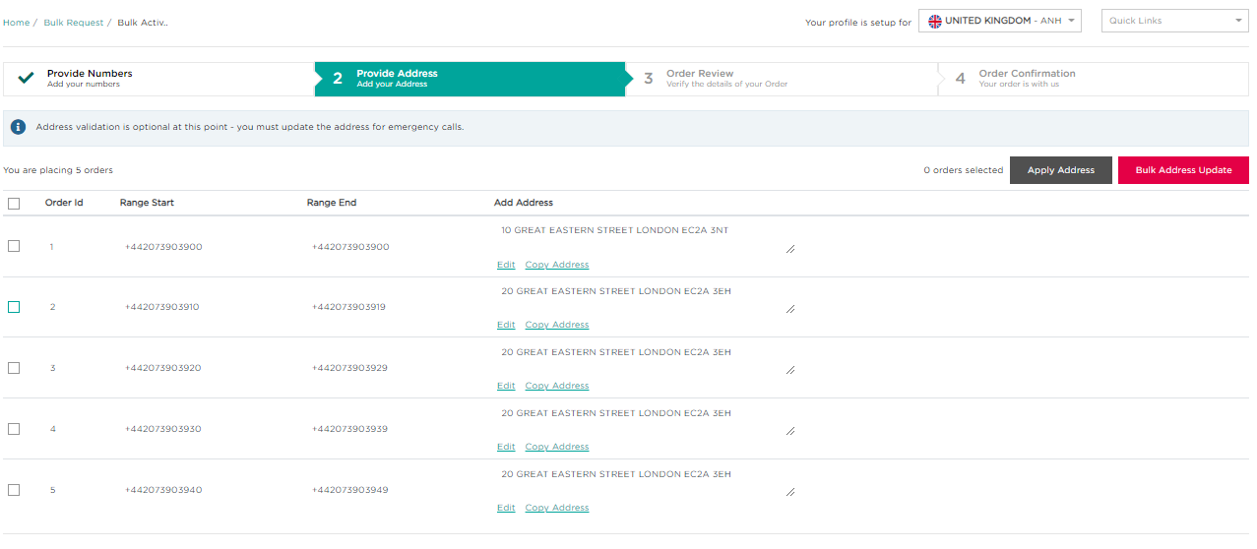
- Click the ‘Copy Address’ text for the order you want to copy the address of
1

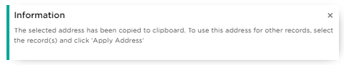
You will see this message on the bottom left of your screen to confirm the chosen address has been copied
- You will then need to check the tick box for the order(s) which you would like to paste the copied address to

- Then click the ‘Apply Address’ button to paste the address to the selected order(s)

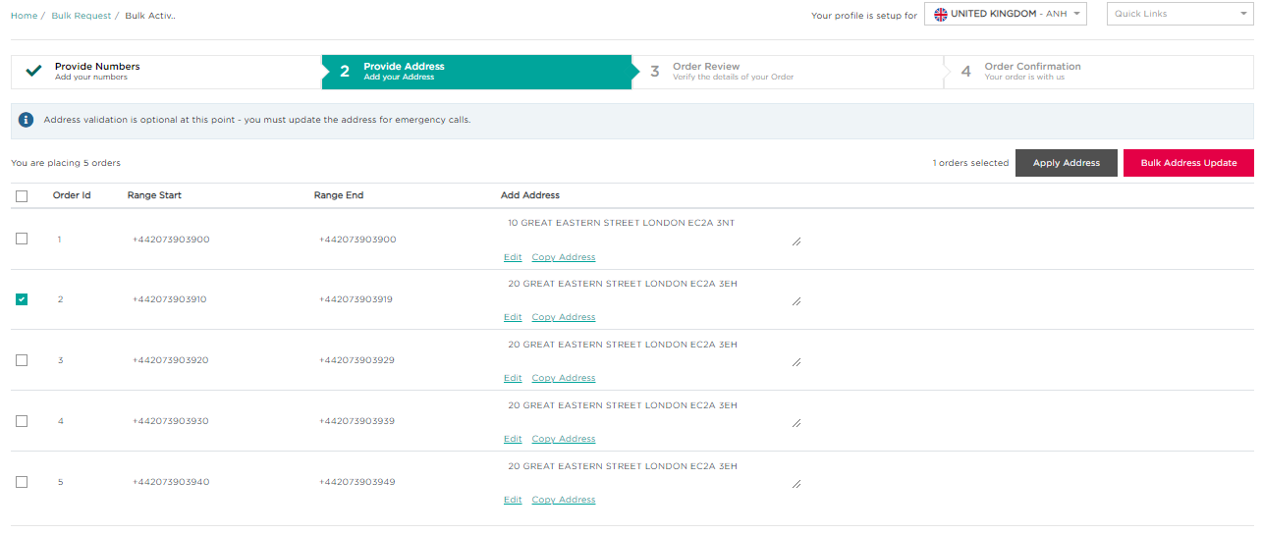
2
3

Your address will then be pasted into the selected order, and you will see the change on the screen

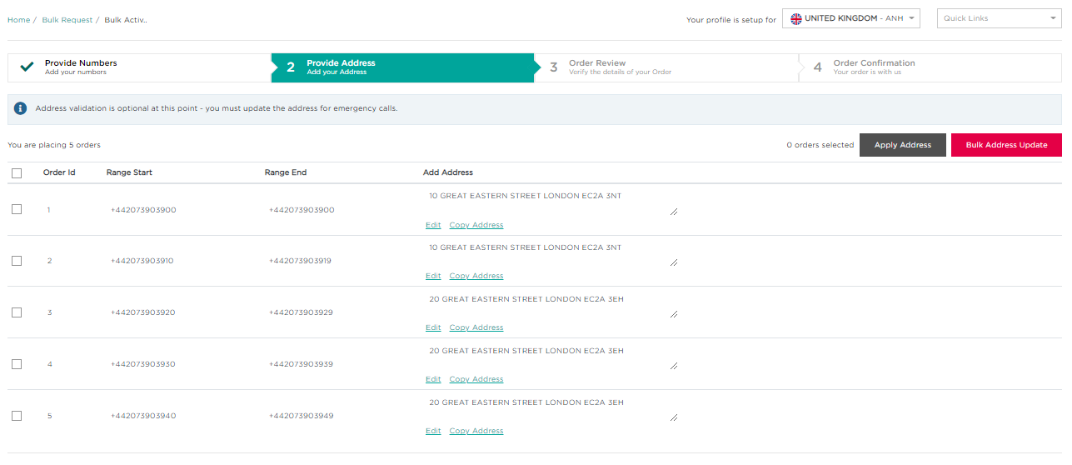

Once you have finalised your address, click ‘Order Review’ to proceed.
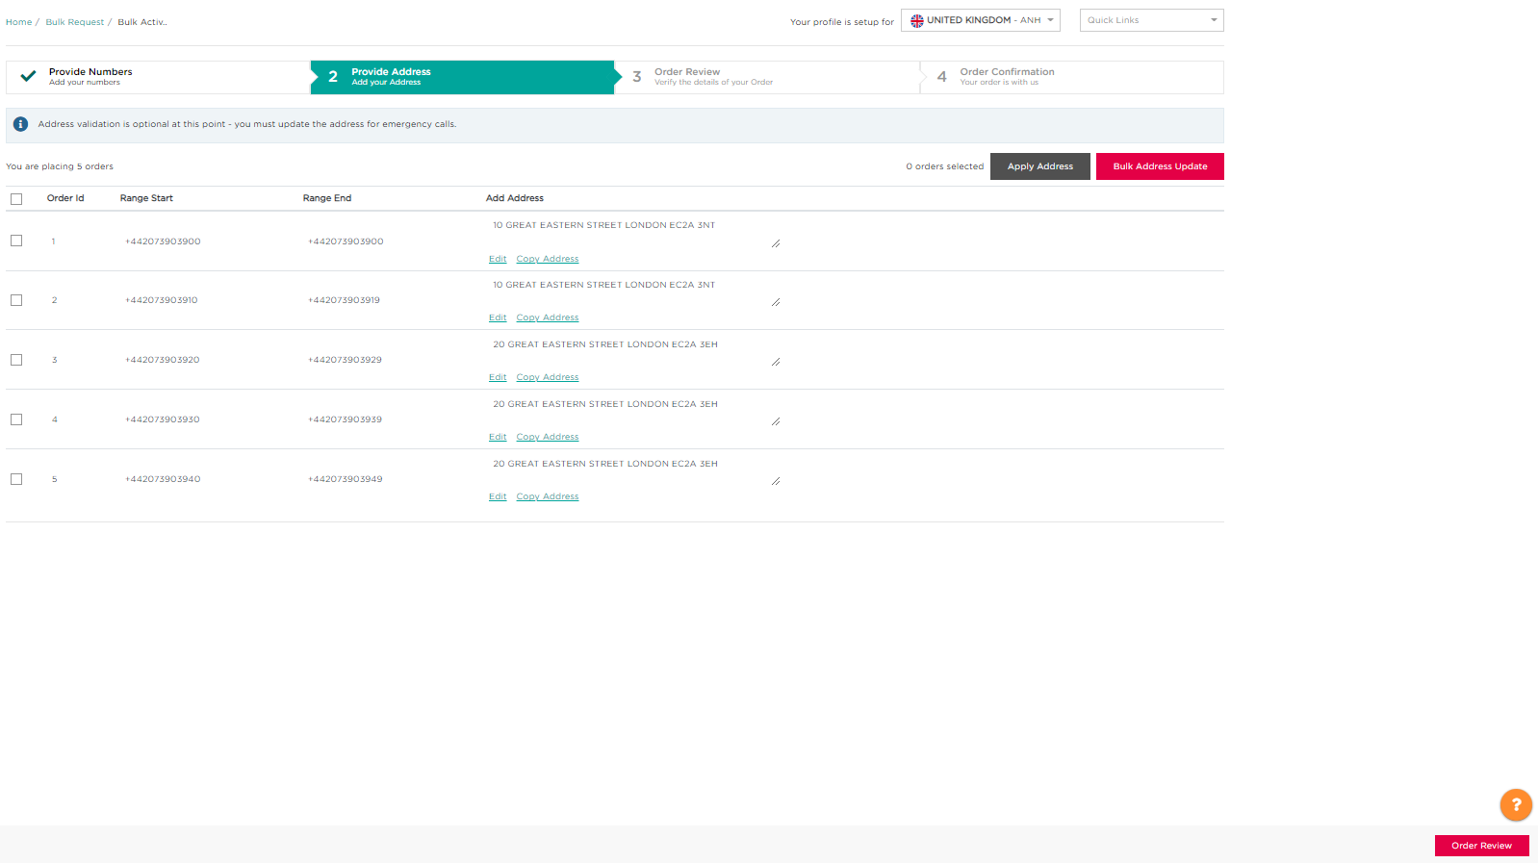

On the Order Review page you are shown a summary of your order, and can also add a reference to your orders, which can be done individually or in bulk.

- To add a reference individually, just enter the text into the textbox next to each order
- To add a reference in bulk, check the tickboxes for the orders you want to input the same reference to
- Then click ‘Bulk Customer Reference’ and add the text, which will then be applied to the selected orders
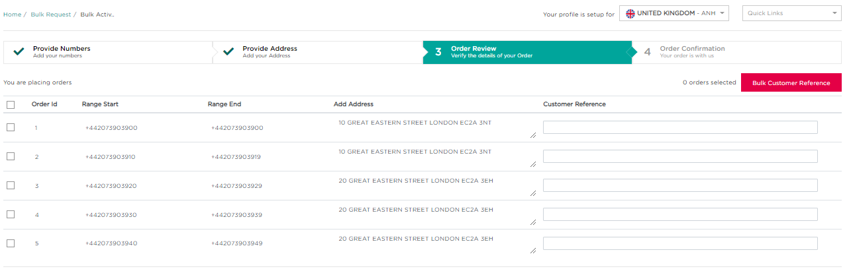
2
3
1

Once you are happy with your order, click the ‘Order Confirmation’ button to proceed.

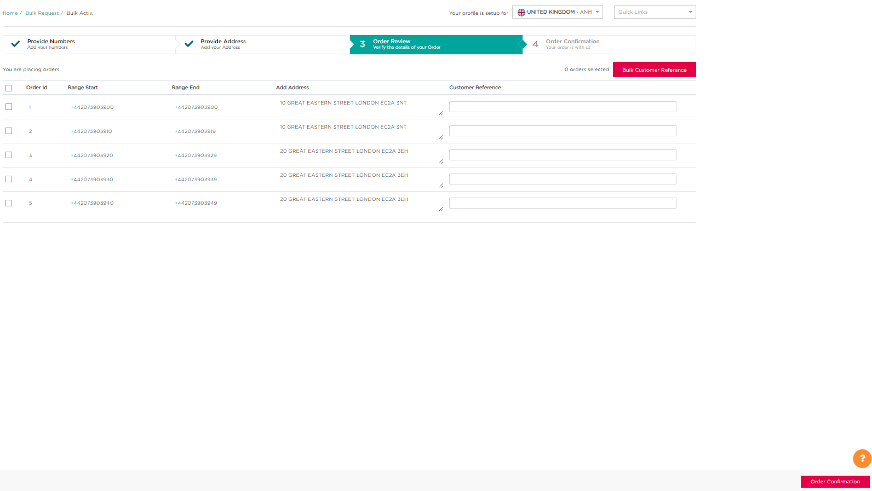

You will then be presented with the following screen once your order is confirmed

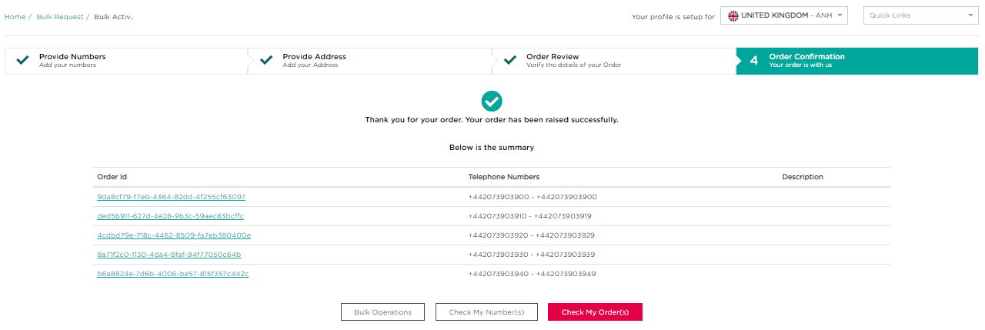

Bulk Port-in
To start your Bulk Port-in order, first you must provide the numbers to port-in.
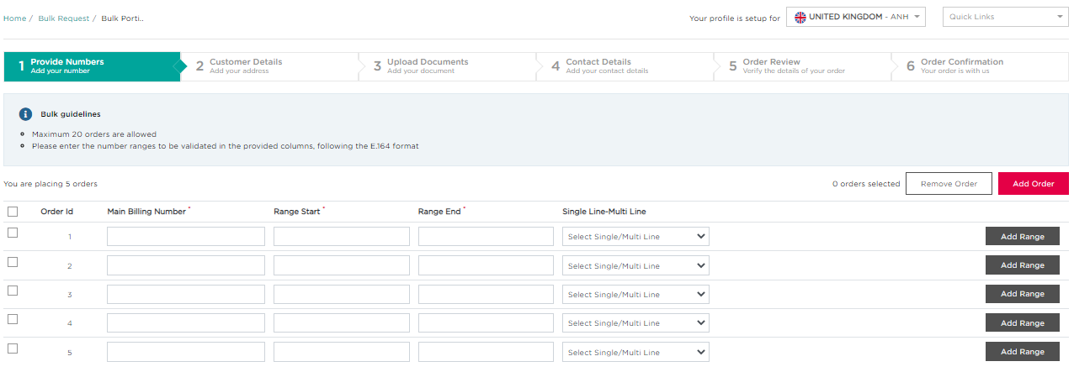
1
3
2

- You can add orders by clicking the ‘Add Order’ button, or remove orders by selecting the orders to remove via the checkboxes and then clicking ‘Remove Order’
- Enter the number ranges you want to activate for each order, including Main Billing Number and Single Line or Multi Line
- You can also add more ranges to an order by clicking the ‘Add Range’ button next to the relevant order:
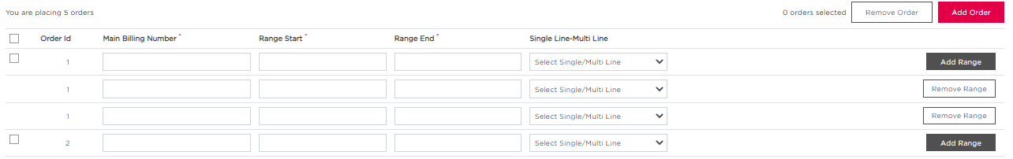
- Once you have entered your orders, click ‘Validate Numbers’ and you will see a message to confirm your numbers have been successfully validated
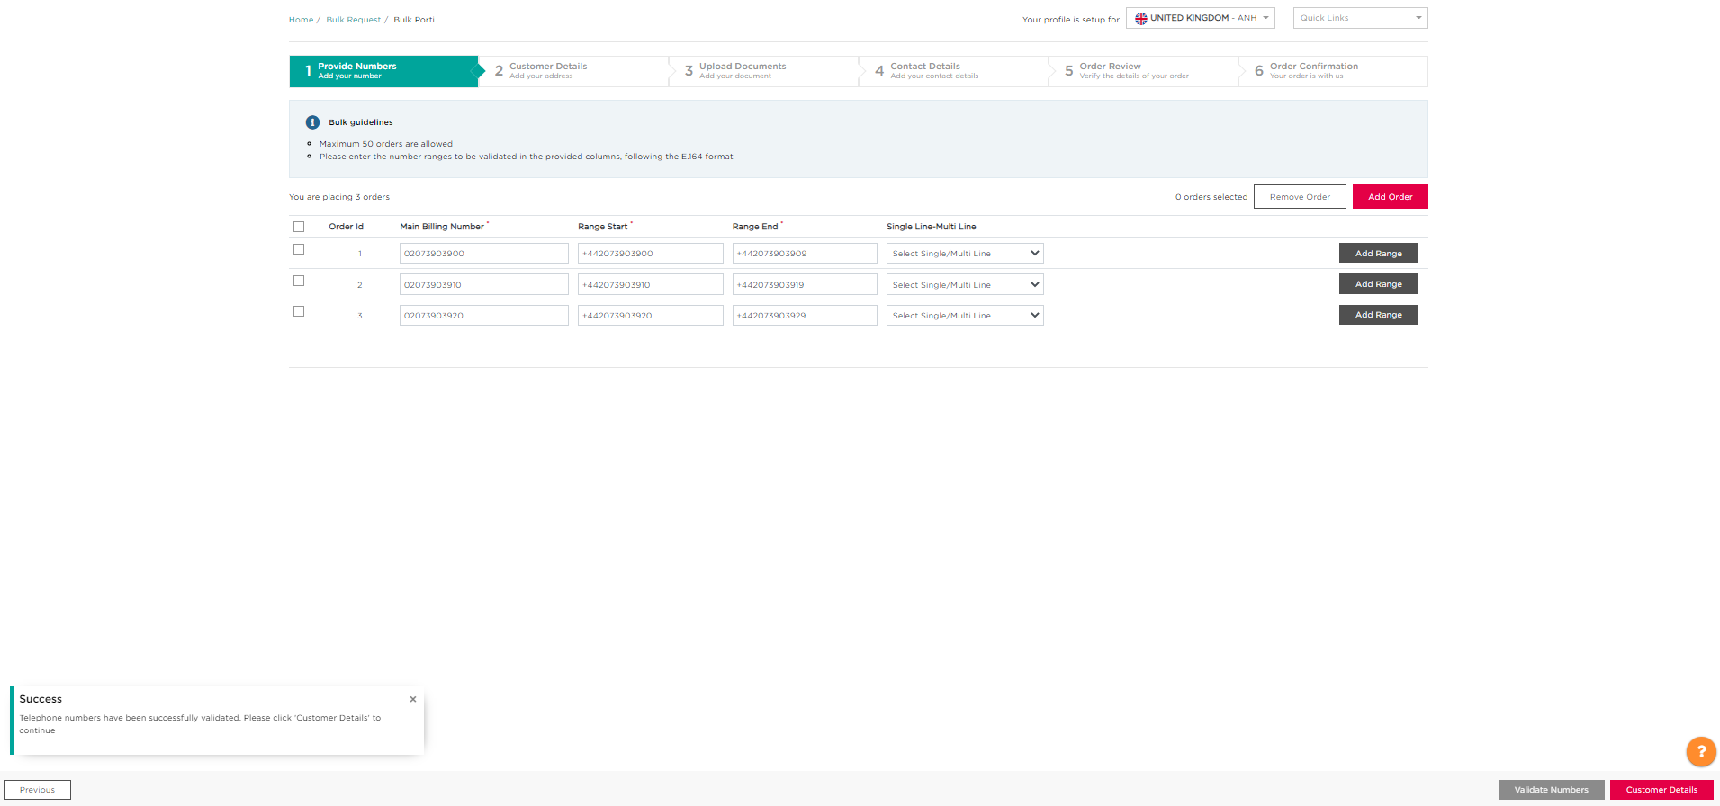
- Then click ‘Customer Details’ to proceed
4
5
4

Next, you will need to add an address for each number range to be activated, for this there are 2 methods, you can add addresses individually or in bulk, both of these methods are described in the previous section for Bulk Activation, so please refer to those for details on how to do this.
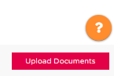
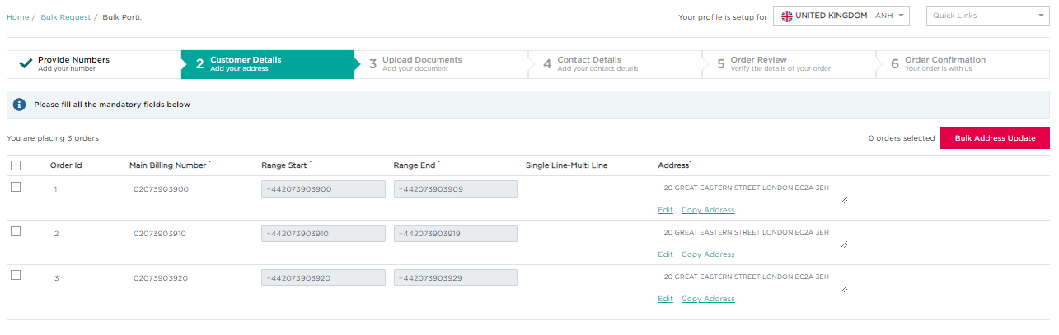
Once you have added the addresses for your orders, click ‘Upload Documents’ to proceed

You can upload the documents associated to your orders either individually or in bulk:

- To upload individually, click ‘Add Document’ on the order you want to add documents for
- To upload in bulk, check the tick boxes for the orders you want to add documents for
- Then click ‘Bulk Upload Document’ to add documents for those selected orders
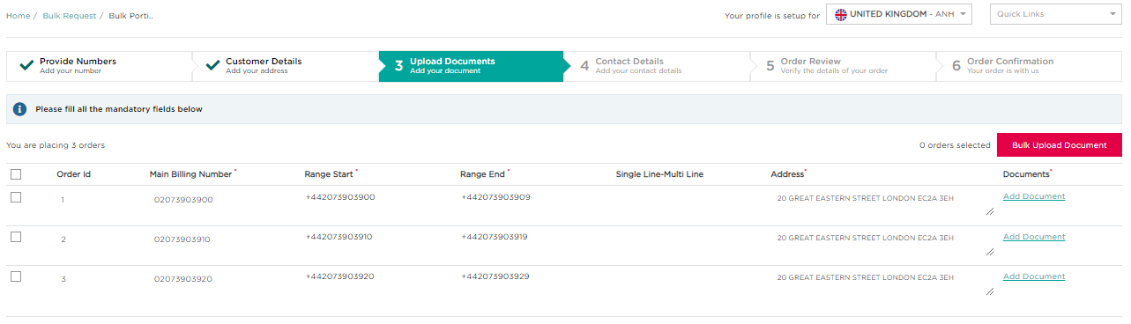
3
2
1
If your bulk port-in orders have different information (i.e. different LOAs), you will need to either complete the ‘Add Document’ flow individually for each order, or complete in bulk and make the required edits for each order thereafter
You must provide a Letter of Authorization, Porting Date, Porting Window and Current Operator to proceed with your port-in and you can also provide an invoice document, any supplementary forms and extra porting information to support your order.

- Once you have entered the required information, click ‘Upload Document’ and they will be applied to your selected order(s)

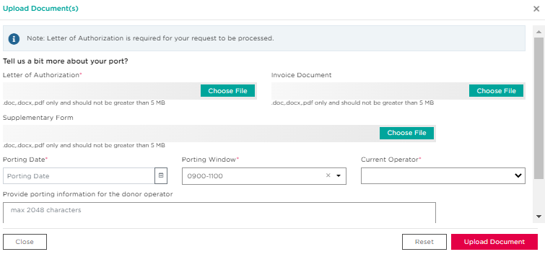
4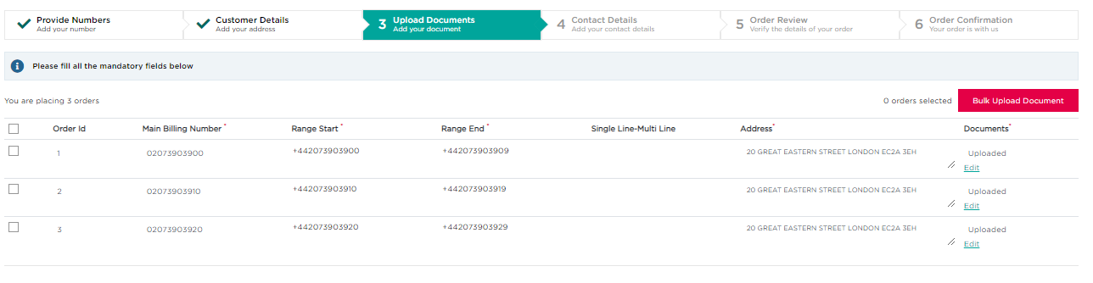
- If needed, you can then edit any order by clicking the ‘Edit’ link next to the relevant order
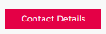
- Then click on ‘Contact Details’ on the bottom right of the screen to proceed
6
5

Then, you will need to add the contact details associated to your orders, which can be done either individually or in bulk
- To upload individually, click ‘Add Contact’ on the order you want to add contact details to
- To upload in bulk, check the tick boxes for the orders you want to add contact details to
- Then click ‘Bulk Contact Details’ to add contact details for those selected orders
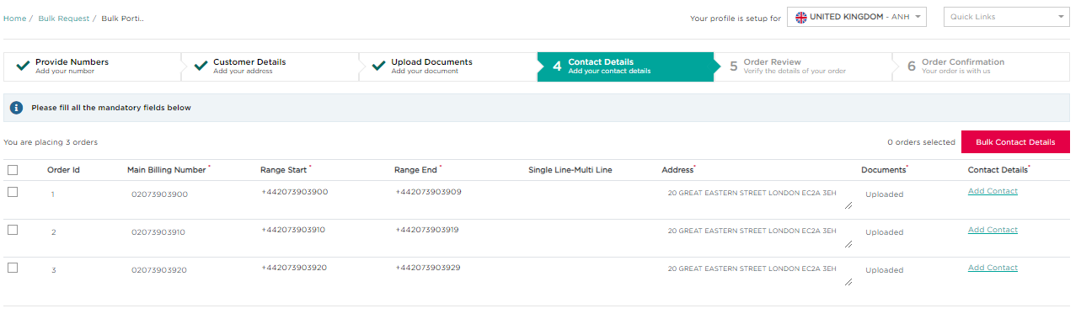
1
2
3
Then enter the required information in the pop-up and click the ‘Order Review’ button on the bottom right of the screen to proceed
On the Order Review page you are shown a summary of your order, and can also add a reference to your orders, which can be done individually or in bulk.
- To add a reference individually, just enter the text into the textbox next to each order
- To add a reference in bulk, check the tick boxes for the orders you want to input the same reference to
- Then click ‘Bulk Customer Reference’ and add the text, which will then be applied to the selected orders
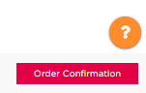
- Click ‘Order Confirmation’ once you are happy with your order to proceed
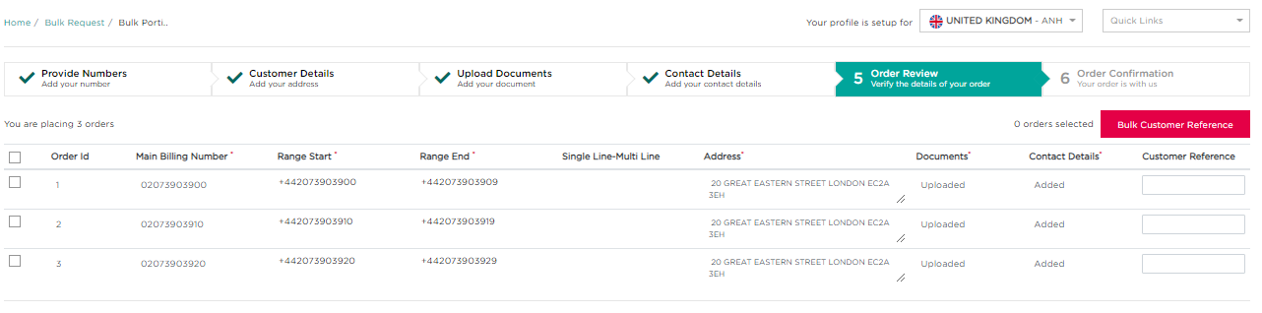
2
3
1
4
You will then be presented with the following screen once your order is confirmed
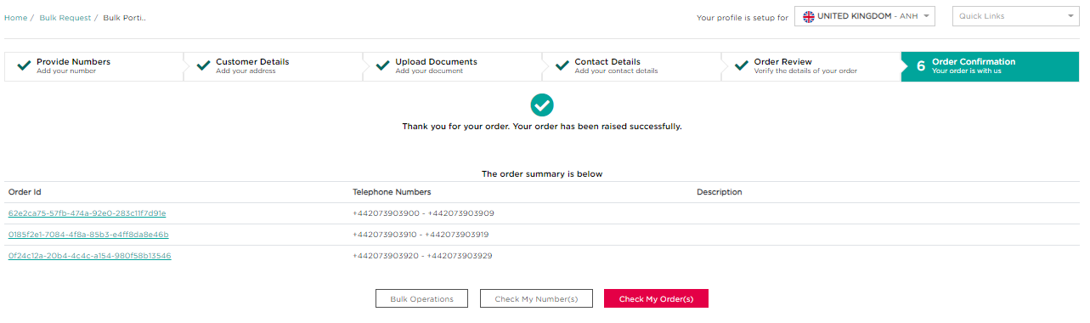

Bulk Address Update
This functionality means you can add or edit the installation and emergency address, and DSU of your activated numbers

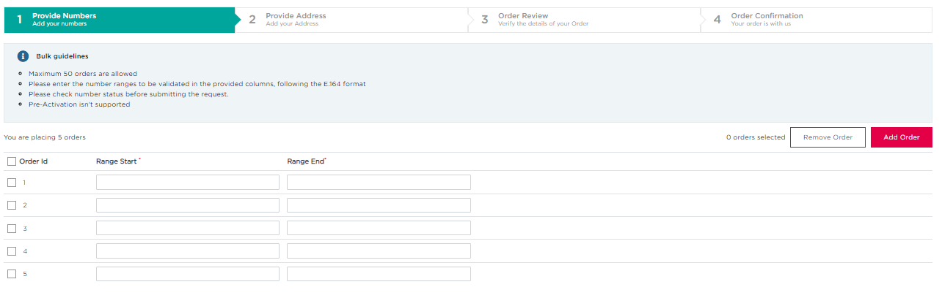
To begin, you need to provide the number ranges for the orders you would like to perform a bulk address update to
2
4
3
1

- You can add orders by clicking the ‘Add Order’ button, or remove orders by selecting the orders to remove via the checkboxes and then clicking ‘Remove Order’
- Enter the number ranges you want to change the address of for each order
- Once all the information is entered, validate your numbers using the ‘Validate Numbers’ button
- Once successfully validated, you will see the following message in the bottom left corner of dire
Then you can click the ‘Provide Address’ button to proceed
Next, you will need to add an address for each number range to be activated, for this there are 2 methods, you can add addresses individually or in bulk, both of these methods are described in the Bulk Activation section, so please refer to that section for details on how to do this.

For Bulk Address Update, you also have the option to Modify an address as well as add an address, which both have the same flow to do either individually or in bulk
When modifying an address, you only have to edit the information you want, and can click the skip button for any stage in which you do not want to change the information, e.g. DSU address
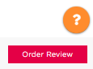
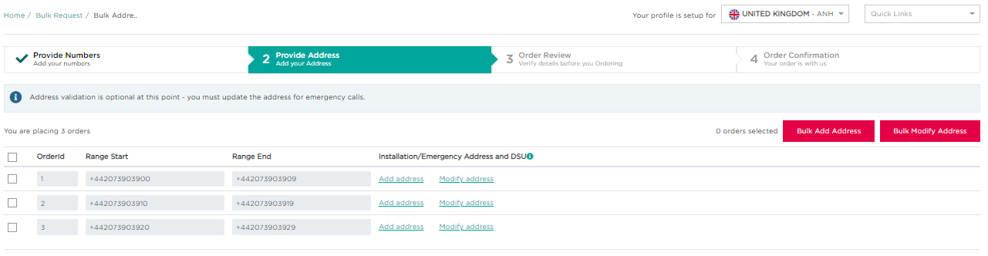

Once you have added/modified the addresses for your orders, click ‘Order Review’ to proceed

On the Order Review page you are shown a summary of your order, and can also add a reference to your orders, you can do this individually or in bulk.

- To add a reference individually, just enter the text into the textbox next to each order
- To add a reference in bulk, check the tick boxes for the orders you want to input the same reference to

- Then click ‘Bulk Customer Reference’ and add the text, which will then be applied to the selected orders

- Click ‘Order Confirmation’ once you are happy with your order to proceed
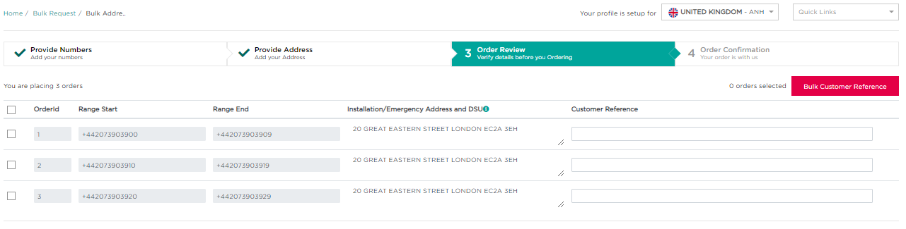
2
3
1

4

You will then be presented with the following screen once your order is confirmed
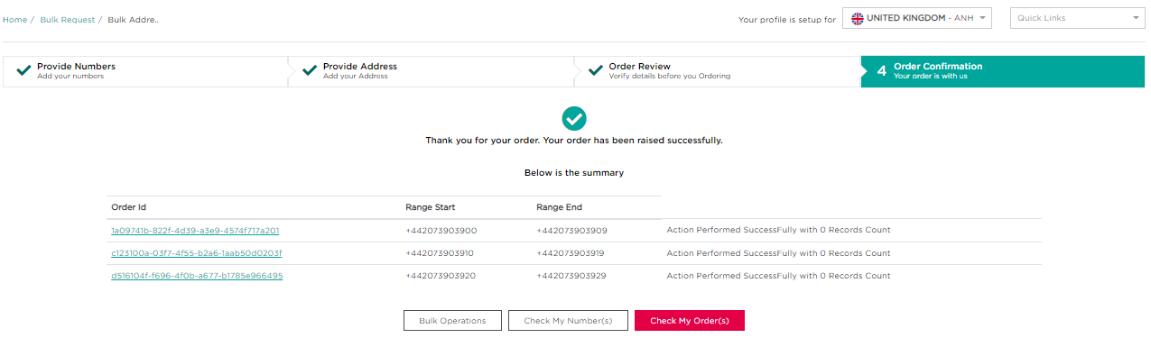

Bulk Reservation
To reserve numbers in bulk via Numbers on Demand, you can either:

- Upload a file of the telephone numbers to be reserved (following the guidelines of the sample file)
- Enter the numbers to be reserved manually
- Once you have added the numbers via one of those methods, you will then to validate these numbers and once successfully validated, you can click ‘Order Review’ to proceed
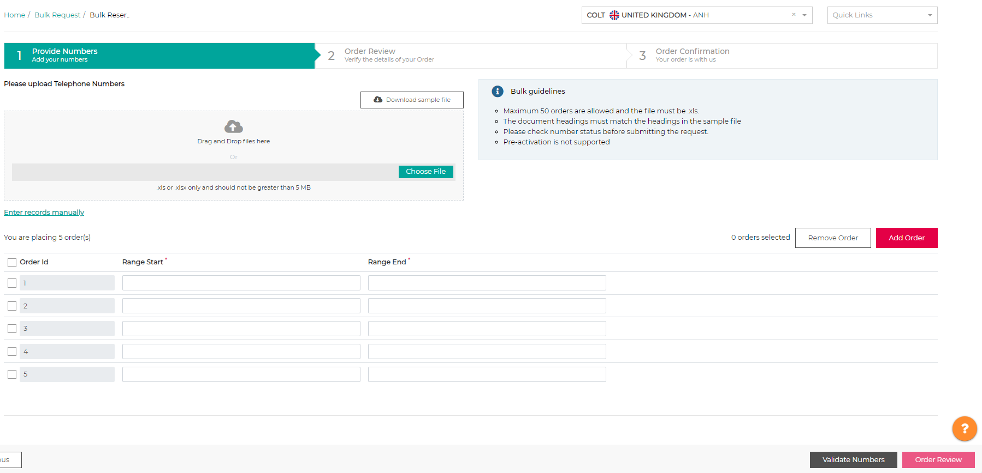
3
2
1

From here, you can review your order and add in any reference information you would like, before clicking ‘Order Confirmation’ to submit your bulk reservation

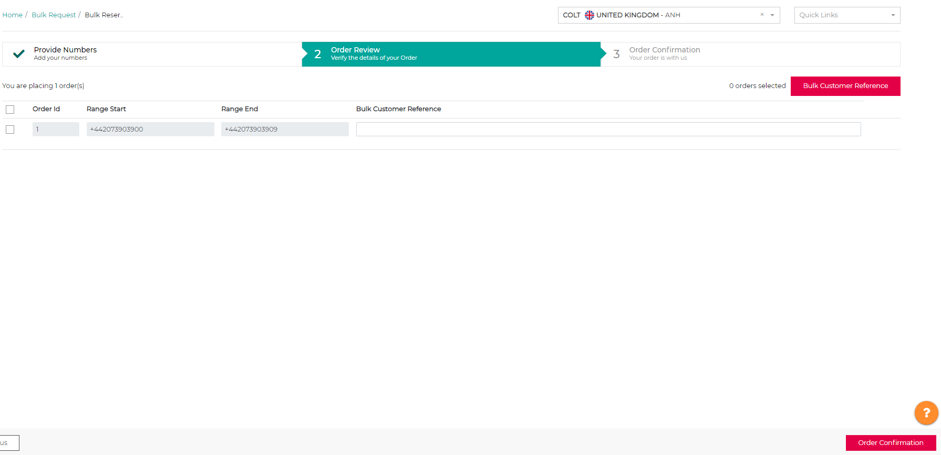

Once completed, you will be presented with the following order confirmation, which includes your Order ID that you can use to track your order

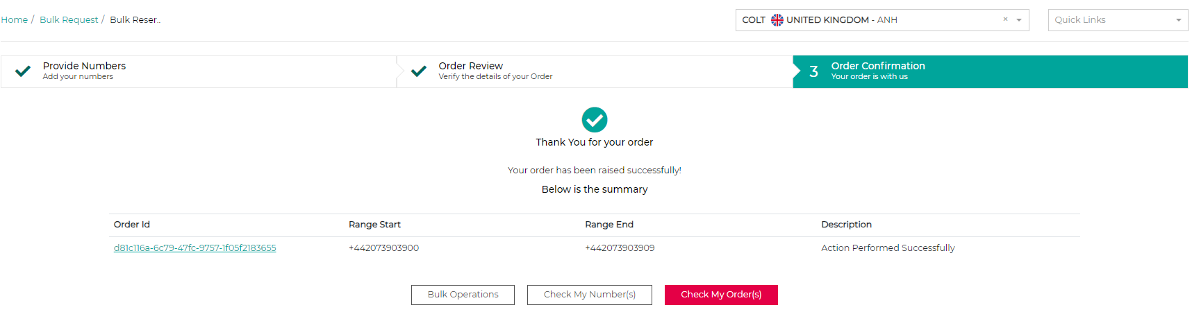

Bulk Cancel Reservation
A maximum of 20 orders are allowed to be processed using Bulk Cancel Reservation
Only numbers or ranges with the ‘Reserved’ status can be cancelled using Bulk Cancel Reservation

To cancel a bulk reservation, you need to either:
- Search for the number or range you would like to cancel the reservation for using the text box
- Upload a file containing the number(s) or range(s) you would like to cancel the reservation for, following the format of the provided sample file

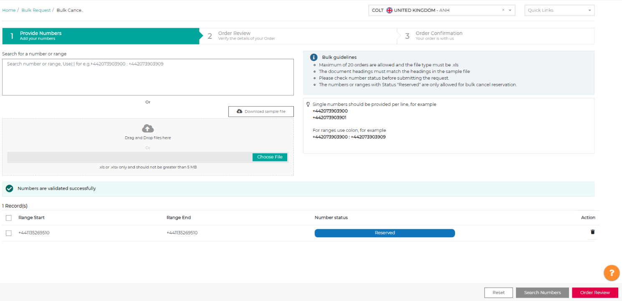
- Once you have added the number/range to be cancelled, you will need to search for it using the Search Numbers button. After that has been validated, you can then proceed to review your order

1

You will then be able to review your order, and you must confirm using the checkbox that you would like to cancel the reservation order shown on the screen.

Once you have done this, you can click ‘Order Confirmation’ in the bottom right corner to submit your bulk reservation cancellation request

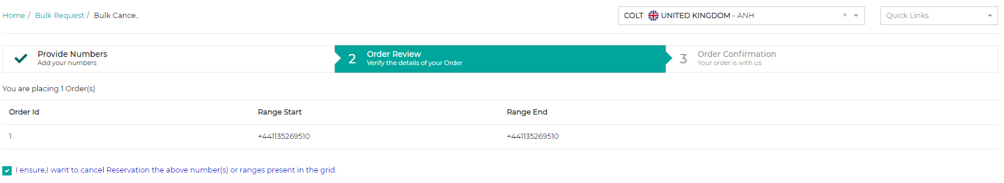

You will need to confrm for the final time that you want to cancel your bulk number reservation for the previously selected number/range. Once you have selected yes, then your bulk number reservation cancellation will have been completed

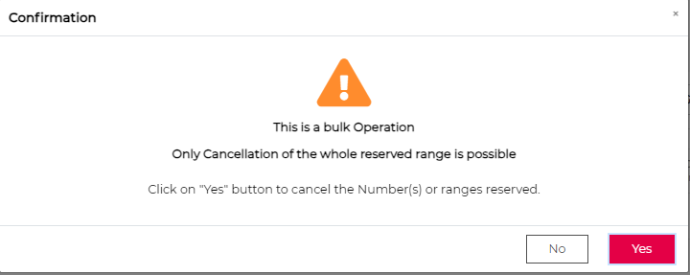

Bulk Deactivation
A maximum of 20 orders are allowed to be processed using Bulk Deactivation
Only numbers or ranges with the ‘Activated’ or ‘Portin Activated’ status can be deactivated using Bulk Deactivation

To complete a bulk deactivation, you need to either:
- Search for the number or range you would like to deactive using the text box
- Upload a file containing the number(s) or range(s) you would like to deactivate, following the format of the provided sample file

- Once you have added the number/range to be deactivated, you will need to search for it using the Search Numbers button. After that has been validated, you can then proceed to review your order

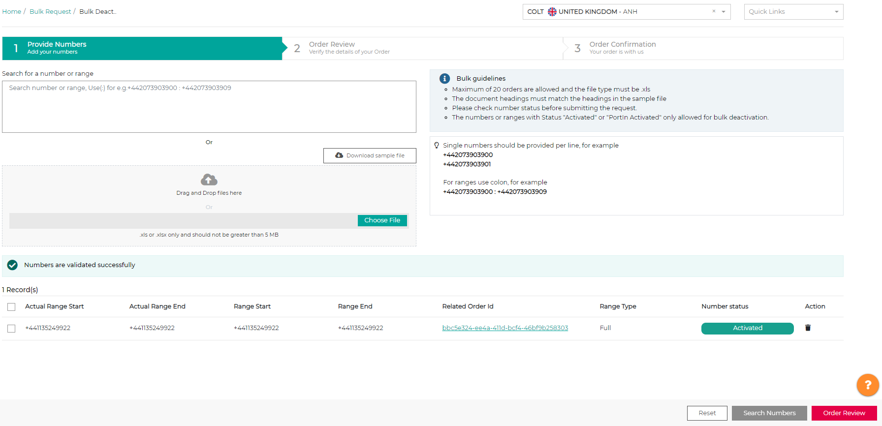

1

You will then be able to review your order, and you must confirm using the checkbox that you would like to deactivate the numbes as shown on the screen.

Once you have done this, you can click ‘Order Confirmation’ in the bottom right corner to submit your bulk deactivation request
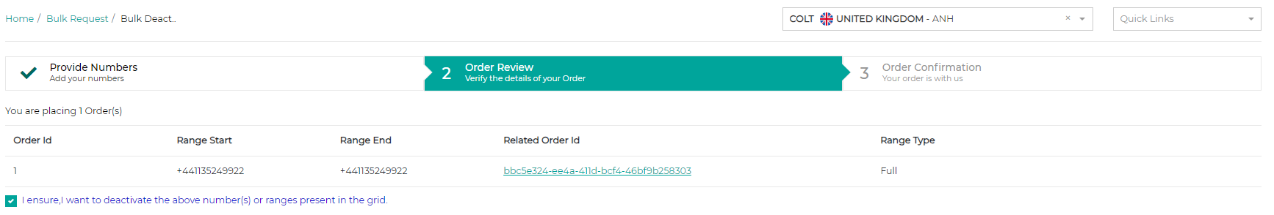

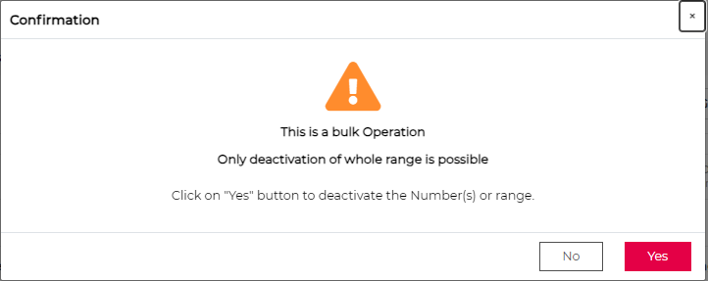

You will need to confrm for the final time that you want to deactivate the previously selected number/range. Once you have selected yes, then your bulk deactivation will have been completed

Reports
To request and download a Colt Number Hosting report, which can provide reports on all your numbers and orders, you need to click on ‘Number Hosting Report’ via the log-in menu of Numbers on Demand or via the ‘Quick Links’ menu.
1

Then you will be taken to the Number Hosting Reports page, where you can see the reports generated from you over the last 7 days,and will be be able to:
- Download an existing Number Hosting report by clicking the Download Report icon
- Request a new Number Hosting report by clicking the link

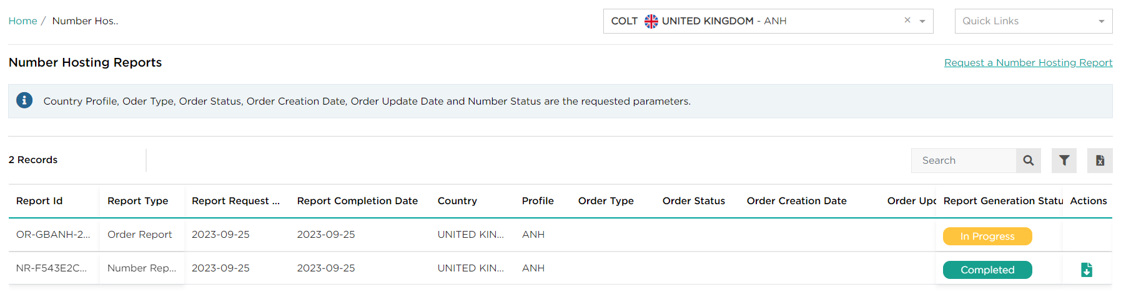
2
1

There are 2 types of Number Hosting reports available to download, a number report or an order report. After clicking the ‘Request a Number Hosting Report’ link, you can request a Number Report by selecting that option, and choosing: the Country and Profile, Number Status (can be all statuses) and Order Update Date range, then click submit.
Only the Country and Profile field is mandatory to complete your request and a Number Report is currently not available for Germany.
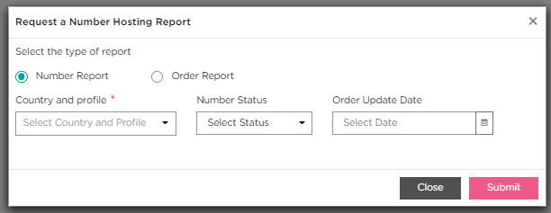

While to download an Order Report, you must tick the Order Report option, and provide: the Country and Profile, Order Type, Order Status, Order Creation Date range and Order Update Date Range, then click submit.
Only the Country and Profile field is mandatory to complete your request.
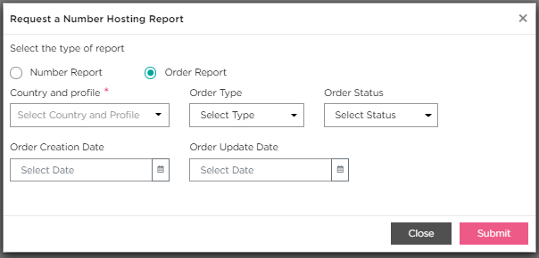

Once you have submitted your report request, you will receive a notification in the bottom left corner of the screen, with the Order ID and information around your report. You can view the progress of your order request on the ‘Number Hosting Reports’ page and you will also receive an email when your report is ready.

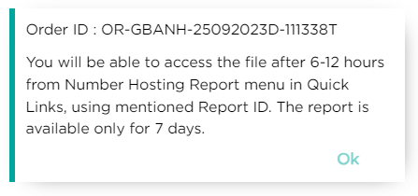

When you receive confirmation your report is ready via email, you can then enter the Report ID in the ‘Number Hosting Reports’ screen and download your report.

Please note that reports are only available to download for 7 days once generated, after this time the report will be unavailable and a new one must be generated

Directory Service Update
Only activated numbers can have their Directory Service updated.
An update to the national Directory Services can be done as part of an Address Update during activation, address update and port-in request by ticking the Directory Service Update box.
On receipt of the Directory Services order in Austria, our local team will be in touch via email to clarify the details of your entry.

To update your customer publication in the Directory Service, from ‘My Telephone Numbers’ page:
- Use the filter icon to refine the results of your numbers :
- Number Status = Activated or Port-in Activated.
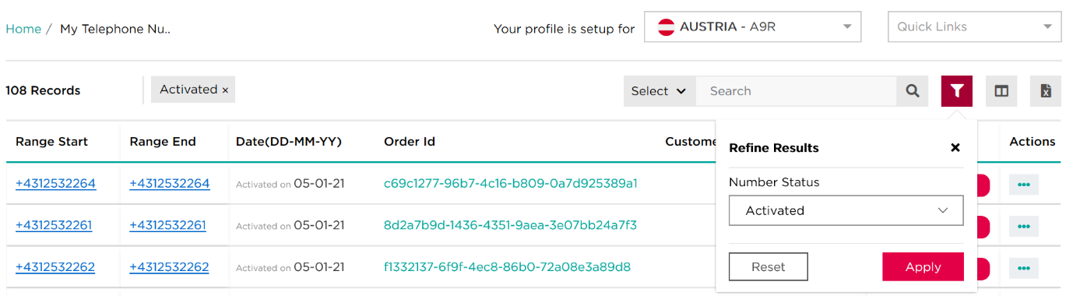
- Click apply to see only your activated numbers
1
3
2

- Click on the three dots icon under the actions column

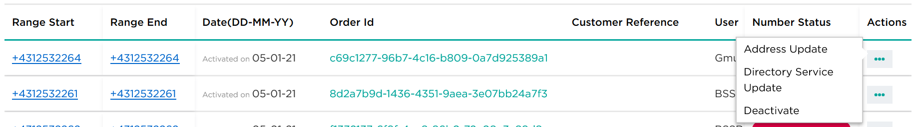
- Select Directory Service Update from the drop down user actions menu
5
4

On Directory Service Update enter the mandatory fields (*), any notes you want to add, and validate your request.
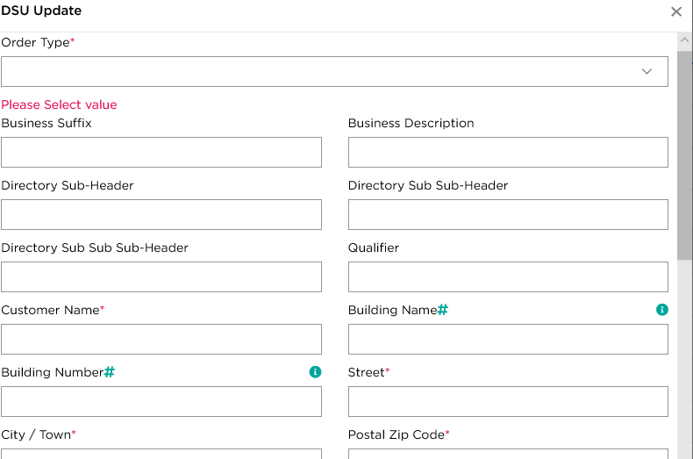
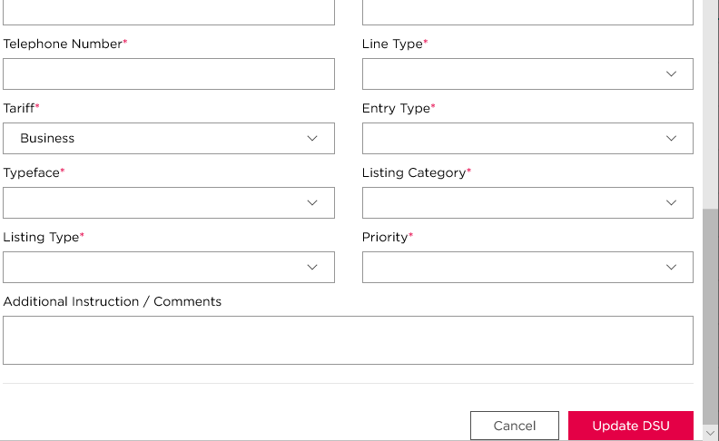

- Order status: shown as completed after your submission. Please expect some delay between your request and the Directory Service update.
- Allowed characters: please check APPENDIX A.
- Please check APPENDIX A for complete information about Directory Service updates.
- Please check APPENDIX B for country codes.

Colt Migrations
There are 2 different methods to migrate numbers which are already activated or ported-in to Colt’s network, to you. They are:
- Number Migrate-In/Out – only for use for migrating numbers & traffic from one of your service profiles to another of your service profiles in the same country and within your reseller domain, or for pre-approved mergers & acquisitions of resellers who both have Colt Wholesale SIP in all countries except the Netherlands

Migrations using Migrate-In/Out flow
Enables you to migrate traffic from one of your service profiles to another both inter- & intra-domain using new Migrate-In and Migrate-out flows
This process supports the following number types:
- Colt owned numbers
- Ported-in numbers
All 20 Colt countries are in scope except the Netherlands.

- Port-in/out – for use in the Netherlands & France and for all other scenarios, e.g. from other Colt Voice products to Wholesale SIP in all countries

Migrations using Port-in/out flow
Enables you to migrate traffic from your existing Colt Voice product to your Wholesale SIP service profile using the existing Port-in flow.
This process supports the following number types:
- Colt owned numbers
- Customer owned numbers (FR)
- Ported-in numbers
All 20 Colt countries are in scope for Colt Voice product to Wholesale SIP migrations.

Migrations using Migrate-In/Out flow
The Number Migrate-in/out functionality is available under ‘Quick links’
- You can move numbers from one service profile to another
- Activated & Port-In activated numbers only
- Profiles must be under the same reseller domain for an Intra Domain migration
- Profiles are from different domains for an Inter Domain migration (in instances of a company merger or acquisition and are subject to Colt check/approval)
- Up to 50 single numbers/ranges can be moved in one order from one profile
  - Only one migration request can be processed at a time from a losing profile. The migration order needs to complete before the next order can be submitted from the same losing profile.
  - Only full ranges can be moved for DE, IT, CH & zone B. Partial range migration is not supported in these countries.
  - All other transactions such as address update, deactivation etc on the number or range must be done before a migration is submitted or after a migration order is completed.
- Inter & Intra migrations can be done in all countries except NL and FR (the FR rules regarding hosted customer numbers are being worked through for release in 2025)

- A new transaction type is being introduced ‘Number Migrate In’ and ‘Number Migrate Out’ which can be queried in NOD and also over API.

- A new ‘Inter Domain Migration Approval’ option enables you to raise & track migration requests in the ‘My Order’ page in NOD.

- Intra & Inter domain migrations do not require any Porting Desk intervention in the process and our updates to the network & systems are all automated with no network downtime. This will improve the order lead time from days/weeks to mins/hours. An email will be sent to the registered customer’s porting desk contact regarding the migration of numbers.
- There is no change or impact to end-customer information used for handling emergency calls.

- Please note that post migration, it remains the end customer’s decision to request to cease numbers or port-out numbers and the standard porting rules and process apply.

Inter Domain migration request and approval process
To request an Inter domain migration, please follow these steps:

- Select ‘Inter Domain Migration Approval’ and enter the service profile.
If the service profile is invalid, an error will be thrown like below.
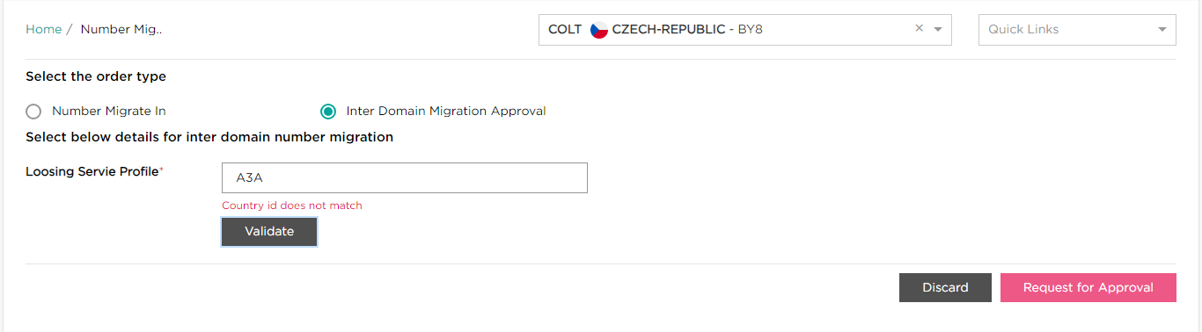
- Mandatory information including the reason for the migration and any supporting documentation must be provided by you You can then click on ‘Request for Approval’.

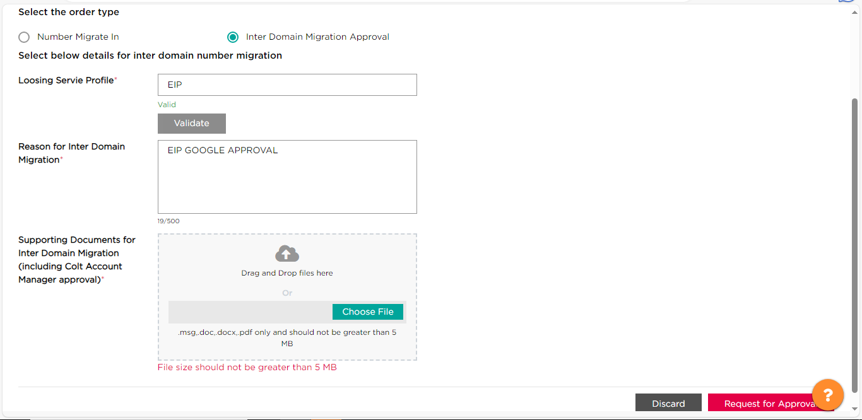
- An order id will be generated.

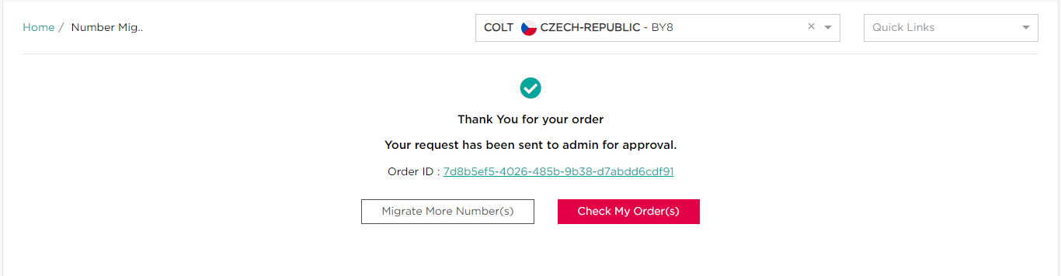
- The inter-domain migration request will move to ‘Review Pending’ status. You can view the order details which will show the basic details.
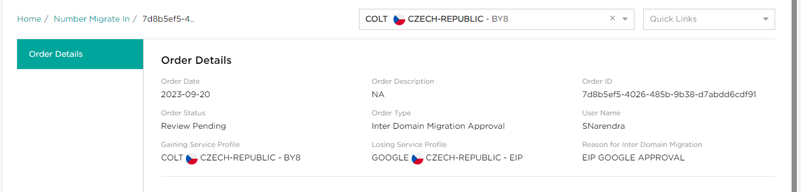
An email will be sent to you informing you about the rejection/acceptance of inter domain migration request.

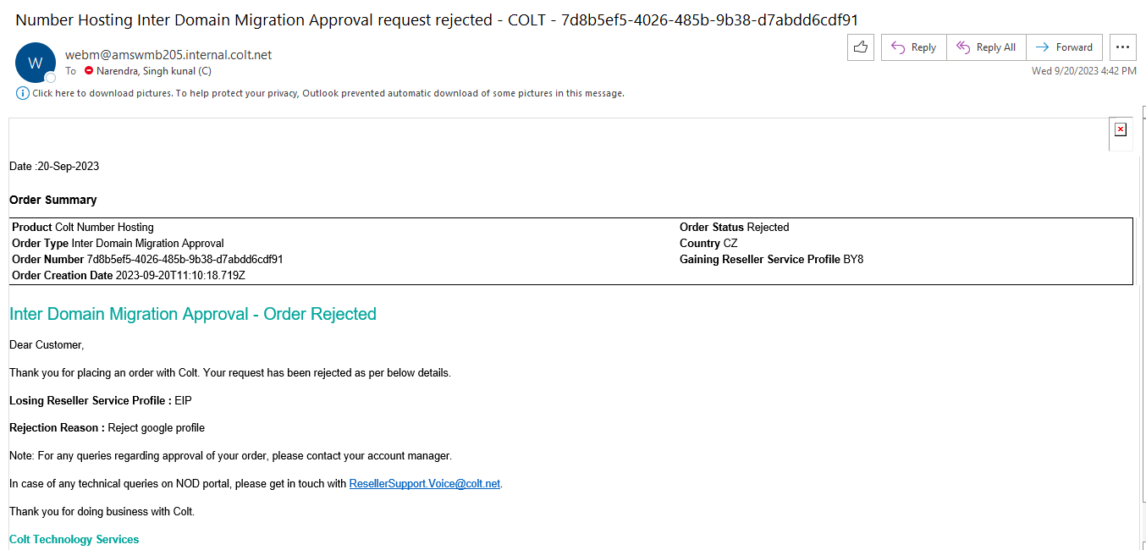
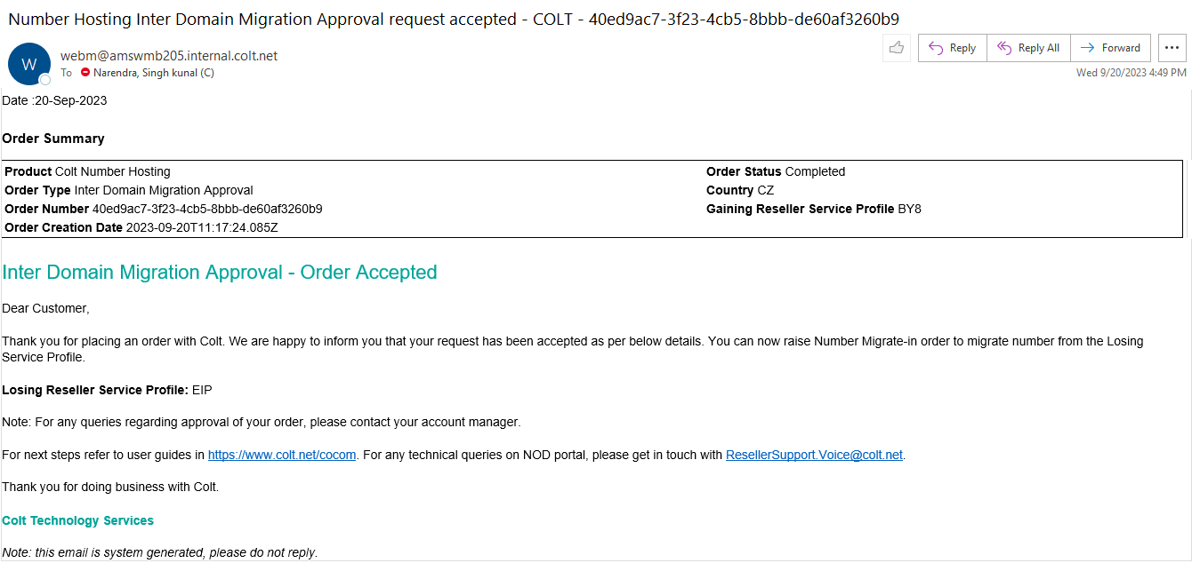
- You can also view the order details.
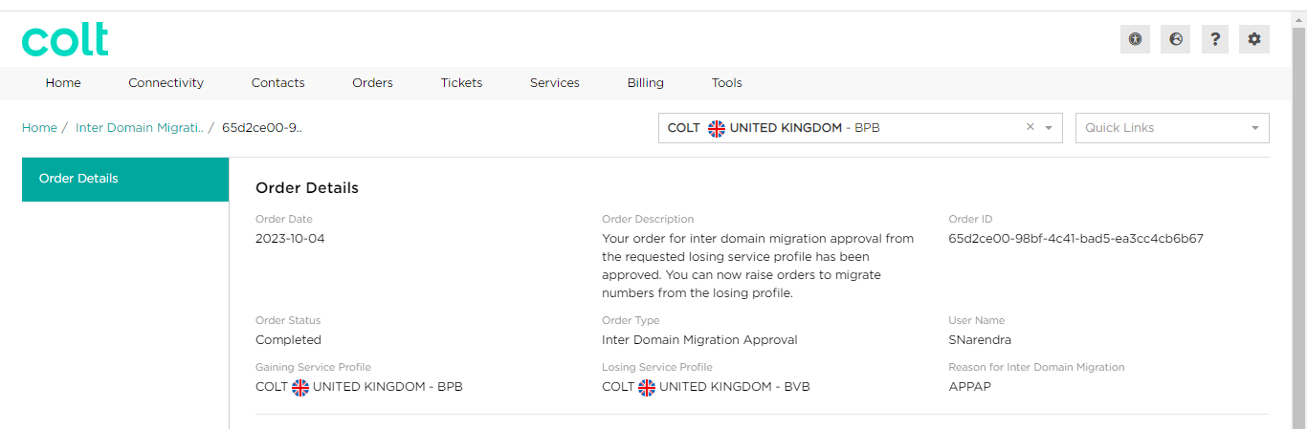
- On receipt of a successful acceptance of the inter-domain migration request, you can now start using the migrate in option. The approved profile(s) will be visible in the dropdown.

Number migrate In
These steps are applicable for both inter & intra domain migrations.

- Select the service profile that you wish to migrate numbers to, and then select the option ‘Number Migrate In’ under the ‘Quick Links’ menu.
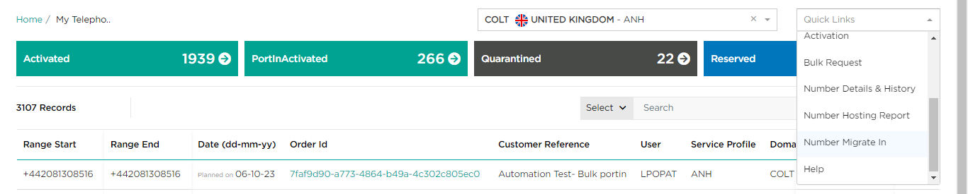
1
- Select the radio button - ‘Number Migrate In’ and select the losing service profile from the drop down and enter the numbers as highlighted below.

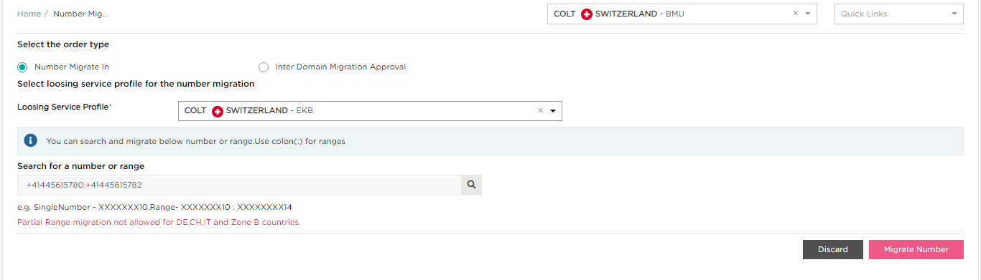
If you’re requesting for a partial range migration for CH, IT, DE and Zone B countries, an error will be thrown as shown above.

The selected numbers numbers will be visible as shown below. You can add up to 50 single numbers/ranges to the grid.

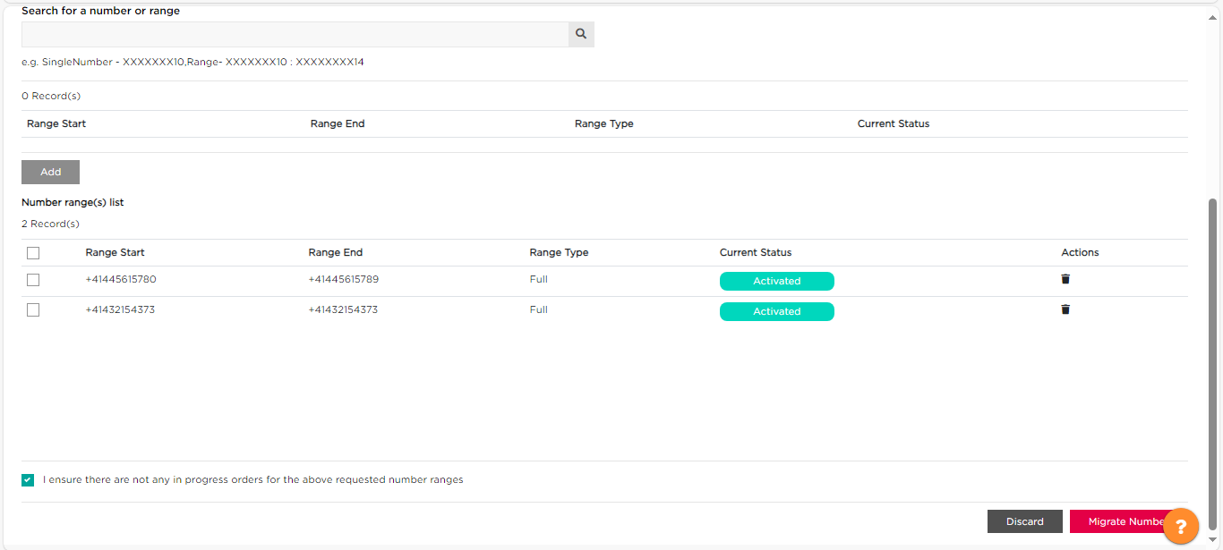
- Click on ‘Migrate Numbers’ button. You’ll get a pop-up confirming the request.
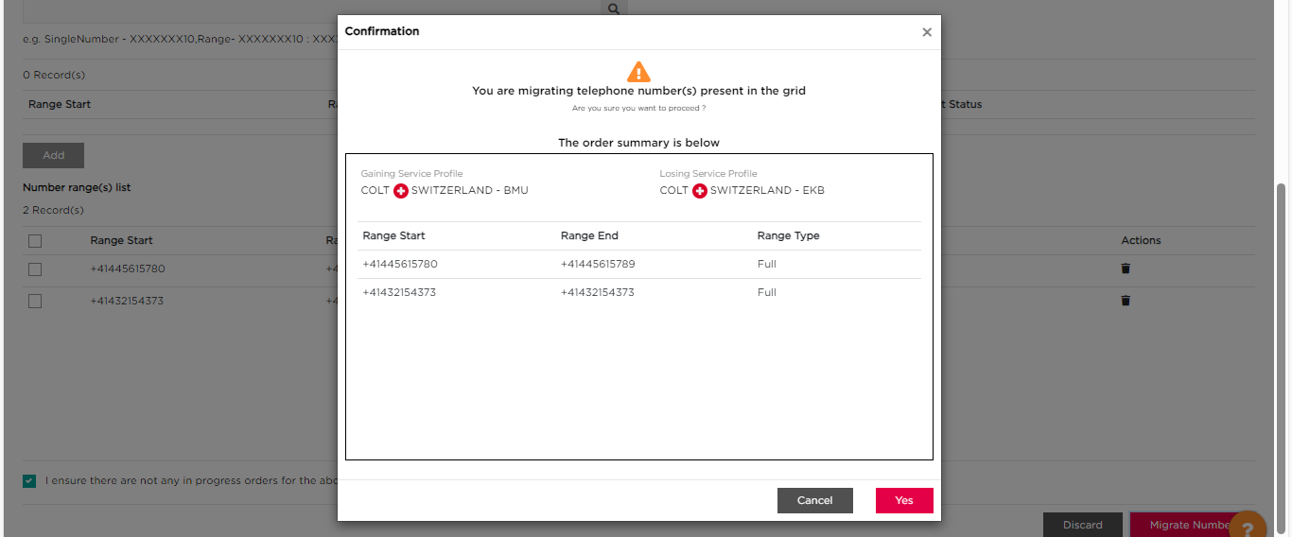

- Select ‘Yes’ and the Migrate-In order will be submitted to Colt.

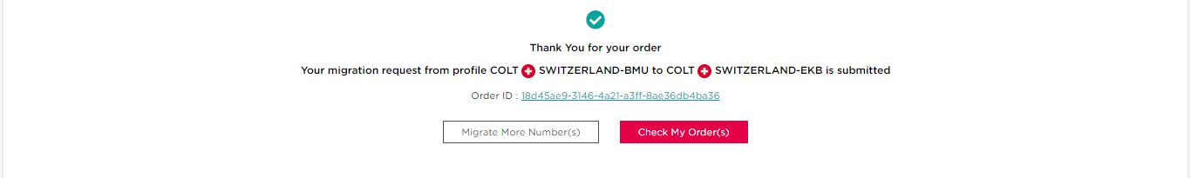
- You can view the order details by clicking on the order id or by searching the order id via the my order page.
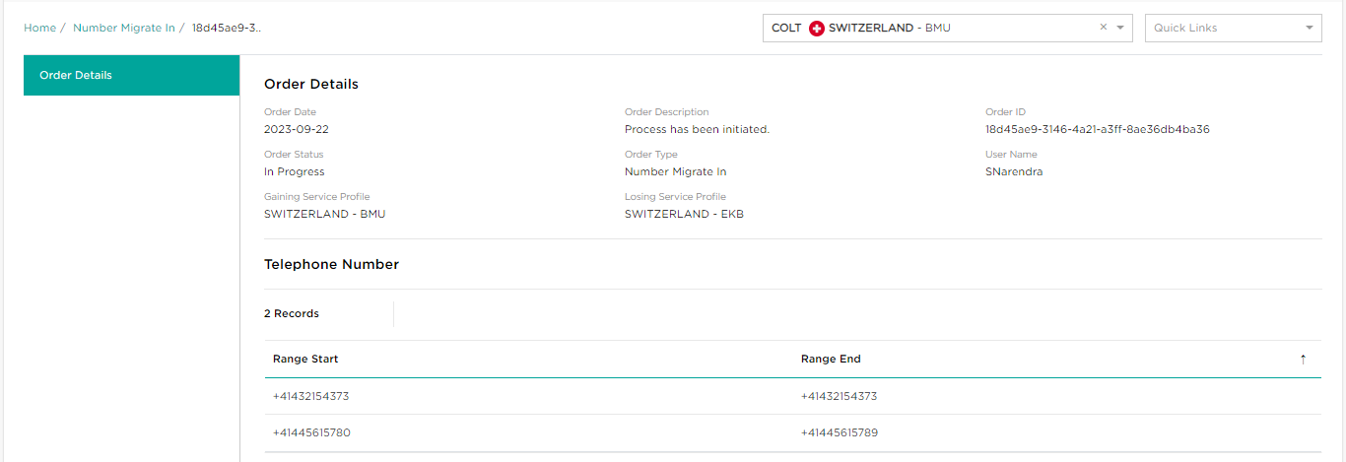
For the gaining service profile, the order type will be ‘Number Migrate In’. Automatically Colt will create a ‘Number migrate Out’ order type against the losing profile.

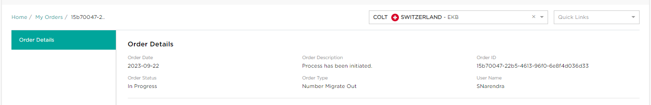
Customer (email ids configured against the losing and gaining service profiles) will be informed about the migration order for both order milestones: ‘In progress’ and ‘Completed’.

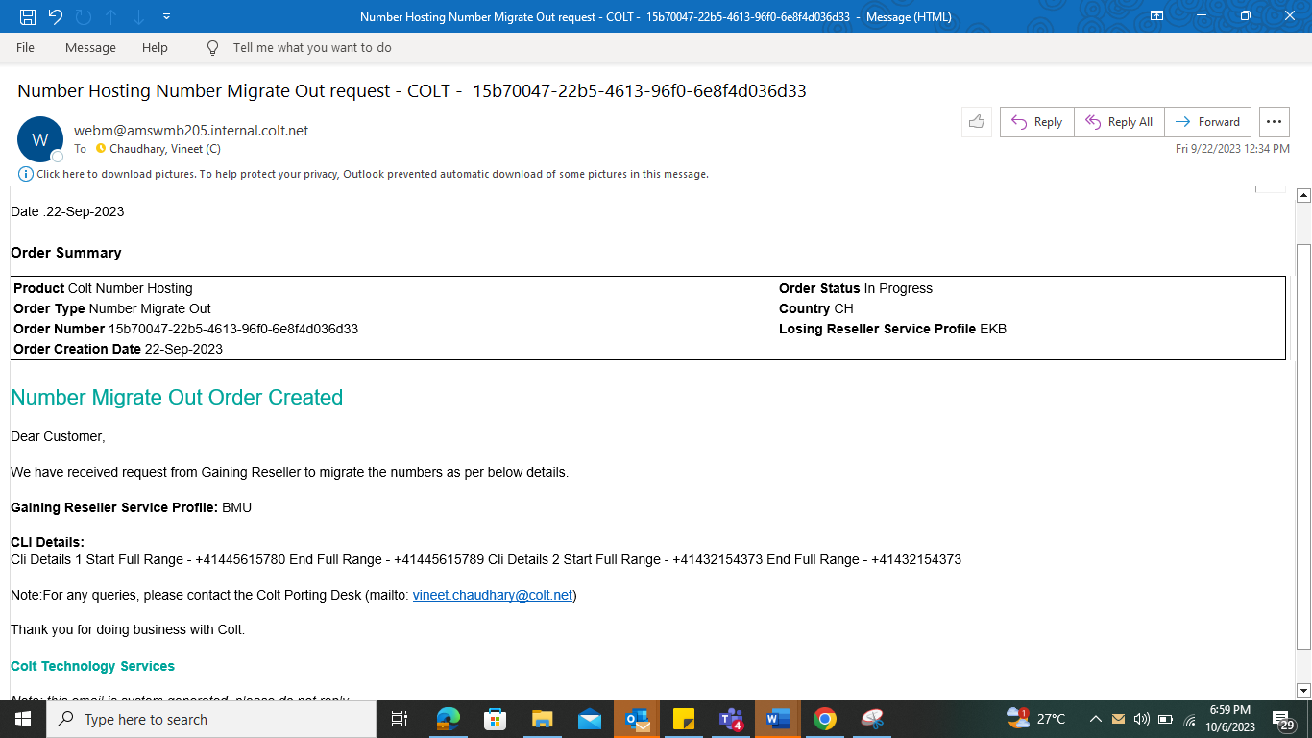
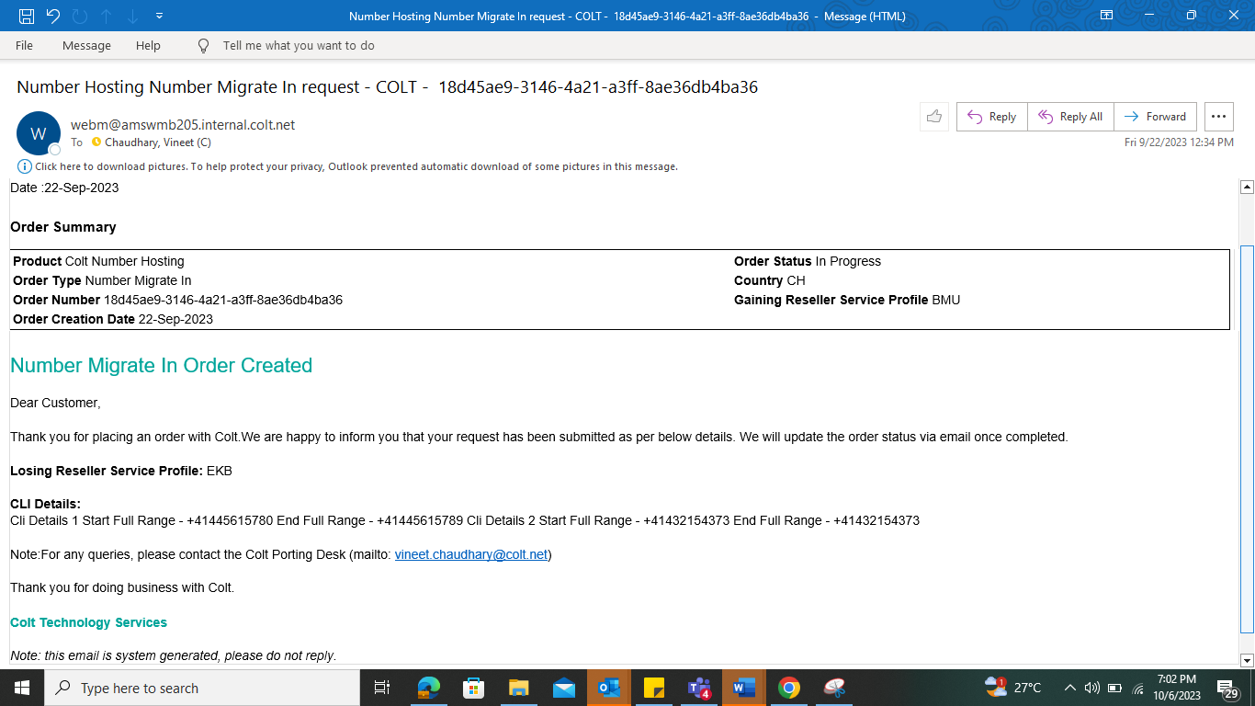
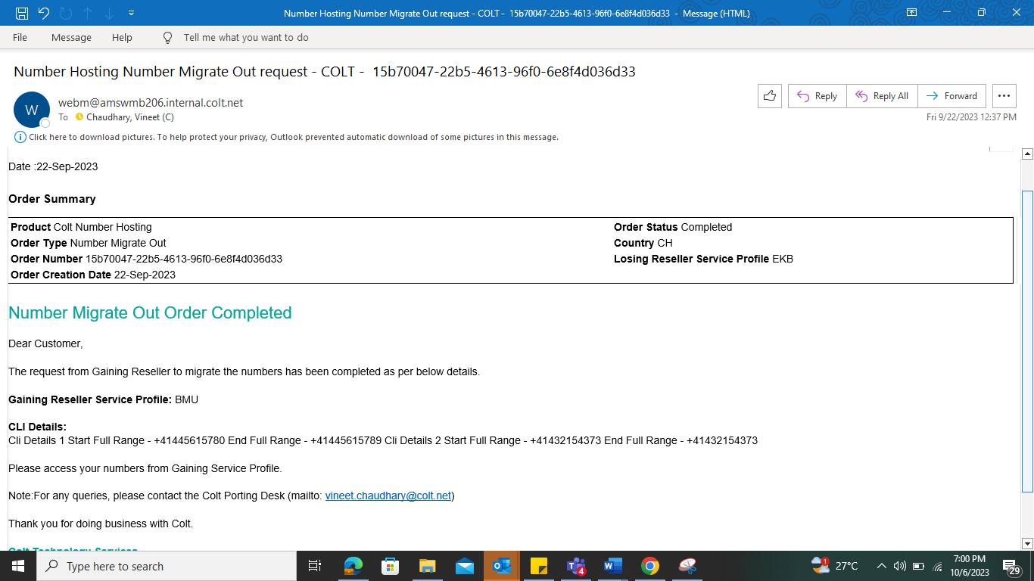

Post completion of the migration, you can view the order as ‘Completed’ and will see the migrated numbers under your gaining service profile.

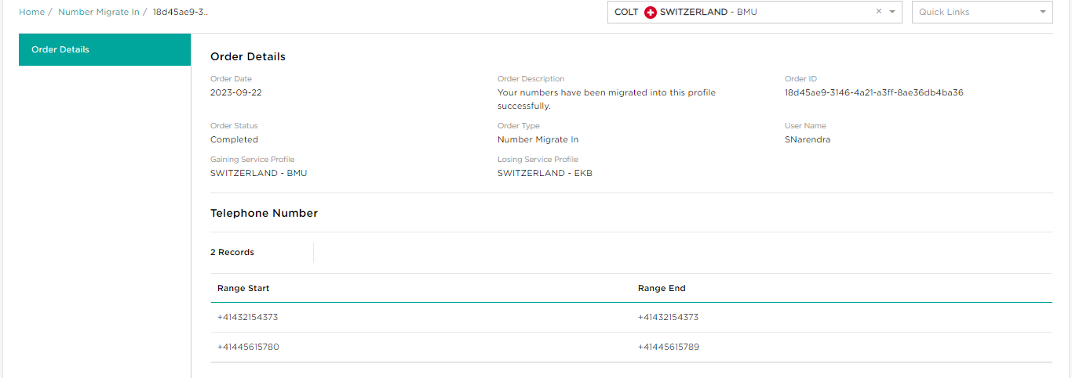
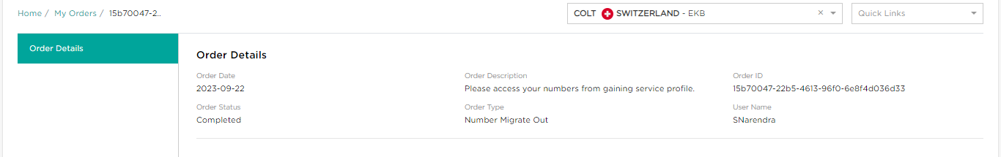

Migrations using port-in/out flow

The second method to migrate numbers which are already activated or ported-in to Colt’s network is to use the Port-in/out flow.

You should use this process for migrating numbers from one service profile to another of your profiles (intra-domain migrations) and inter-domain migrations in the Netherlands & in France for hosted customer numbers (which are out of scope of the first method above). You should also use this second method for all other scenarios, e.g. migrating numbers & traffic from other Colt Voice products to Wholesale SIP in all countries.

Enables you to migrate traffic from your existing Colt Voice product to your Wholesale SIP service profile using the existing Port-in flow.
This process supports the following number types:
- Colt owned numbers
- Customer own numbers (FR)
- Ported-in numbers
All 20 Colt countries are in scope for Colt Voice product to Wholesale SIP migrations.

- Go to ‘Port-in’ via the quick links menu

- Please enter the required information for each stage as per the process in the Port-in section of this guide, with the following exceptions for the ‘Upload Documents’ step:
For SIP Trunking to Wholesale SIP migrations for the same legal customer:
- The Letter of Authorisation does not need to be completed with input from the end-user, however please upload the LOA containing their name (as the file is mandatory)

- Select Colt as the losing provider in all countries except DE & NL

- In the porting information box, please specify that this is a Colt to Colt migration (in France please specify if it is a ‘Colt to you’ or ‘you to you migration’, in the case where ‘you’ are a registered operator and have signed an OPTA mandate with Colt)
For SIP Trunking to Wholesale SIP migrations between different legal customers:

- The Letter of Authorisation does not need to be completed with input from the end-user, but please upload the LOA containing their name (as the file is mandatory). However, an end-customer signature is required for France, Italy, Spain, Germany, Austria, Switzerland, as it is needed for the approval to migrate their numbers

- Select Colt as the losing provider in all countries except DE & NL

- In the porting information box, please specify that this is a Colt to Colt migration (in France please specify if it is a ‘Colt to you’ or ‘losing operator to you migration’, in the case where ‘you’ are a registered operator and have signed an OPTA mandate with Colt)
All order updates will be sent to the email address you provided in the port-in order. You will be provided with an Order ID, which you can check in the My Orders or My Telephone Numbers pages.

Is there any downtime during migration using the port-in/out process?
There is a maximum 30 minute outage window and it is usually expected a 2-3 mins downtime for each individual migrated single/DDI range. Calls that are in progress will not be impacted.
Can I migrate OOH?
Colt recommends performing migrations within business hours so our support teams are available to support you; however, OOH migration is available on an exception only basis and this is chargeable
DDI migrations using the port-in/out process are managed manually, so larger migrations would be subject to review and approval

Documentation
Colt provides you a comprehensive documentation suite for Wholesale SIP which you can find at https://developer.colt.net/wholesale-sip-documentation and in the help section of the portal

GLOSSARY
Term | Description
B2B | Business to Business
CC | Country code (e.g +44)
CDR | Call Detail Record
CFA | Customer Feedback Awaited
CLI | Calling Line Identification / telephone number
Cocom | The Colt Communication System
Colt Online | Colt Web-based portal to manage your services.
FOC | Firm Order Commitment
GNP | Geographic Number Portability
HTML | Hyper Text Markup Language
HTTP | Hypertext Transfer Protocol
HTTPS | Hypertext Transfer Protocol Secure
LAC | Local Area Code
LOA | Letter of Authorization
NoD | Numbers on Demand
OOH | Out of Hours (related to porting)
PTT | Public Telegraph Telephony [operator]: Any fixed-line network operator but typically the major incumbent operator within the country,
SBC | Session Border Controller (SIP trunking related)
STO | Submitted to Operator
Surrendering (Donor) Carrier | The carrier being requested to port the numbers to Colt.
TLS | Transport Layer Security (SIP trunking related)
Trunk | Logical entity used for VoIP signaling and media, defined between a unique pair of IP addresses on the Colt SBC and Customer VoIP platform
Trunkgroup | A group of trunks that share the same DDI number ranges and typically used for resiliency
URL | Uniform Resource Locator
WWW | World Wide Web
XML | eXtensible Markup Language

Help
On each screen in Numbers on Demand there is an orange question in the bottom right corner of the screen.

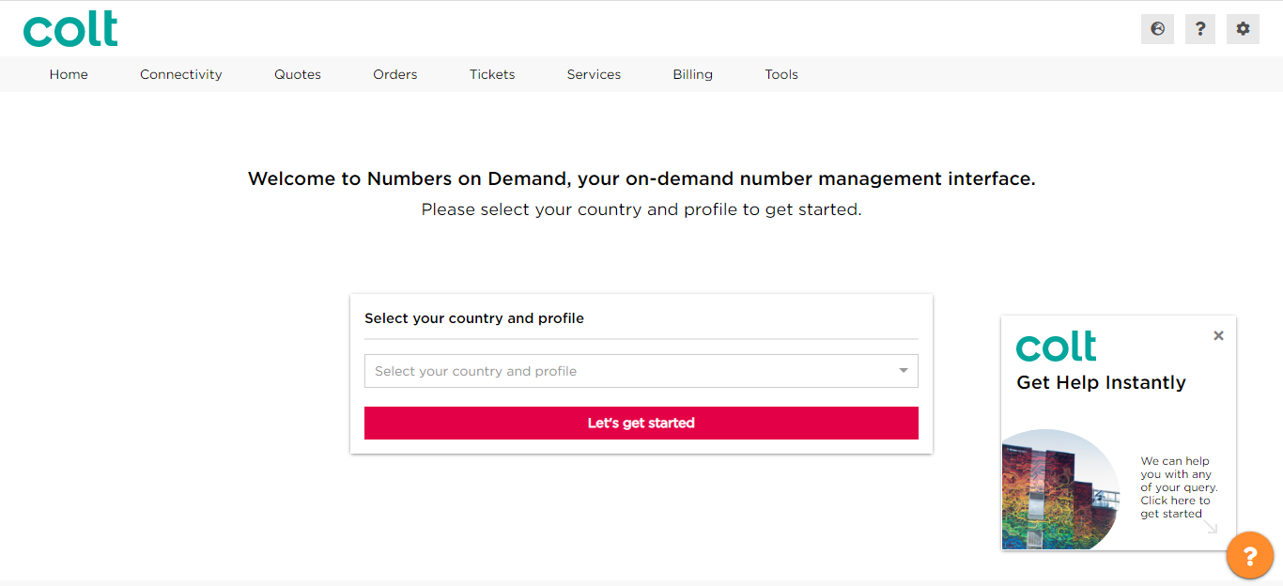
By clicking on this a pop-up menu will appear, which will provide you with a range of options to help you.
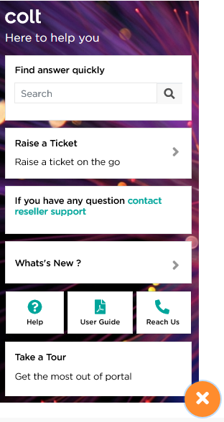
1
2
3
4
5
8
6
7
- Enter a question or key-words into here, and a range of relevant answers will be displayed. When you click on this you will be taken to the answer in our Colt Online Help Desk
- If you have any problems, you can raise a ticket directly here
- Directly contact our Reseller Support team in case of any issues while using the portal
- Find out the latest developments in the portal
- Find details of the help section and some important information
- Find the latest version of the User Guide to download
- You will be taken to our page with the information to contact us
- Find our videos to guide you on the main features of the portal

- Colt Voice APIs Service Matrix

Please refer to the Colt Voice APIs Service Matrix at https://developer.colt.net/wholesale-sip-documentation under the ‘User Guides for Wholesale SIP’ section.

In the Service Matrix you will find the following details:
- Allowed characters
- Complete list of business messages, with code and description
- Directory Service Update (DSU)

- Country Code
Country Code (Zone A countries) | Country Name
AT | Austria
BE | Belgium
CH | Switzerland
DE | Germany
DK | Denmark
ES | Spain
FR | France
GB | Great Britain (also named UK)
IE | Ireland
IT | Italy
NL | Netherlands
PT | Portugal
SE | Sweden

Country Code (Zone B countries) | Country Name
CZ | Czech Republic
FI | Finland
LX | Luxemborug
NO | Norway
RO | Romania
SK | Slovakia

- Spanish Numbering Plan for LACs starting with ‘8’
Geo Nomadic Numbers
Geo Numbers
NA

Spain Numbering plan with LAC starting with '8'
Zona Provincial | Indicativos/  Local Area Code (1st 3 digits of number) | 4th digit of number
Zona Provincial | Indicativos/  Local Area Code (1st 3 digits of number) | 0 | 1 | 2 | 3 | 4 | 5 | 6 | 7 | 8 | 9
01 - Araba/Álava | 845
02 - Albacete | 867
03 - Alicante/Alacant | 865
04 - Almería | 850
05 - Ávila | 820
06 - Badajoz | 824
07 - Balears, Illes | 871
08 - Barcelona | 830
09 - Burgos | 847
10 - Cáceres | 827
11 - Cádiz & 51-Ceuta | 856
12 - Castellón/Castelló | 864
13 - Ciudad Real | 826
14 - Córdoba | 857
15 - Coruña, A | 881
16 - Cuenca | 869
17 - Girona | 872
18 - Granada | 858
19 - Guadalajara | 849
20 - Gipuzkoa | 843
21 - Huelva | 859
22 - Huesca | 874
23 - Jaén | 853
24 - León | 887
25 - Lleida | 873
26 - Rioja, La | 841
27 - Lugo | 882
28 - Madrid | 810
29 - Málaga & 52-Melilla | 851
30 - Murcia | 868
31 - Navarra | 848
32 - Ourense | 888
33 - Asturias | 884
34 - Palencia | 879
35 - Palmas, Las | 828
36 - Pontevedra | 886
37 - Salamanca | 823
38 - Santa Cruz de Tenerife | 822
39 - Cantabria | 842
40 - Segovia | 821
41 - Sevilla | 854
42 - Soria | 875
43 - Tarragona | 877
44 - Teruel | 878
45 - Toledo | 825
46 - Valencia/Valéncia | 860
47 - Valladolid | 883
48 - Bizkaia | 846
49 - Zamora | 880
50 - Zaragoza | 876

Here if LAC is 877 and 4th Digit is
0 then Number is considered as Geo Number.
1 then Number is considered as Geo Nomadic Number.
2 then Number is considered as Geo Number.
3 then Number is Invalid
4 then Number is considered as Geo Number.
5 then Number is Invalid
6 then Number is considered as Geo Number.
7 then Number is Invalid
8 then Number is Invalid
9 then Number is considered as Geo Number.

Appendix B(ii): List of Spanish Provinces with LAC

List of Spanish provinces with LAC
Zona Provincial | Indicativos/Local Area Code (1st 3 digits of number)  a= 5,6 b= 4,5 c= 1,2 d=4,5 e= 0,1,2,3 f= 4,6  g= 0,1,2,3,4,5,6,7,8 h= 0,1,2,3,4,5,6,7,8,9
Zona Provincial | LAC starting with 8 | LAC starting with 9
01 - Araba/Álava | 845 | 945
02 - Albacete | 867 | 967
03 - Alicante/Alacant | 86a | 96a
04 - Almería | 850 | 950
05 - Ávila | 820 | 920
06 - Badajoz | 824 | 924
07 - Balears, Illes | 871 | 971
08 - Barcelona | 830 | 93g
09 - Burgos | 847 | 947
10 - Cáceres | 827 | 927
11 - Cádiz | 856 | 956
12 - Castellón/Castelló | 864 | 964
13 - Ciudad Real | 826 | 926
14 - Córdoba | 857 | 957
15 - Coruña, A | 881 | 981
16 - Cuenca | 869 | 969
17 - Girona | 872 | 972
18 - Granada | 858 | 958
19 - Guadalajara | 849 | 949
20 - Gipuzkoa | 843 | 943
21 - Huelva | 859 | 959
22 - Huesca | 874 | 974
23 - Jaén | 853 | 953
24 - León | 887 | 987
25 - Lleida | 873 | 973
26 - Rioja, La | 841 | 941
27 - Lugo | 882 | 982
28 - Madrid | 810 | 91h
29 - Málaga | 85c | 95c
30 - Murcia | 868 | 968
31 - Navarra | 848 | 948
32 - Ourense | 888 | 988
33 - Asturias | 88b | 98b
34 - Palencia | 879 | 979
35 - Palmas, Las | 828 | 928
36 - Pontevedra | 886 | 986
37 - Salamanca | 823 | 923
38 - Santa Cruz de Tenerife | 822 | 922
39 - Cantabria | 842 | 942
40 - Segovia | 821 | 921
41 - Sevilla | 85d | 95d
42 - Soria | 875 | 975
43 - Tarragona | 877 | 977
44 - Teruel | 878 | 978
45 - Toledo | 825 | 925
46 - Valencia/Valéncia | 86e | 96e
47 - Valladolid | 883 | 983
48 - Bizkaia | 84f | 94f
49 - Zamora | 880 | 980
50 - Zaragoza | 876 | 976
51-Ceuta | 856
52-Melilla | 851

Here if LAC is ‘86a’ ,’96a’ and a=5,6 then applicable LACs are ‘865’, ‘866’, ‘965’ and ‘966’.

